|  |  |
| --- | --- |
|  |  |
|  | |
| April 20, 2017. Renesas Electronics Corporation.  Specify document type and unique identifier here. (Type and identifier selection rules are described on the Wiki.)  INTEGRITY® Virtualization Environment Performance Evaluation Report　rev1.3 | |

User’s Manual

1. Revision History 5

2. Project Requirements 6

2.1. System requirements 6

2.1.1. OEM Display / NAVI / HUD Architecture 6

2.2. Metrics and parameters for evaluation 7

3. Virtualization PoC Implementation. Setup and Hardware Configuration 8

3.1. Introduction 8

3.2. Virtualization PoC Setup 8

3.3. Hardware Components List 10

3.4. The Salvator-X board features 11

4. Virtualization PoC Implementation. Software 12

4.1. Center Information 14

4.1.1. 3D navigation 14

4.1.2. HMI 15

4.1.3. Back monitor 16

4.1.4. Video/Audio playback with media player 17

4.2. Instrument Cluster 18

4.2.1. Meter Cluster 18

4.3. Head-up display 19

4.3.1. Telltale 19

4.3.2. Back monitor 20

5. Measurement 21

5.1. CPU Load 24

5.1.1. Total CPU usage on Linux 24

5.1.2. Total CPU usage of Hypervisor(Multivisor) 27

5.1.3. Total CPU usage on INTEGRITY 30

5.1.4. The overhead (CPU usage) compared virtualized Linux with native Linux 33

5.1.5. Overhead API Forwarding performance (for Hypervisor) 37

5.1.6. Math operation (for Hypervisor) 40

5.2. Bus Load/Bandwidth 42

5.2.1. Total bus bandwidth on virtualization environment 42

5.2.2. Total bus bandwidth on native Linux environment 44

5.2.3. Total bus bandwidth on native INTEGRITY environment 46

5.2.4. The overhead (DDR memory bandwidth) compared virtualized Linux with native Linux 47

5.3. Bus Latency 49

5.3.1. Bus Latency on virtualization environment 49

5.3.2. Bus Latency on native LINUX environment 49

5.3.3. Bus Occupancy on virtualization environment 49

5.3.4. Insufficient Bus utilization for native Linux environment 49

5.3.5. Bus Data Occupancy 50

5.3.6. Ethernet bus utilization 50

5.4. Boot Time 51

5.4.1. From power on to booting of INTEGRITY OS 52

5.4.2. From power on to starting up of Meter cluster application on INTEGRITY 54

5.4.3. From power on to booting of Linux OS 56

5.4.4. From power on to starting up of Video app and MAP/HMI of graphics on Linux OS 58

5.5. Interrupt Time 60

5.5.1. Delay time for interrupt 60

5.5.2. Delay time variation 62

5.5.3. Lock Synchronization latency 62

5.6. Drawing Performance 63

5.6.1. FPS on Linux graphics 63

5.6.2. FPS on INTEGRITY graphics 66

5.6.3. The overhead (FPS) compared virtualized Linux with native Linux 69

5.7. Video & Audio Performance 71

5.7.1. FPS on Linux Video decode 71

5.7.2. The overhead (FPS) compared virtualized Linux with native Linux 74

5.7.3. Audio playback performance 75

5.7.4. H.264 decoder/encoder latency 76

5.8. Camera Performance 78

5.8.1. FPS on Linux of camera 78

5.8.2. FPS on INTEGRITY of camera 80

5.8.3. The overhead (FPS) compared virtualized Linux with native Linux 81

5.9. Display Performance 83

5.9.1. OpenGL Performance 83

5.9.2. Total performance of display system 83

5.9.3. The overhead (processing time) of display virtualization 84

5.9.4. Image composition performance 86

5.10. RAM I/O Performance 88

5.10.1. RAM I/O Performance 88

5.11. Memory Performance 91

5.11.1. Sequential reading performance 91

5.11.2. Sequential writing performance 98

5.11.3. Random reading performance 100

5.11.4. Random writing performance 105

5.11.5. Memory Allocate/Deallocate performance 109

5.11.6. Read Cached/Uncached memory performance 113

5.11.7. TLB(Translation look aside buffer) miss performance 114

5.11.8. VA - IPA -PA conversion performance 117

5.12. Network Performance(Linux) 119

5.12.1. Send / Receive data to cloud 119

5.12.2. Packet Loss 119

5.12.3. End-to-end Input events delivery latency 119

5.12.4. Delay variation(Jitter) 119

5.12.5. Send / Receive data to cloud 119

5.12.6. Throughput(Bandwidth) 119

5.12.7. Ethernet Bit error rate (BER) 119

5.13. Power Consumption Performance 120

5.13.1. standby current 120

5.13.2. Power consumption when sleep mode 120

5.13.3. Average power usage performance 120

5.14. RTOS performance 121

5.14.1. INTEGRITY OS Performance 121

5.15. Application Switching performance 125

5.15.1. Application Switching performance 125

5.16. Malicious App 126

5.16.1. INTEGRITY meter cluster application keeps 60fps even if Linux malicious app runs 126

5.16.2. INTEGRITY meter cluster application keeps 60fps even if memory leak or memory corruption is occurred on Linux side 129

5.17. Robustness 132

5.17.1. Unexpected memory access blocking system by using IPMMU,LifeCycle 132

5.18. Rebooting of Linux 134

5.18.1. INTEGRITY meter cluster application keeps 60fps even if Linux rebooting is executed 134

5.19. Memory usage 136

5.19.1. Check the memory usage of Multivisor 136

5.20. Stress Tolerance 141

5.20.1. Perform a continuous test for 48 hours with stress of various tools and video/audio playback 141

5.21. Security 142

5.21.1. Domain, Application Isolation 142

5.21.2. Illegal access of Resources / Memory 143

5.21.3. Encryption/Decryption Performance 143

5.21.4. Secure boot process for each domain 143

5.22. End-to-End Latency 143

5.22.1. End-to-End UI Latency between RTOS and Linux (Image, binary, text) 143

5.23. Memory Utilization of Each Module 144

5.23.1. Memory utilization in IVI (Center Information) 144

5.23.2. Memory utilization in meter (Instrument Cluster) 145

5.23.3. Memory utilization in HUD (Head-up display) 149

5.24. Network Performance(RTOS, Multivisor) 153

5.24.1. Send / Receive data to cloud 153

5.24.2. Packet Loss 153

5.24.3. End-to-end Input events delivery latency 153

5.24.4. Delay variation(Jitter) 153

5.24.5. Throughput(Bandwidth) 153

5.24.6. Data Queuing 153

5.24.7. Ethernet Bit error rate (BER) 153

# Revision History

Following changes have been made on top of official End of Feb 28 release.

|  |  |  |  |
| --- | --- | --- | --- |
| rev | Date | Description | Note |
| 1.0 | Feb 28, 2017 | Created official release |  |
| 1.1 | March 17, 2017 | Update following section  2.1.1, 3.1, 5.1, 5.2, 5.4, 5.5.1, 5.5.2,5.6, 5.7, 5.8.1,5.9.3, 5.10.1, 5.11, 5.17.1, 5.19, 5.20, 5.23 |  |
| 1.2 | March 21, 2017 | Update following section  5.2.4 |  |
| 1.3 | April 20,217 | Update following section  5.4 |  |

# Project Requirements

Virtualization PoC project scope and requirements are based on the following documents (provided by Renesas):

* 1Soc_Evaluation_Parameter_v0.4.11.xlsx

## System requirements

### OEM Display / NAVI / HUD Architecture

The following architecture needs to be evaluated.

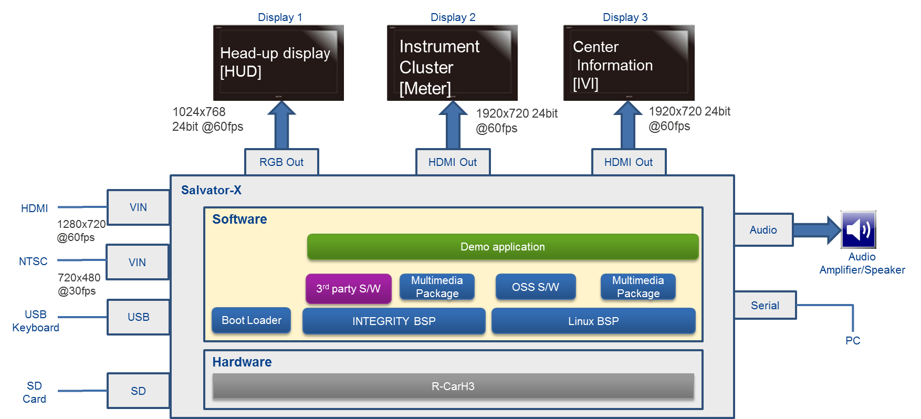

Figure 2‑1: Image of System architecture

## Metrics and parameters for evaluation

Virtualization PoC evaluates the following viewpoints.

* CPU Load
* Bus Load/Bandwidth
* Bus Latency
* Boot Time
* Interrupt Time
* Drawing Performance
* Video & Audio Performance
* Camera Performance
* Display Performance
* RAM I/O Performance
* Memory Performance
* Network Performance(Linux)
* Power Consumption Performance
* RTOS performance
* Application Switching performance
* Malicious App
* Robustness
* Rebooting of Linux
* Memory usage
* Stress Tolerance
* Security
* End-to-End Latency
* Memory Utilization of Each Module
* Network Performance(RTOS, Multivisor)

Currently we are using R-Car H3 WS1.1 with DDR2400. When moving to WS2.0, it will be set to 3200, which is expected to improve benchmark results.

# Virtualization PoC Implementation. Setup and Hardware Configuration

## Introduction

This chapter describes hardware required for virtualization PoC setup.

## Virtualization PoC Setup

The following figure shows the virtualization PoC setup.

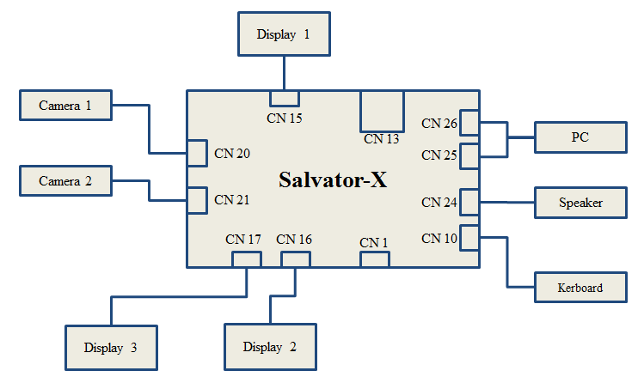

Figure 3‑1: Virtualization PoC setup

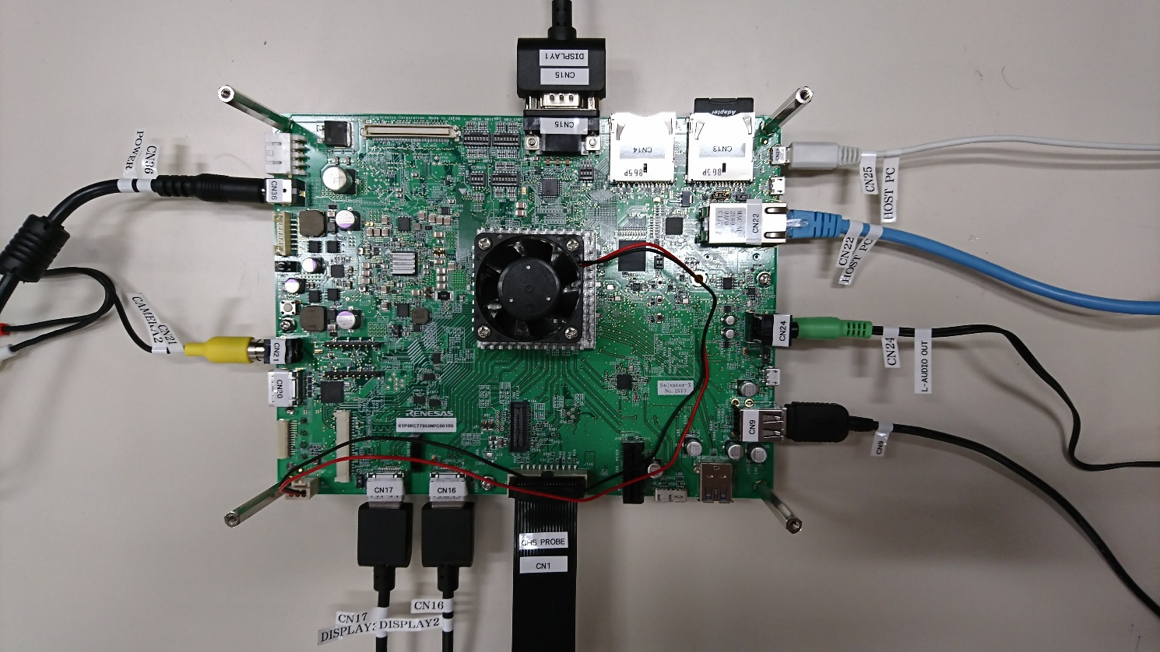

Figure 3‑2: Virtualization PoC top view

Table 3‑1: Connector List

|  |  |  |
| --- | --- | --- |
| **Connector** | **Item** | **Description** |
| CN 10 | Keyboard | Insert a USB-Keyboard |
| CN 13 | SD Card | Insert a SD card |
| CN 15 | Display 1 | Connect an Analog RGB Display (use for display Head-up display) |
| CN 16 | Display 2 | Connect a HDMI Display (use for display Center Information) |
| CN 17 | Display 3 | Connect a HDMI Display (use for display Instrument Cluster) |
| CN 21 | Camera 2 | Connect a NTSC Camera |
| CN 24 | Speaker | Connect a stereo speaker to AudioOut |
| CN 25/CN26 | PC | Connect a PC (use for terminal software on PC) |

## Hardware Components List

The following Table shows the virtualization Hardware components.

Table 3‑2: Hardware Components List

|  |  |  |
| --- | --- | --- |
| **Item** | **Quantity** | **Description** |
| Salvator-X board | 1 | R-Car H3-SiP System Evaluation Board |
| Display | 3 | On-Lap 1303I, 13.3 inch, microHDMI support |
| Speaker | 1 | SANWA MM-SPL2N2 |
| USB charger | 1 | SANWA 700-AC011-W |
| Power Supply TAP | 1 | SANWA TAP-TSH61N |
| SD card (*) | 7 | IO-DATA: SDMCH-W8G/A x5,  IO-DATA: BMS-8G10RW x2 |
| Camera | 1 | Gopro HERO3+ miniHDMI,miniUSB support |
| mini HDMI to HDMI Converter cable | 1 | Sony DLC-HEU10A |
| miniUSB to NTSC Converter cable | 1 | Gopro ACMPS-301 |
|  | | |
| (*) This product includes components of the PowerVR SDK from Imagination Technologies Limited. | | |

## The Salvator-X board features

The following table shows the Salvator-X board features.

Table 3‑3: Salvator-X board features

|  |  |
| --- | --- |
| **Item** | **Description** |
| SoC |  R-CarH3-SiPand its also includes LPDDR4-3200 memories and RPC flash memory |
| Display Interfaces |  2 channels HDMI output connector for HDMI0 and HDMI1   LVDS output connector for LVDS   Analog RGB output connector for DU |
| Video Input Interfaces |  HDMI input connector for CSI0   CVBS input connector for CS1 |
| Audio Interfaces |  Audio output connector for SSI0   Microphone input connector for SSI1 |
| Storage Interfaces |  USB2.0 type micro AB receptacle for USB0   2 channels USB2.0 type A receptacle for USB1 and USB2   USB3.0 type A receptacle for USB0   USB3.0 type micro B receptacle for USB1   Serial ATA connector for SATA   2 channels SD Card Slot for SDHI0 and SDHI3   eMMC memory for MMCIF0 |
| Network Interfaces |  PCIE x1 connector for PCIEC0   BT/Wi-Fi connector for PCIEC1   GbE connector for EtherAVB |
| Peripheral Interfaces |  2 channels ‘Debug Serial’ connector for SCIF2_A and SCIF1/HSCIF1_A |
| Debugger Interfaces |  20-pin JTAG connector |
| Peripheral connectors |  External memory connector for LBSC   Four EXIO connectors for LBSC, SSI, and various modules |
| Power Supply |  DC12.0V input |
| Operating temperature |  +25 degrees C at ambient temperature |

# Virtualization PoC Implementation. Software

This chapter describes software required for virtualization PoC setup.

The following figure shows the software configurations.

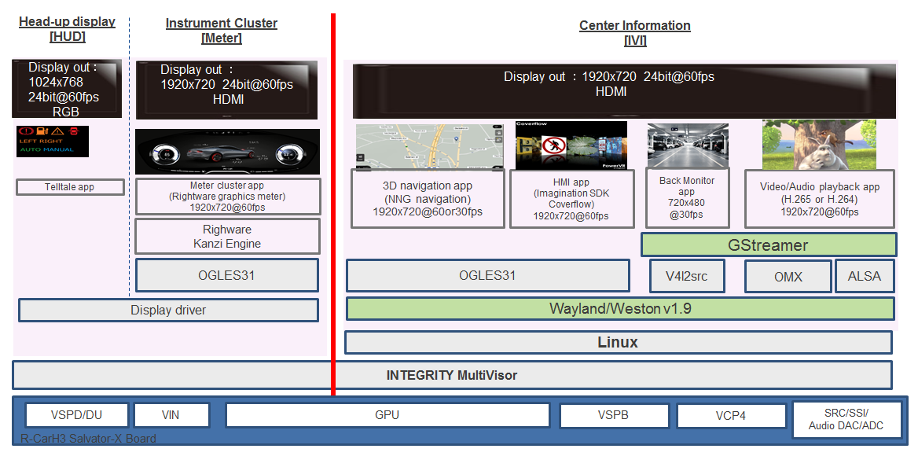

Figure 4‑1: Image of Software configurations

Virtualization PoC doesn't have Back Monitor on Head-up display. Evaluation is performed according to the specification on each OS.

The following Table shows the software lists.

Table 4‑1: Software lists

|  |  |  |  |
| --- | --- | --- | --- |
| **Category** | **Item** | **Model name** | **Version** |
| OS | Yocto | - | 2.7.0 |
| INTEGRITY | - | T9.0 |
| Driver /  Middleware | R-eBSP  RENESAS RTP0RC7795SIPB0010S Basic Driver Package for INTEGRITY(R) Multivisor(TM) source package | RTP0RC7795SIPB0010S-ITGBDPM | 0.2.10 |
| R-eBSP  RENESAS RTP0RC7795SIPB0010S Basic Driver Package for INTEGRITY(R) Multivisor(TM) source package | Linux patch for RENESAS RTP0RC7795SIPB0010S Basic Driver Package for INTEGRITY(R) Multivisor(TM) | 0.2.10 |
| Graphics  R8A7795 GX6650 OpenGL ES 3.1 Library for INTEGRITY(R) Multivisor | RTM0RC7795GLTG0011SGH2C | 1.1.4a |
| Graphics  R8A7795 GX6650 OpenGL ES 3.1 Library for Linux on INTEGRITY(R) Multivisor | RTM0RC7795GLTG0011SL40C | 1.1.4a |
| OMX Media Component Common Library for Linux | RTM0AC0000XCMCTL30SL40C | 3.0.2 |
| OMX Media Component Video Decoder Common Library for Linux | RTM0AC0000XVCMND30SL40C | 3.0.2 |
| OMX Media Component H.264 Decoder Library for Linux | RTM0AC0000XV264D30SL40C | 3.0.2 |
| UVCS Driver for Linux | RCG3VUDRL4001ZDO | 3.0.2 |
| OMX Media Component Audio Common Library for Linux | RTM0AC0000XACMND30SL40C | 3.0.2 |
| OMX Media Component for AAC-LC Decoder Library for Linux | RTM0AC0000XAAACD30SL40C | 3.0.2 |
| AAC-LC 2ch Decoder Middleware Library for Linux | RTM0AC0000ADAACMZ1SL40C | 3.0.2 |
| Application | 3D navigation | - | 9.35.0.0  Aug 31 2016 Demo (20160915) |
| HMI | - | 3.5 |
| Video/Audio playback with media player | - | 1.4.5 |
| Meter cluster | - | 20161222 |
| Telltale | - | 0.2.10a |
| Back monitor for HUD | - | 0.2.10a |

## Center Information

This section describes application software for Center Information.

### 3D navigation

The following figure shows the image of 3D navigation.

Note: NNG navigation shall be installed only when we evaluate it. The deliverables shall not include it.

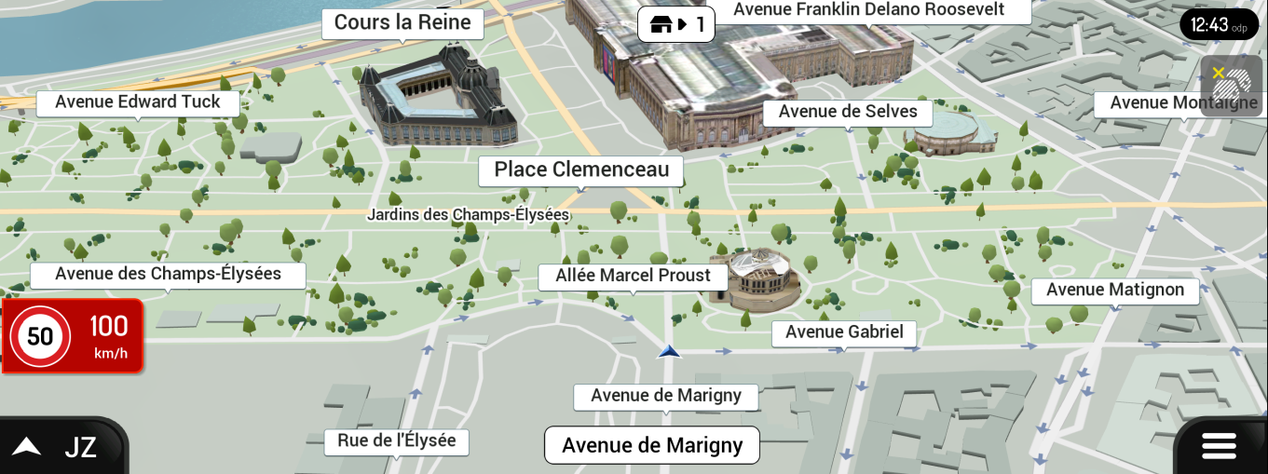

Figure 4‑2: Image of 3D navigation

The following table shows the 3D navigation features.

Table 4‑2: 3D navigation features

|  |  |
| --- | --- |
| **Item** | **Description** |
| Application | * NNG navigation * OpenGL ES 3.1 application |
| Resolution | * 1920x720 |

### HMI

The following figure shows the image of HMI.



Figure 4‑3: Image of HMI

The following table shows the HMI features.

Table 4‑3: HMI features

|  |  |
| --- | --- |
| **Item** | **Description** |
| Application | * Imagination SDK Coverflow * OpenGL ES 3.1 application |
| Resolution | * 1920x720 |

### Back monitor

The following figure shows the image of Back monitor.

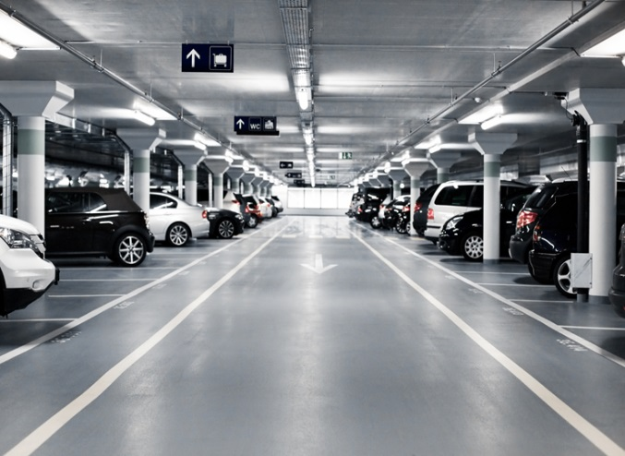

Figure 4‑4: Image of Back monitor

The following table shows the Back monitor features.

Table 4‑4: Back monitor features

|  |  |
| --- | --- |
| **Item** | **Description** |
| Application | * NTSC Camera application on Gstreamer |
| Frame per second | * 30 |
| Resolution | * 720x480 |

### Video/Audio playback with media player

The following figure shows the image of Video/Audio playback with media player.



Figure 4‑5: Image of Video/Audio playback with media player

The following table shows the Video/Audio playback with media player features.

Table 4‑5: Video/Audio playback with media player features

|  |  |
| --- | --- |
| **Item** | **Description** |
| Application | * GStreamer |
| Video Codec | * H.264 |
| Frame per second | * Maximum 60 fps |
| Resolution | * 1920 x720 |
| Media file location | * SD storage |

## Instrument Cluster

This section describes application software for Instrument Cluster.

### Meter Cluster

The following figure shows the image of Meter Cluster.

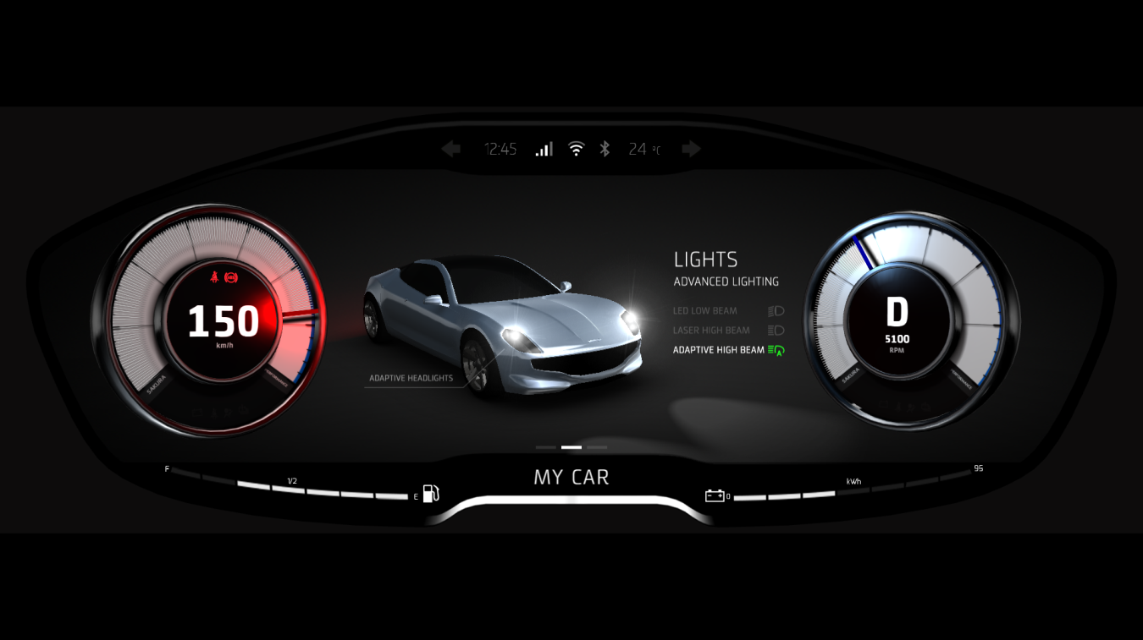

Figure 4‑6: Image of Meter Cluster

The following table shows the Meter Cluster features.

Table 4‑6: Meter Cluster features

|  |  |
| --- | --- |
| **Item** | **Description** |
| Application | * Sakura * Rightware graphics meter * OpenGL ES 3.1 application running on Rightware Kanzi |
| Frame per second | * 60 |
| Resolution | * 1920x720 |

## Head-up display

This section describes application software for Head-up display.

### Telltale

The following figure shows the image of Telltale.

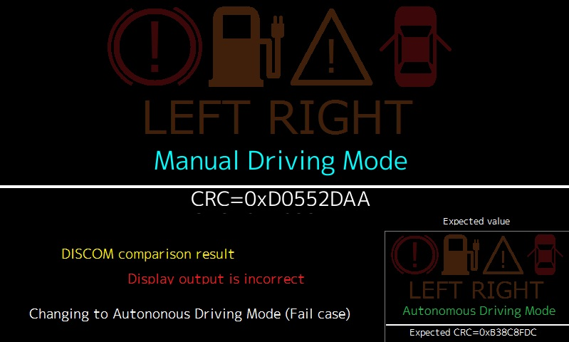

Figure 4‑7: Image of Telltale

The following table shows the Telltale features.

Table 4‑7: Telltale features

|  |  |
| --- | --- |
| **Item** | **Description** |
| Application | * DISCOM * Telltale, the simulated car status indicator on HUD or meter cluster. * This demonstrates the operation of DISCOM module, to check whether the display contents are correct or not. * All text and image drawings are performed by software. |
| Frame per second | * 60fps |
| Resolution | * 800x480 |

### Back monitor

The following figure shows the image of Back monitor.



Figure 4‑8: Image of Back monitor

The following table shows the Back monitor features.

Table 4‑8: Back monitor features

|  |  |
| --- | --- |
| **Item** | **Description** |
| Application | * HDMI Camera Application made by Renesas |
| Frame per second | * 60 |
| Resolution | * 1280x720 |

# Measurement

Executing the performance test, there are four test environments below.

If no special mentions in performance test procedure, set up a configuration that matches each type of measurement cases. Then start performance test.

INTEGRITY kernel is included debug library

*Note :*

*Type1,3,4 are using the debug library in INTEGRITY kernel in order to measure performance from INTEGRITY side. It may produce some overhead came from debug functionality.*

*The underlined text in each consideration includes our guess or assumption.*

This evaluation uses 4 types of Test environment. It is use for the following reasons.

Type 1 use for measuring PoC performance.

When comparing the performance of Linux, compare virtualized Linux of Type 4 and native Linux of Type 2.

Type 3 use for measuring only INTEGRITY.

* Virtualization PoC (Type1)

It is to build up the different character OS/application environments into the some domains, typically safety (INTEGRITY) and open (Linux).

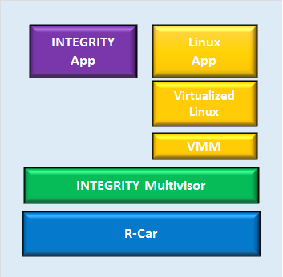

Figure 5‑1: Image of Virtualization PoC(Type1)

* Native Linux (Type2)

It is to build up the only Linux OS on R-car board without INTEGRITY Multivisor.

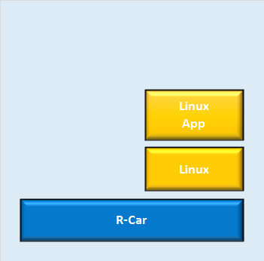

Figure 5‑2: Image of Native Linux(Type2)

Native INTEGRITY (Type3)

It is based on build up the virtualization PoC, in addition stop the function of virtualized Linux part.

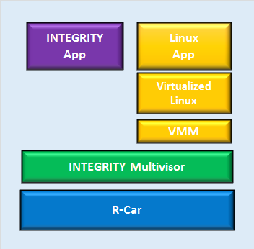

Stop the function of virtualized Linux part

Figure 5‑3: Image of Native INTEGRITY(Type3)

* Virtualized Linux(Type4)

It is based on build up the virtualization PoC, in addition stop the function of INTEGRITY App part.

INTEGRITY including drivers and INTEGRITY Multivisor are running, because INTEGRITY and INTEGRITY Multivisor are actually same modules.



Stop the function of INTEGRITY App

Figure 5‑4: Image of virtualized Linux(Type4)

*Attention:*

*When you test following cases except section 5.4,*

*please write U-Boot to HyperFlash in Appendix A and download monolith binary in Appendix B.*

*Appendix A and Appendix B require MULTI and GreenHills Probe.*

The following list shows the version of the measurement tool used for measurement.

Table 5‑1: measurement tool lists

|  |  |
| --- | --- |
| **Measurement Tool** | **Version** |
| UnixBench | 5.1.3 |
| lmbench | 3.0 alpha-9 |
| Busmoni(INTEGRITY) | RENESAS original |
| Busmoni(Linux) | 1.2 |
| Cyclictest | 0.9.2 |
| gsize | T9.0 (Including INTEGRITY) |
| IPMMUDemo | T9.0 (Including INTEGRITY) |
| random_write | RENESAS original |
| alloc_dealloc | RENESAS original |
|  |  |
|  |  |

The following list shows the build configurations used for measurement.

Table 5‑2: Build configurations

|  |  |  |
| --- | --- | --- |
| **Configurations** | **Setting** | **Note** |
| INTEGRITY kernel configurations | -kernel | Use the normal kernel |
| -ldebug | Use the debug library to use some debugging functions |

## CPU Load

### Total CPU usage on Linux

1. Description

Measure the CPU usage of Center Information application on native Linux using Unixbench.

1. Precondition

* Measure on native Linux(Type2)
* Use Unixbench on terminal software.
* Use “cat /proc/stat” command in order to measure the average of CPU load.

1. How to measure

* Only “cat /proc/stat” command

1. Login to Linux.

salvator-x login: root

1. Run “cat /proc/stat” command as the “measure start” of CPU status.

root@salvator-x:~# cat /proc/stat

After finishing a command, you will see the log like below.

cpu 101077 0 25728 270652 4690 0 1982 0 0 0

cpu0 19369 0 7014 67547 386 0 1981 0 0 0

cpu1 22733 0 6785 71907 1136 0 0 0 0 0

cpu2 27188 0 6164 67437 1714 0 0 0 0 0

cpu3 31786 0 5763 63760 1453 0 0 0 0 0

These items mean “usr”, ”nice”, “sys”, “idle” in turn.

1. Waiting for 10 minutes.
2. Run “cat /proc/stat” command as the “measure end” of CPU status.
3. Calculate the CPU load with following formula.
4. CPU usage = 100 – “idle ratio”

“idle ratio” = “idle” of “measure end” - “idle” of “measure start”/ Total CPU count

Total CPU count = Sum of (“measure end”-“measure start”)

* Unixbench and “cat /proc/stat” command

1. Login to Linux.

salvator-x login: root

1. Run the following command to change the directory.

root@salvator-x:~# cd tools/UnixBench

1. Run the following command to burden the software.

root@salvator-x:~/tools/UnixBench# ./Run -c 4 -i 100 syscall&

1. Run “cat /proc/stat” command as the “measure start” of CPU status.

root@salvator-x:~# cat /proc/stat

1. Waiting for 10 minutes.
2. Run “cat /proc/stat” command as the “measure end” of CPU status.
3. Calculate the CPU load with the above formula.
4. Result

Table 5‑3: Only “cat /proc/stat” command Result(%)

|  |  |
| --- | --- |
| **Test environment** | **CPU Usage.** |
| **Native Linux**  **(Type2)** | 31.6 |

Table 5‑4: Unixbench and “cat /proc/stat” command Result(%)

|  |  |
| --- | --- |
| **Test environment** | **CPU Usage.** |
| **Native Linux**  **(Type2)** | 84.6 |

* Only “cat /proc/stat” command

Result of “measure start”

root@salvator-x:~# cat /proc/stat

cpu 101077 0 25728 270652 4690 0 1982 0 0 0

cpu0 19369 0 7014 67547 386 0 1981 0 0 0

cpu1 22733 0 6785 71907 1136 0 0 0 0 0

cpu2 27188 0 6164 67437 1714 0 0 0 0 0

cpu3 31786 0 5763 63760 1453 0 0 0 0 0

Result of “measure end”

root@salvator-x:~# cat /proc/stat

cpu 163044 0 40878 437813 4782 0 1984 0 0 0

cpu0 31650 0 11245 110965 406 0 1983 0 0 0

cpu1 36322 0 10726 115796 1152 0 0 0 0 0

cpu2 43863 0 9780 108582 1758 0 0 0 0 0

cpu3 51208 0 9126 102468 1465 0 0 0 0 0

Calculation:

CPU load = 100 – (167161/244372) = 31.6 %

|  |  |  |  |  |  |
| --- | --- | --- | --- | --- | --- |
|  | usr | nice | sys | idle | other |
| measure end | 163044 | 0 | 40878 | 437813 | 6766 |
| measure start | 101077 | 0 | 25728 | 270652 | 6672 |
| difference | 61967 | 0 | 15150 | 167161 | 92 | 244372(Sum) |

* Unixbench and “cat /proc/stat” command

Result of “measure start”

root@salvator-x:~/tools/UnixBench# cat /proc/stat

cpu 32059 0 41454 43550 3951 0 1239 0 0 0

cpu0 7268 0 10083 9880 398 0 1239 0 0 0

cpu1 7751 0 10485 11634 1243 0 0 0 0 0

cpu2 8369 0 10490 11281 994 0 0 0 0 0

cpu3 8670 0 10394 10754 1315 0 0 0 0 0

Result of “measure end”

root@salvator-x:~/tools/UnixBench# cat /proc/stat

cpu 103536 0 169657 80465 4820 0 2852 0 0 0

cpu0 24481 0 41070 19083 596 0 2852 0 0 0

cpu1 25201 0 42952 21432 1460 0 0 0 0 0

cpu2 26168 0 43118 20586 1222 0 0 0 0 0

cpu3 27686 0 42516 19363 1541 0 0 0 0 0

Calculation:

CPU load = 100 – (36915/239077) = 84.6 %

|  |  |  |  |  |  |
| --- | --- | --- | --- | --- | --- |
|  | usr | nice | sys | idle | other |
| measure end | 103536 | 0 | 169657 | 80465 | 7672 |
| measure start | 32059 | 0 | 41454 | 43550 | 5190 |
| difference | 71477 | 0 | 128203 | 36915 | 2482 | 239077(Sum) |

1. Consideration

This result(%) is the percentage of all 4 CPU resources, so if only the 1 core is fully occupied and other cores are idle, the result becomes 25%.

From the table 5-3, this PoC demo program consumes about the power of one whole CPU.

The table 5-4 increases approximately 53% CPU load in addition to table 5-3.

### Total CPU usage of Hypervisor(Multivisor)

1. Description

Measure the total CPU utilization of Multivisor Task (VM task of guest OS) when using the application of Center Information application on virtualized Linux using Multi Debugger.

1. Precondition

* Measure on virtualized Linux (Type4)
* Use a tool including in Multi Debugger.

1. How to measure
2. Select [Target] – [Connect] from Menu bar
3. Select “Dynamic Download/INDRT Connection (rtserv2) for Device Tree” and press “Connect” button.
4. Select “Run mode target”
5. Run the following command on “Trg” tab.

INDRT2>ct

1. Waiting for 10 minutes.
2. Run the following command on “Trg” tab.

INDRT2>lt

After finishing a command, you will see the log like below.

MultivisorTask0-3 means CPU usage of Linux on virtualization.

multivisor_vmm 0x000000000022a000/0x0000000000c3b000

0xffffffa6c0073000 pending 127 0x0000000000000790/0x0000000000002000 0.00% Initial

0xffffffa00a876000 pending 254 0x0000000000000280/0x0000000000000dd0 0.00% OSAAgent

0xffffffa6feedd000 pending 127 0x00000000000004b0/0x0000000000000dd0 0.00% AsyncPollTask

0xffffffa6feea0000 pending 127 0x00000000000011f0/0x0000000000002dd0 0.00% GipcStdio_StdinTask

0xffffffa6fee9a000 pending 127 0x0000000000001210/0x0000000000002dd0 0.00% GipcStdio_StdoutTask

0xffffffa6fee96000 pending 200 0x0000000000000440/0x0000000000001dd0 36.54% MultivisorTask0

0xffffffa6fee92000 pending 200 0x00000000000003d0/0x0000000000001dd0 31.61% MultivisorTask1

*0xffffffa6fee8d000 running 200 0x00000000000003d0/0x0000000000001dd0 36.74% MultivisorTask2

0xffffffa6fee89000 pending 200 0x0000000000001410/0x0000000000001dd0 40.84% MultivisorTask3

1. Result

This result is average of MultivisorTask0-3. MultivisorTask0-3 means CPU usage of Linux on virtualization.

Table 5‑5: Result of Type4(%)

|  |  |
| --- | --- |
| **Test environment** | **CPU Usage.** |
| **Virtualized Linux (Type4)** | 36.43 |

Memory: Used/Size or

Task Id Status Pri Stack:HiWater/Size Time Task Name

-------------------- ---------------- --- ------------------------------------- ------- ---------

Type4_kernel 0x000000000012c000/0x00000000170aa000

0xffffffa010010000 exited 127 0x0000000000000630/0x0000000000008000 0.00% Initial

*0xffffffa010012000 running 0 0x0000000000000028/0x0000000000000400 62.00% Idle0

0xffffffa010014000 running 0 0x0000000000000028/0x0000000000000400 66.39% Idle1

0xffffffa010016000 running 0 0x0000000000000028/0x0000000000000400 61.48% Idle2

0xffffffa010018000 running 0 0x0000000000000028/0x0000000000000400 57.57% Idle3

0xffffffa6c00c0000 pending 254 0x0000000000000060/0x0000000000001000 0.00% RunModePartnerTask

0xffffffa6c00c2000 pending 254 0x0000000000001240/0x0000000000004800 0.00% ResourceManager

0xffffffa6c00c6000 pending 200 0x00000000000000f8/0x0000000000001000 0.00% rcar-avb-0

0xffffffa6c00c8000 pending 253 0x00000000000006e8/0x0000000000005000 0.00% DriverDebugControl

0xffffffa6c00d3000 pending 255 0x0000000000000360/0x0000000000002000 0.00% GipcTarget_Dispatch

*0xffffffa6c00dc000 running 254 0x00000000000001e8/0x0000000000002000 0.00% IDB_Receiver

0xffffffa6c00e0000 pending 254 0x00000000000001b0/0x0000000000002000 0.00% IDB_Sender

0xffffffa6c00e2000 pending 127 0x0000000000000358/0x0000000000008000 0.00% FrameBufferManagerTask

0xffffffa6c00e6000 pending 127 0x00000000000002e0/0x0000000000008000 0.12% VINManagerTask

0xffffffa6c00e8000 pending 150 0x0000000000000488/0x0000000000002000 0.00% SDIOCardIOTask

0xffffffa6c00ea000 pending 150 0x00000000000004e0/0x0000000000002000 0.00% SDIOCardIOTask1

0xffffffa6c00ed000 pending 254 0x00000000000001d0/0x0000000000000dd0 0.00% OSAAgent

0xffffffa6c00f1000 pending 11 0x0000000000000090/0x0000000000001000 0.00% VirtualDriverMediator

0xffffffa6c00f5000 pending 11 0x0000000000000090/0x0000000000001000 0.00% VirtualDriverMediator

0xffffffa6c00f8000 pending 11 0x0000000000000090/0x0000000000001000 0.00% VirtualDriverMediator

0xffffffa6c00fc000 pending 11 0x0000000000000090/0x0000000000001000 0.00% VirtualDriverMediator

0xffffffa6c00ff000 pending 11 0x0000000000000090/0x0000000000001000 0.00% VirtualDriverMediator

0xffffffa6c0102000 pending 11 0x0000000000000090/0x0000000000001000 0.00% VirtualDriverMediator

0xffffffa6c0106000 pending 11 0x0000000000000090/0x0000000000001000 0.00% VirtualDriverMediator

0xffffffa6c0109000 pending 11 0x0000000000000090/0x0000000000001000 0.00% VirtualDriverMediator

0xffffffa6c010c000 pending 11 0x0000000000000090/0x0000000000001000 0.00% VirtualDriverMediator

0xffffffa6c010f000 pending 11 0x0000000000000090/0x0000000000001000 0.00% VirtualDriverMediator

0xffffffa6c0112000 pending 11 0x0000000000000090/0x0000000000001000 0.00% VirtualDriverMediator

0xffffffa6c0116000 pending 11 0x0000000000000090/0x0000000000001000 0.00% VirtualDriverMediator

0xffffffa6c0119000 pending 11 0x0000000000000090/0x0000000000001000 0.00% VirtualDriverMediator

0xffffffa6c011c000 pending 11 0x0000000000000090/0x0000000000001000 0.00% VirtualDriverMediator

0xffffffa6c011f000 pending 11 0x0000000000000090/0x0000000000001000 0.00% VirtualDriverMediator

0xffffffa6c0122000 pending 11 0x0000000000000090/0x0000000000001000 0.00% VirtualDriverMediator

0xffffffa6c0126000 pending 11 0x0000000000000090/0x0000000000001000 0.00% VirtualDriverMediator

0xffffffa6c0129000 pending 11 0x0000000000000090/0x0000000000001000 0.00% VirtualDriverMediator

0xffffffa6c012b000 pending 128 0x0000000000000170/0x0000000000003cb8 0.00% PosixServer

0x0000000000006000/0x0000000000006000

FBServer 0x0000000000000000/0x000000000103d000

0xffffffa6c0077000 pending 127 0x0000000000001560/0x0000000000006000 0.00% Initial

0xffffffa00c936000 pending 254 0x0000000000000280/0x0000000000000dd0 0.00% OSAAgent

pvrserver_as0 0x0000000001fb9000/0x0000000009dfd000

0xffffffa6c0076000 pending 200 0x0000000000000f00/0x0000000000006000 0.00% Initial

0xffffffa00c8f6000 pending 254 0x0000000000000280/0x0000000000000dd0 0.00% OSAAgent

0xffffffa6ee648000 pending 200 0x0000000000000310/0x000000000000fdd0 0.00% pvr_defer_free

0xffffffa6ee636000 pending 200 0x00000000000005d0/0x000000000000fdd0 0.00% pvr_device_wdg

0xffffffa6ec75e000 pending 200 0x00000000000002a0/0x0000000000000dd0 1.25% 3DGIntrTask

0xffffffa6ec750000 pending 200 0x0000000000000060/0x0000000000000dd0 0.00% GRAPHICS_MISR

0xffffffa6ec74d000 pending 200 0x0000000000000230/0x0000000000000dd0 1.86% GRAPHICS_MISR

0xffffffa6ec746000 pending 128 0x0000000000000050/0x0000000000003dd0 0.00% CheckSSHRebootThread

multivisor_net_server 0x0000000000003000/0x0000000000040000

0xffffffa6c0075000 pending 127 0x0000000000000790/0x0000000000002000 0.00% Initial

0xffffffa00a8f6000 pending 254 0x0000000000000280/0x0000000000000dd0 0.00% OSAAgent

multivisor_loader 0x0000000000000000/0x000000000c823000

0xffffffa6c0074000 exited 127 0x00000000000008f0/0x0000000000002000 0.00% Initial

0xffffffa00a8b3000 pending 254 0x0000000000000310/0x0000000000001dd0 0.00% LoaderTask

0xffffffa00a8a9000 pending 254 0x0000000000000220/0x0000000000001dd0 0.00% MULTILoadAgent

0xffffffa00a8a6000 halted 254 0x0000000000000000/0x0000000000000dd0 0.00% LoaderHelperTask

0xffffffa00a8a3000 halted 254 0x0000000000000000/0x0000000000000dd0 0.00% LoaderHelperTask

0xffffffa00a8a0000 halted 254 0x0000000000000000/0x0000000000000dd0 0.00% LoaderHelperTask

0xffffffa00a89c000 pending 254 0x0000000000000280/0x0000000000000dd0 0.00% OSAAgent

multivisor_vmm 0x000000000022a000/0x0000000000c3b000

0xffffffa6c0073000 pending 127 0x0000000000000790/0x0000000000002000 0.00% Initial

0xffffffa00a876000 pending 254 0x0000000000000280/0x0000000000000dd0 0.00% OSAAgent

0xffffffa6feedd000 pending 127 0x00000000000004b0/0x0000000000000dd0 0.00% AsyncPollTask

0xffffffa6feea0000 pending 127 0x00000000000011f0/0x0000000000002dd0 0.00% GipcStdio_StdinTask

0xffffffa6fee9a000 pending 127 0x0000000000001210/0x0000000000002dd0 0.00% GipcStdio_StdoutTask

0xffffffa6fee96000 pending 200 0x0000000000000440/0x0000000000001dd0 36.54% MultivisorTask0

0xffffffa6fee92000 pending 200 0x00000000000003d0/0x0000000000001dd0 31.61% MultivisorTask1

*0xffffffa6fee8d000 running 200 0x00000000000003d0/0x0000000000001dd0 36.74% MultivisorTask2

0xffffffa6fee89000 pending 200 0x0000000000001410/0x0000000000001dd0 40.84% MultivisorTask3

ip46router_devtree_module 0x000000000003b000/0x00000000004af000

0xffffffa6c0072000 exited 127 0x0000000000000af0/0x0000000000003000 0.00% Initial

0xffffffa00a836000 pending 254 0x0000000000000280/0x0000000000000dd0 0.00% OSAAgent

0xffffffa00a831000 pending 200 0x00000000000000c0/0x0000000000000dd0 0.00% rcar-avb-0

*0xffffffa00a828000 running 253 0x00000000000007a0/0x0000000000004dd0 0.06% DriverDebugService

0xffffffa6ff353000 pending 200 0x00000000000005a0/0x0000000000005dd0 0.24% InetServer

0xffffffa6ff341000 pending 200 0x00000000000001a0/0x0000000000003dd0 0.00% FibArpRefreshTask0

0xffffffa6ff332000 pending 127 0x0000000000000080/0x0000000000000dd0 0.00% PingWatchdog_ResetTask

ivfsserver_devtree_module 0x00000000000ca000/0x000000000073d000

0xffffffa6c0071000 exited 127 0x0000000000000880/0x0000000000002000 0.00% Initial

0xffffffa00a736000 pending 254 0x0000000000000280/0x0000000000000dd0 0.00% OSAAgent

0xffffffa6ff954000 pending 152 0x00000000000000c0/0x0000000000003dd0 0.00% HealthMonitor

0xffffffa6ff949000 pending 150 0x0000000000000a40/0x0000000000008dd0 0.00% FileServer

0xffffffa6ff942000 pending 149 0x00000000000005d0/0x0000000000003dd0 0.03% NFSTimerTask

0xffffffa6ff8c1000 pending 152 0x0000000000000180/0x0000000000004dd0 0.00% IOTask

0xffffffa6ff8b4000 pending 150 0x0000000000000910/0x0000000000008dd0 0.00% IOAssistant0

0xffffffa6ff8ab000 pending 150 0x0000000000000690/0x0000000000006dd0 0.00% Syncer

0xffffffa6ff8a4000 halted 151 0x0000000000000090/0x0000000000003dd0 0.00% Unmounter

0xffffffa6ff88d000 pending 150 0x00000000000004c0/0x0000000000008dd0 0.00% IOAssistant1

devtree_generic_server_module 0x00000000002b6000/0x0000000001501000

0xffffffa6c0070000 pending 127 0x0000000000000860/0x0000000000002000 0.00% Initial

0xffffffa6fbf56000 pending 220 0x00000000000003f0/0x0000000000001dd0 0.00% fb-map-server

1. Consideration

The measured result is 36.4 % on this virtualized Linux environment. As the corresponding result on the native Linux is 31.6%, the CPU load on the virtualized Linux is 4.8% higher. From the result of 5.1.4, the virtualization overhead of the Linux itself is relatively small, so the possible factor of the CPU load difference is the GPU driver which require a large number of interrupt and event processing.

### Total CPU usage on INTEGRITY

1. Description

Measure the CPU usage of Instrument Cluster / Head-up display application on native INTEGRITY.

1. Precondition

* Measure on native INTEGRITY (Type3)
* Use a tool including in Multi Debugger.

1. How to measure
2. Refer to 5.1.2.

After finishing a command in 6 procedures, see the log like below.

[Instrument Cluster]

See at the left value of "Initial", “PosixServer” and “name_too_long” in section of “sakura”.

Sakura 0x00000000000df000/0x0000000004000000

0xffffffa6c00d9000 pending 127 0x00000000000187b0/0x0000000000200000 14.37% Initial

0xffffffa00fab3000 pending 128 0x0000000000000168/0x0000000000003cb8 0.00% PosixServer

0xffffffa00faae000 pending 254 0x0000000000000280/0x0000000000000dd0 0.00% OSAAgent

0xffffffa00fa4b000 pending 127 0x0000000000000b38/0x0000000000003cb8 0.00% name_too_long

[Head-up display application]

See at the left value of "Initial" in section of “DISCOM_sample_virt”.

DISCOM_sample_virt 0x0000000000005000/0x0000000000080000

0xffffffa6c00e0000 pending 127 0x0000000000000af0/0x0000000000008000 0.64% Initial

0xffffffa00fe76000 pending 254 0x0000000000000280/0x0000000000000dd0 0.00% OSAAgent

This log (%) is based on one CPU base. If the all CPUs are fully loaded, the value will be 400%.

1. Result

Result is based on full CPU base. If the all CPUs are fully loaded, the value will be 100%.

Table 5‑6: Result(%)

|  |  |
| --- | --- |
| **Test environment** | **Total CPU Usage.** |
| **Native INTEGRITY (Type3)** | 7.39% |

|  |  |  |
| --- | --- | --- |
| **Test environment** | **Application** | **CPU Usage.** |
| **Native INTEGRITY (Type3)** | **DISCOM_sample_virt** | 0.16 |
| **Sakura** | 3.59 |
| **Other Task** | 3.63 |

Memory: Used/Size or

Task Id Status Pri Stack:HiWater/Size Time Task Name

-------------------- ---------------- --- ------------------------------------- ------- ---------

Type3_kernel 0x000000000017f000/0x000000000ccaa000

0xffffffa6c0010000 exited 127 0x0000000000000630/0x0000000000008000 0.00% Initial

0xffffffa6c0012000 running 0 0x0000000000000028/0x0000000000000400 87.58% Idle0

0xffffffa6c0014000 running 0 0x0000000000000028/0x0000000000000400 93.19% Idle1

0xffffffa6c0016000 running 0 0x0000000000000028/0x0000000000000400 94.48% Idle2

*0xffffffa6c0018000 running 0 0x0000000000000028/0x0000000000000400 92.65% Idle3

0xffffffa6c012f000 pending 254 0x0000000000000060/0x0000000000001000 0.00% RunModePartnerTask

0xffffffa6c0131000 pending 254 0x0000000000001140/0x0000000000004800 1.19% ResourceManager

0xffffffa6c0135000 pending 200 0x00000000000000f8/0x0000000000001000 0.00% rcar-avb-0

0xffffffa6c0137000 pending 253 0x00000000000006e8/0x0000000000005000 0.00% DriverDebugControl

0xffffffa6c0142000 pending 255 0x0000000000000360/0x0000000000002000 0.00% GipcTarget_Dispatch

*0xffffffa6c014d000 running 254 0x00000000000001e8/0x0000000000002000 0.01% IDB_Receiver

0xffffffa6c014f000 pending 254 0x00000000000001b0/0x0000000000002000 0.00% IDB_Sender

0xffffffa6c0151000 pending 127 0x0000000000000358/0x0000000000008000 0.00% FrameBufferManagerTask

0xffffffa6c0155000 pending 127 0x00000000000002e8/0x0000000000008000 0.02% VINManagerTask

0xffffffa6c0157000 pending 150 0x0000000000000480/0x0000000000002000 0.00% SDIOCardIOTask

0xffffffa6c0159000 pending 150 0x00000000000004e8/0x0000000000002000 0.00% SDIOCardIOTask1

0xffffffa6c015c000 pending 254 0x00000000000001d0/0x0000000000000dd0 0.00% OSAAgent

0xffffffa6c0160000 pending 11 0x0000000000000090/0x0000000000001000 0.00% VirtualDriverMediator

0xffffffa6c0163000 pending 11 0x0000000000000090/0x0000000000001000 0.00% VirtualDriverMediator

0xffffffa6c0166000 pending 11 0x0000000000000090/0x0000000000001000 0.00% VirtualDriverMediator

0xffffffa6c016a000 pending 11 0x0000000000000090/0x0000000000001000 0.00% VirtualDriverMediator

0xffffffa6c016d000 pending 11 0x0000000000000090/0x0000000000001000 0.00% VirtualDriverMediator

0xffffffa6c0170000 pending 11 0x0000000000000090/0x0000000000001000 0.00% VirtualDriverMediator

0xffffffa6c0173000 pending 11 0x0000000000000090/0x0000000000001000 0.00% VirtualDriverMediator

0xffffffa6c0176000 pending 11 0x0000000000000090/0x0000000000001000 0.00% VirtualDriverMediator

0xffffffa6c0179000 pending 11 0x0000000000000090/0x0000000000001000 0.00% VirtualDriverMediator

0xffffffa6c017c000 pending 11 0x0000000000000090/0x0000000000001000 0.00% VirtualDriverMediator

0xffffffa6c017f000 pending 11 0x0000000000000090/0x0000000000001000 0.00% VirtualDriverMediator

0xffffffa6c0182000 pending 11 0x0000000000000090/0x0000000000001000 0.00% VirtualDriverMediator

0xffffffa6c0185000 pending 11 0x0000000000000090/0x0000000000001000 0.00% VirtualDriverMediator

0xffffffa6c0188000 pending 11 0x0000000000000090/0x0000000000001000 0.00% VirtualDriverMediator

0xffffffa6c018c000 pending 11 0x0000000000000090/0x0000000000001000 0.00% VirtualDriverMediator

0xffffffa6c018f000 pending 11 0x0000000000000090/0x0000000000001000 0.00% VirtualDriverMediator

0xffffffa6c0192000 pending 11 0x0000000000000090/0x0000000000001000 0.00% VirtualDriverMediator

0xffffffa6c0195000 pending 11 0x0000000000000090/0x0000000000001000 0.00% VirtualDriverMediator

0xffffffa6c0198000 pending 128 0x0000000000000178/0x0000000000003cb8 0.00% PosixServer

INT_Logo_sample_virt 0x0000000000003000/0x0000000000040000

0xffffffa6c00e3000 pending 127 0x0000000000000880/0x0000000000008000 0.00% Initial

0xffffffa011ef6000 pending 254 0x0000000000000280/0x0000000000000dd0 0.00% OSAAgent

FBServer 0x0000000000000000/0x000000000103d000

0xffffffa6c00e2000 pending 127 0x00000000000017d0/0x0000000000006000 0.39% Initial

0xffffffa011eb6000 pending 254 0x0000000000000280/0x0000000000000dd0 0.00% OSAAgent

pvrserver_as0 0x00000000025b5000/0x0000000009dfd000

0xffffffa6c00e1000 pending 200 0x0000000000000b80/0x0000000000006000 7.98% Initial

0xffffffa011e76000 pending 254 0x0000000000000280/0x0000000000000dd0 0.00% OSAAgent

0xffffffa6ee648000 pending 200 0x0000000000000310/0x000000000000fdd0 0.00% pvr_defer_free

0xffffffa6ee636000 pending 200 0x0000000000000350/0x000000000000fdd0 0.00% pvr_device_wdg

0xffffffa6ec75a000 pending 200 0x00000000000002a0/0x0000000000000dd0 1.04% 3DGIntrTask

0xffffffa6ec74c000 pending 200 0x00000000000000e0/0x0000000000000dd0 0.12% GRAPHICS_MISR

0xffffffa6ec749000 pending 200 0x0000000000000530/0x0000000000000dd0 1.99% GRAPHICS_MISR

0xffffffa6ec742000 pending 128 0x0000000000000050/0x0000000000003dd0 0.00% CheckSSHRebootThread

0xffffffa6ec68c000 pending 200 0x0000000000000330/0x0000000000000dd0 0.26% DC_OS_Task

0xffffffa6ec689000 pending 200 0x0000000000000120/0x0000000000000dd0 0.83% GRAPHICS_MISR

0xffffffa6ec675000 pending 200 0x0000000000000570/0x0000000000000dd0 0.45% FBIntrTask

DISCOM_sample_virt 0x0000000000005000/0x0000000000080000

0xffffffa6c00e0000 pending 127 0x0000000000000af0/0x0000000000008000 0.64% Initial

0xffffffa00fe76000 pending 254 0x0000000000000280/0x0000000000000dd0 0.00% OSAAgent

multivisor_net_server 0x0000000000003000/0x0000000000040000

0xffffffa6c00df000 pending 127 0x0000000000000790/0x0000000000002000 0.00% Initial

0xffffffa00fdf6000 pending 254 0x0000000000000280/0x0000000000000dd0 0.00% OSAAgent

multivisor_loader 0x0000000000000000/0x000000000c823000

0xffffffa6c00de000 exited 127 0x00000000000008f0/0x0000000000002000 0.00% Initial

0xffffffa00fdb3000 pending 254 0x0000000000000310/0x0000000000001dd0 0.00% LoaderTask

0xffffffa00fda9000 pending 254 0x0000000000000220/0x0000000000001dd0 0.00% MULTILoadAgent

0xffffffa00fda6000 halted 254 0x0000000000000000/0x0000000000000dd0 0.00% LoaderHelperTask

0xffffffa00fda3000 halted 254 0x0000000000000000/0x0000000000000dd0 0.00% LoaderHelperTask

0xffffffa00fda0000 halted 254 0x0000000000000000/0x0000000000000dd0 0.00% LoaderHelperTask

0xffffffa00fd9c000 pending 254 0x0000000000000280/0x0000000000000dd0 0.00% OSAAgent

multivisor_vmm 0x0000000000003000/0x0000000000040000

0xffffffa6c00dd000 halted 127 0x0000000000000670/0x0000000000002000 0.00% Initial

0xffffffa00fd76000 pending 254 0x0000000000000280/0x0000000000000dd0 0.00% OSAAgent

ip46router_devtree_module 0x0000000000041000/0x00000000004af000

0xffffffa6c00dc000 exited 127 0x0000000000000af0/0x0000000000003000 0.00% Initial

0xffffffa00fd36000 pending 254 0x0000000000000280/0x0000000000000dd0 0.00% OSAAgent

0xffffffa00fd31000 pending 200 0x00000000000000c0/0x0000000000000dd0 0.00% rcar-avb-0

*0xffffffa00fd28000 running 253 0x00000000000007a0/0x0000000000004dd0 0.15% DriverDebugService

*0xffffffa6ff353000 pending 200 0x00000000000005a0/0x0000000000005dd0 0.10% InetServer

0xffffffa6ff341000 pending 200 0x00000000000000f0/0x0000000000003dd0 0.00% FibArpRefreshTask0

0xffffffa6ff327000 pending 127 0x0000000000000080/0x0000000000000dd0 0.00% PingWatchdog_ResetTask

ivfsserver_devtree_module 0x00000000000ca000/0x000000000073d000

0xffffffa6c00db000 exited 127 0x0000000000000880/0x0000000000002000 0.00% Initial

0xffffffa00fc36000 pending 254 0x0000000000000280/0x0000000000000dd0 0.00% OSAAgent

0xffffffa6ff954000 pending 152 0x00000000000000c0/0x0000000000003dd0 0.00% HealthMonitor

0xffffffa6ff949000 pending 150 0x0000000000000a40/0x0000000000008dd0 0.00% FileServer

0xffffffa6ff942000 pending 149 0x00000000000005d0/0x0000000000003dd0 0.00% NFSTimerTask

0xffffffa6ff8c1000 pending 152 0x0000000000000180/0x0000000000004dd0 0.00% IOTask

0xffffffa6ff8b4000 pending 150 0x0000000000000910/0x0000000000008dd0 0.00% IOAssistant0

0xffffffa6ff8ab000 pending 150 0x0000000000000690/0x0000000000006dd0 0.00% Syncer

0xffffffa6ff8a4000 halted 151 0x0000000000000090/0x0000000000003dd0 0.00% Unmounter

0xffffffa6ff899000 pending 150 0x0000000000000450/0x0000000000008dd0 0.00% IOAssistant1

devtree_generic_server_module 0x00000000002b6000/0x0000000001501000

0xffffffa6c00da000 pending 127 0x0000000000000860/0x0000000000002000 0.00% Initial

0xffffffa6fbf56000 pending 220 0x00000000000003f0/0x0000000000001dd0 0.00% fb-map-server

Sakura 0x00000000000df000/0x0000000004000000

0xffffffa6c00d9000 pending 127 0x00000000000187b0/0x0000000000200000 14.37% Initial

0xffffffa00fab3000 pending 128 0x0000000000000168/0x0000000000003cb8 0.00% PosixServer

0xffffffa00faae000 pending 254 0x0000000000000280/0x0000000000000dd0 0.00% OSAAgent

0xffffffa00fa4b000 pending 127 0x0000000000000b38/0x0000000000003cb8 0.00% name_too_long

1. Consideration

Telltale application (DISCOM_sample_virt) draws periodically (3 seconds/1 frame draw), so it may result 0

to 0.5 percent depends on the measurement timing.

Meter cluster application (Sakura) uses OpenGLES library and application, and it is designed to consume

under 12.5% of CPU.

### The overhead (CPU usage) compared virtualized Linux with native Linux

1. Description

Compare the overhead (CPU usage) of using the application of Center Information on virtualized Linux and native Linux.

1. Precondition

* Measure on virtualized Linux and native Linux (Type4 and Type2)
* Use Unixbench on terminal software.
* Compare the performance between virtualized Linux and native Linux.

1. How to measure

* Type2

1. measurement method of Unixbench refer to 5.1.1.

* Type4

1. Login to Linux.

salvator-x login: root

1. Run the following command to change the directory.

root@salvator-x:~# cd tools/UnixBench

1. Run the following command to burden the software.

root@salvator-x:~/tools/UnixBench# ./Run -c 4 -i 100 syscall

1. Run “cat /proc/stat” command as the “measure start” of CPU status.

root@salvator-x:~# cat /proc/stat

* Compare

1. Check the overhead as follows.

(Virtualized Linux) - (Native Linux)

1. Result

Table 5‑7: Virtualized Linux (Type2) Result(%)

|  |  |
| --- | --- |
| **Test environment** | **CPU Usage.** |
| **Native Linux (Type2)** | 74.57 |

Table 5‑8: Native Linux (Type4) Result(%)

|  |  |
| --- | --- |
| **Test environment** | **CPU Usage.** |
| **Virtualized Linux (Type4)** | 76.09 |

Table 5‑9: Compare Result

|  |  |  |
| --- | --- | --- |
| **Test environment** | **Value(%)** | **Overhead: (B –A)** |
| (A) Native Linux (Type2) | 74.57 | 1.52 % |
| (B) Virtualized Linux (Type4) | 76.09 |

* Type2 Result.

Result of “measure start”

root@salvator-x:~# cat /proc/stat

cpu 72 0 262 7836 481 0 5 0 0 0

cpu0 22 0 61 1867 199 0 5 0 0 0

cpu1 12 0 55 2015 90 0 0 0 0 0

cpu2 18 0 108 1915 104 0 0 0 0 0

cpu3 20 0 36 2037 87 0 0 0 0 0

Result of “measure end”

root@salvator-x:~/tools/UnixBench# cat /proc/stat

cpu 116184 0 285179 145004 1706 0 9 0 0 0

cpu0 28644 0 71690 36094 498 0 9 0 0 0

cpu1 29248 0 71079 36560 167 0 0 0 0 0

cpu2 29182 0 71203 36153 486 0 0 0 0 0

cpu3 29110 0 71205 36195 553 0 0 0 0 0

Calculation:

CPU load = 100 – (137168/532496) = 74.57 %

|  |  |  |  |  |  |
| --- | --- | --- | --- | --- | --- |
|  | usr | nice | sys | idle | other |
| measure end | 116184 | 0 | 285179 | 145004 | 1715 |
| measure start | 72 | 0 | 262 | 7836 | 486 |
| Difference | 116112 | 0 | 284917 | 137168 | 1229 | 539426(Sum) |

* Type4 Result.

Memory: Used/Size or

Task Id Status Pri Stack:HiWater/Size Time Task Name

-------------------- ---------------- --- ------------------------------------- ------- ---------

Type4_kernel 0x000000000012c000/0x00000000170aa000

0xffffffa010010000 exited 127 0x0000000000000630/0x0000000000008000 0.00% Initial

0xffffffa010012000 running 0 0x0000000000000028/0x0000000000000400 23.61% Idle0

0xffffffa010014000 running 0 0x0000000000000028/0x0000000000000400 23.91% Idle1

*0xffffffa010016000 running 0 0x0000000000000028/0x0000000000000400 23.92% Idle2

*0xffffffa010018000 running 0 0x0000000000000028/0x0000000000000400 23.94% Idle3

0xffffffa6c00c0000 pending 254 0x0000000000000060/0x0000000000001000 0.00% RunModePartnerTask

0xffffffa6c00c2000 pending 254 0x0000000000001130/0x0000000000004800 0.00% ResourceManager

0xffffffa6c00c6000 pending 200 0x00000000000000f8/0x0000000000001000 0.00% rcar-avb-0

0xffffffa6c00c8000 pending 253 0x00000000000006e8/0x0000000000005000 0.00% DriverDebugControl

0xffffffa6c00d2000 pending 255 0x0000000000000360/0x0000000000002000 0.00% GipcTarget_Dispatch

*0xffffffa6c00de000 running 254 0x00000000000001e8/0x0000000000002000 0.00% IDB_Receiver

0xffffffa6c00e0000 pending 254 0x00000000000001b0/0x0000000000002000 0.00% IDB_Sender

0xffffffa6c00e2000 pending 127 0x0000000000000358/0x0000000000008000 0.00% FrameBufferManagerTask

0xffffffa6c00e6000 pending 127 0x00000000000002e0/0x0000000000008000 0.00% VINManagerTask

0xffffffa6c00e8000 pending 150 0x0000000000000488/0x0000000000002000 0.00% SDIOCardIOTask

0xffffffa6c00ea000 pending 150 0x00000000000004e0/0x0000000000002000 0.00% SDIOCardIOTask1

0xffffffa6c00ed000 pending 254 0x00000000000001d0/0x0000000000000dd0 0.00% OSAAgent

0xffffffa6c00f1000 pending 11 0x0000000000000090/0x0000000000001000 0.00% VirtualDriverMediator

0xffffffa6c00f5000 pending 11 0x0000000000000090/0x0000000000001000 0.00% VirtualDriverMediator

0xffffffa6c00f8000 pending 11 0x0000000000000090/0x0000000000001000 0.00% VirtualDriverMediator

0xffffffa6c00fc000 pending 11 0x0000000000000090/0x0000000000001000 0.00% VirtualDriverMediator

0xffffffa6c00ff000 pending 11 0x0000000000000090/0x0000000000001000 0.00% VirtualDriverMediator

0xffffffa6c0102000 pending 11 0x0000000000000090/0x0000000000001000 0.00% VirtualDriverMediator

0xffffffa6c0106000 pending 11 0x0000000000000090/0x0000000000001000 0.00% VirtualDriverMediator

0xffffffa6c0109000 pending 11 0x0000000000000090/0x0000000000001000 0.00% VirtualDriverMediator

0xffffffa6c010c000 pending 11 0x0000000000000090/0x0000000000001000 0.00% VirtualDriverMediator

0xffffffa6c010f000 pending 11 0x0000000000000090/0x0000000000001000 0.00% VirtualDriverMediator

0xffffffa6c0112000 pending 11 0x0000000000000090/0x0000000000001000 0.00% VirtualDriverMediator

0xffffffa6c0116000 pending 11 0x0000000000000090/0x0000000000001000 0.00% VirtualDriverMediator

0xffffffa6c0119000 pending 11 0x0000000000000090/0x0000000000001000 0.00% VirtualDriverMediator

0xffffffa6c011c000 pending 11 0x0000000000000090/0x0000000000001000 0.00% VirtualDriverMediator

0xffffffa6c011f000 pending 11 0x0000000000000090/0x0000000000001000 0.00% VirtualDriverMediator

0xffffffa6c0122000 pending 11 0x0000000000000090/0x0000000000001000 0.00% VirtualDriverMediator

0xffffffa6c0126000 pending 11 0x0000000000000090/0x0000000000001000 0.00% VirtualDriverMediator

0xffffffa6c0129000 pending 11 0x0000000000000090/0x0000000000001000 0.00% VirtualDriverMediator

0xffffffa6c012b000 pending 128 0x0000000000000170/0x0000000000003cb8 0.00% PosixServer

0x0000000000006000/0x0000000000006000

FBServer 0x0000000000000000/0x000000000103d000

0xffffffa6c0077000 pending 127 0x0000000000001560/0x0000000000006000 0.00% Initial

0xffffffa00c936000 pending 254 0x0000000000000280/0x0000000000000dd0 0.00% OSAAgent

pvrserver_as0 0x0000000001fb9000/0x0000000009dfd000

0xffffffa6c0076000 pending 200 0x0000000000000f00/0x0000000000006000 0.00% Initial

0xffffffa00c8f6000 pending 254 0x0000000000000280/0x0000000000000dd0 0.00% OSAAgent

0xffffffa6ee648000 pending 200 0x0000000000000310/0x000000000000fdd0 0.00% pvr_defer_free

0xffffffa6ee636000 pending 200 0x00000000000005d0/0x000000000000fdd0 0.00% pvr_device_wdg

0xffffffa6ec75e000 pending 200 0x00000000000002a0/0x0000000000000dd0 0.00% 3DGIntrTask

0xffffffa6ec750000 pending 200 0x0000000000000060/0x0000000000000dd0 0.00% GRAPHICS_MISR

0xffffffa6ec74d000 pending 200 0x0000000000000200/0x0000000000000dd0 0.00% GRAPHICS_MISR

0xffffffa6ec746000 pending 128 0x0000000000000050/0x0000000000003dd0 0.00% CheckSSHRebootThread

multivisor_net_server 0x0000000000003000/0x0000000000040000

0xffffffa6c0075000 pending 127 0x0000000000000790/0x0000000000002000 0.00% Initial

0xffffffa00a8f6000 pending 254 0x0000000000000280/0x0000000000000dd0 0.00% OSAAgent

multivisor_loader 0x0000000000000000/0x000000000c823000

0xffffffa6c0074000 exited 127 0x0000000000000530/0x0000000000002000 0.00% Initial

0xffffffa00a8b3000 pending 254 0x0000000000000680/0x0000000000001dd0 0.00% LoaderTask

0xffffffa00a8a9000 pending 254 0x0000000000000220/0x0000000000001dd0 0.00% MULTILoadAgent

0xffffffa00a8a6000 halted 254 0x0000000000000000/0x0000000000000dd0 0.00% LoaderHelperTask

0xffffffa00a8a3000 halted 254 0x0000000000000000/0x0000000000000dd0 0.00% LoaderHelperTask

0xffffffa00a8a0000 halted 254 0x0000000000000000/0x0000000000000dd0 0.00% LoaderHelperTask

0xffffffa00a89c000 pending 254 0x0000000000000280/0x0000000000000dd0 0.00% OSAAgent

multivisor_vmm 0x000000000022a000/0x0000000000c3b000

0xffffffa6c0073000 pending 127 0x0000000000000790/0x0000000000002000 0.00% Initial

0xffffffa00a876000 pending 254 0x0000000000000280/0x0000000000000dd0 0.00% OSAAgent

0xffffffa6feedd000 pending 127 0x00000000000004b0/0x0000000000000dd0 0.00% AsyncPollTask

0xffffffa6feea0000 pending 127 0x00000000000011f0/0x0000000000002dd0 0.00% GipcStdio_StdinTask

0xffffffa6fee9a000 pending 127 0x0000000000001210/0x0000000000002dd0 0.00% GipcStdio_StdoutTask

0xffffffa6fee96000 pending 200 0x00000000000003d0/0x0000000000001dd0 76.32% MultivisorTask0

0xffffffa6fee92000 pending 200 0x0000000000001410/0x0000000000001dd0 76.02% MultivisorTask1

0xffffffa6fee8d000 pending 200 0x00000000000003d0/0x0000000000001dd0 76.03% MultivisorTask2

0xffffffa6fee89000 pending 200 0x00000000000003d0/0x0000000000001dd0 76.02% MultivisorTask3

ip46router_devtree_module 0x000000000003b000/0x00000000004af000

0xffffffa6c0072000 exited 127 0x0000000000000690/0x0000000000003000 0.00% Initial

0xffffffa00a836000 pending 254 0x0000000000000280/0x0000000000000dd0 0.00% OSAAgent

0xffffffa00a831000 pending 200 0x00000000000000c0/0x0000000000000dd0 0.00% rcar-avb-0

*0xffffffa00a828000 running 253 0x00000000000007a0/0x0000000000004dd0 0.02% DriverDebugService

0xffffffa6ff353000 pending 200 0x00000000000005a0/0x0000000000005dd0 0.00% InetServer

0xffffffa6ff341000 pending 200 0x00000000000000f0/0x0000000000003dd0 0.00% FibArpRefreshTask0

0xffffffa6ff32b000 pending 127 0x0000000000000080/0x0000000000000dd0 0.00% PingWatchdog_ResetTask

ivfsserver_devtree_module 0x00000000000ca000/0x000000000073d000

0xffffffa6c0071000 exited 127 0x0000000000000880/0x0000000000002000 0.00% Initial

0xffffffa00a736000 pending 254 0x0000000000000280/0x0000000000000dd0 0.00% OSAAgent

0xffffffa6ff954000 pending 152 0x00000000000000c0/0x0000000000003dd0 0.00% HealthMonitor

0xffffffa6ff949000 pending 150 0x0000000000000a40/0x0000000000008dd0 0.00% FileServer

0xffffffa6ff942000 pending 149 0x00000000000005d0/0x0000000000003dd0 0.00% NFSTimerTask

0xffffffa6ff8c1000 pending 152 0x0000000000000180/0x0000000000004dd0 0.00% IOTask

0xffffffa6ff8b4000 pending 150 0x0000000000000910/0x0000000000008dd0 0.00% IOAssistant0

0xffffffa6ff8ab000 pending 150 0x0000000000000690/0x0000000000006dd0 0.00% Syncer

0xffffffa6ff8a4000 halted 151 0x0000000000000090/0x0000000000003dd0 0.00% Unmounter

0xffffffa6ff88d000 pending 150 0x0000000000000490/0x0000000000008dd0 0.00% IOAssistant1

devtree_generic_server_module 0x00000000002b6000/0x0000000001501000

0xffffffa6c0070000 pending 127 0x0000000000000860/0x0000000000002000 0.00% Initial

0xffffffa6fbf56000 pending 220 0x00000000000003f0/0x0000000000001dd0 0.00% fb-map-server

1. Consideration

The CPU load difference of the virtualized Linux and the native Linux is 1.52%, and the possible factors of the CPU load difference are interrupt virtualization overhead and the debug service overhead of the INTEGRITY kernel.

### Overhead API Forwarding performance (for Hypervisor)

1. Description

Measure the GIPC communication of API Forwarding when using the Center Information application on virtualization Linux only GIPC test application in both OSes.

The following figure shows the measurement part of the API transfer.

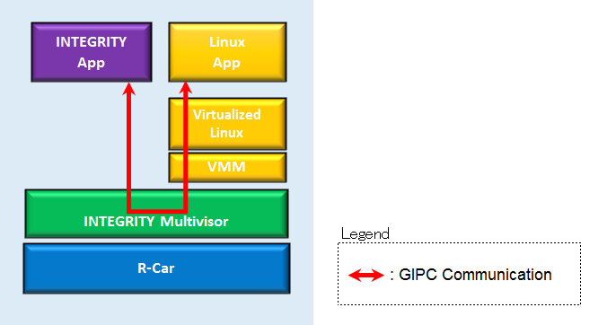

Figure 5‑5: Images of API transfer

GIPC is an API provided for INTEGRITY OS to communicate INTEGRITY and Linux.

1. Precondition

* Measure on virtualization Linux (Type4)
* Use GIPC communication performance tool only. (RENESAS original)
* Transfer data

The communication size (amount) to be measured is as follows.

16byte, 128byte, 4Kbyte, 64Kbyte, 128 byte, 256 byte, 384 byte, 512 byte, 640 byte,

768 byte, 896 byte, 1024 byte, 1152 byte, 1280 byte

* Verified 100,1000,10000 times and use the average as the result value.

1. How to measure
2. Select [Target] - [Connect] from Menu bar of MULTI.
3. Select “Dynamic Download/INDRT Connection (rtserv2) for Device Tree” and press “Connect” button.
4. Select “Run mode target”
5. Select [Target] - [Load Module] - [Load Module...] from Menu bar.
6. Load the " GIPCMeasure_dyn.ael" file included in the deliverables.
7. Press F5 for start.
8. Login to Linux from Terminal software.

salvator-x login: root

1. Run the following command to change the directory.

root@salvator-x:~# cd tools

1. Run the following command to measure the GIPC communication.

root@salvator-x:~/tools# ./gipc_main fbcon_gipc_alias

After finishing a command, you will see the log like below.

Check the following results at the number of times, size, and communication time.

number of loops = 100

buffer size = 16

processing time:615

number of loops = 100

buffer size = 128

processing time:637

number of loops = 100

buffer size = 256

processing time:665

1. Result

Table 5‑10: Result

|  |  |
| --- | --- |
|  | **Virtualized Linux (Type4) [us]** |
| **size** | **10000 times** |
| **16byte** | 5.67 |
| **128byte** | 5.63 |
| **256byte** | 5.60 |
| **384byte** | 5.60 |
| **512byte** | 5.57 |
| **640byte** | 5.56 |
| **768byte** | 5.55 |
| **896byte** | 5.57 |
| **1024byte** | 5.54 |
| **1152byte** | 5.57 |
| **1280byte** | 5.54 |
| **4Kbyte** | 5.53 |
| **64Kbyte** | 5.54 |

1. Consideration

There is some interference from other Tasks running that causes the average to differ so much from the minimum, which requires further Renesas investigation to eliminate.

### Math operation (for Hypervisor)

1. Description

Measure the floating point performance when using the Center Information application on virtualization PoC using whetstone of Unixbench.

1. Precondition

* Measure on virtualization PoC and native Linux (Type1 and Type2) Native Linux value is reference.
* Use Unixbench on terminal software.

1. How to measure
2. Login to Linux.

salvator-x login: root

1. Run the following command to change the directory.

root@salvator-x:~# cd tools/UnixBench

1. Run the following command to measure the floating point performance 10 times.

root@salvator-x:~/tools/UnixBench# i=1; while [ $i -le 10 ]; do ./Run -c 4 whetstone-double; i=$(expr $i + 1);done

After finishing a command, you will see the log like below.

Red square is results.

Benchmark Run: Fri Jan 02 1970 00:01:29 - 00:05:28

4 CPUs in system; running 4 parallel copies of tests

Double-Precision Whetstone 5701.0 MWIPS (9.9 s, 7 samples)

1. Result

Table 5‑11: Result(MWIPS)

|  |  |  |  |  |  |  |  |  |  |  |  |
| --- | --- | --- | --- | --- | --- | --- | --- | --- | --- | --- | --- |
| **Test environment** | Ave. | 1 | 2 | 3 | 4 | 5 | 6 | 7 | 8 | 9 | 10 |
| **Native Linux**  **(Type2)** | 5714.46 | 5712.10 | 5715.20 | 5715.00 | 5714.10 | 5716.40 | 5711.90 | 5716.20 | 5717.20 | 5711.20 | 5715.30 |
| **Virtualization PoC**  **(Type1)** | 5728.36 | 5701.00 | 5689.10 | 5734.50 | 5736.50 | 5736.50 | 5737.20 | 5738.50 | 5736.20 | 5737.50 | 5736.60 |

Table 5‑12: Overhead(%)

|  |  |  |
| --- | --- | --- |
| **Test environment** | **Value(MWIPS)** | **Overhead: ((B – A) /A)*100** |
| (A) Native Linux (Type2) | 5714.46 | 0.24% |
| (B) Virtualization PoC(Type1) | 5728.36 |

1. Consideration

The result is as expected, the virtualization overhead is less than the variation of each test result.

## Bus Load/Bandwidth

### Total bus bandwidth on virtualization environment

1. Description

Measure the DDR memory bandwidth (MB /s) on virtualization PoC.

Measurement tool is bandwidth monitoring tool that is made by Renesas.

1. Precondition

* Measure on virtualization PoC (Type1)
* Use bandwidth monitoring tool for INTEGRITY.
* Verified 10 times and use the average as the result value.

1. How to measure
2. Select [Target] - [Connect] from Menu bar.
3. Select “Dynamic Download/INDRT Connection (rtserv2) for Device Tree” and press “Connect” button.
4. Select “Run mode target”
5. Select [Target] - [Load Module] - [Load Module...] from Menu bar.
6. Load the "Busmoni_dyn.ael" file in the following path.

<...int1144\modules\renesas\app\Busmoni_sample\Busmoni>

1. Press F5 for start.
2. Run the following command on "I/O" tab.

Please input command: -p UC11 -c 1

After finishing a command, you will see the log like below.

Red square is results.

Please input command: -p UC11 -c 1

Device "R-Car H3 ES1.1"

-----------------------------------------------------------------

UC11: DDR R = 3000MiB/s W = 1945MiB/s

-----------------------------------------------------------------

1. Select [Target] - [Unload Module] - [Unload Module...] from Menu bar.
2. Unload the "Busmoni_dyn.ael" file in the following path.

<...int1144\modules\renesas\app\Busmoni_sample\Busmoni>

1. Run from step 3 to step8 process 10 seconds after the result is displayed.

Repeat this 9 times.

1. Result

Table 5‑13: Result

|  |  |  |
| --- | --- | --- |
|  | **Virtualization PoC (Type1)** | |
|  | **R(MB/s)** | **W(MB/s)** |
| **Ave.** | 3070.23 | 2004.67 |
| **1** | 3145.73 | 2039.48 |
| **2** | 2889.88 | 1977.61 |
| **3** | 3011.51 | 2037.38 |
| **4** | 3058.70 | 2018.51 |
| **5** | 3178.23 | 1991.25 |
| **6** | 2984.25 | 2101.35 |
| **7** | 3159.36 | 1974.47 |
| **8** | 3197.11 | 2048.92 |
| **9** | 2904.56 | 1872.76 |
| **10** | 3172.99 | 1984.95 |

1. Consideration

Approximately 5.1GB/s (read+write) is observed in this virtualization environment.

The calculated DDR bus bandwidth is 38.4GB/s (DDR2400 x 32 bit x 4 channels), this use case is considered that it has enough performance margin.

### Total bus bandwidth on native Linux environment

1. Description

Measure the DDR memory bandwidth (MB / s) on native Linux.

Measurement tool is bandwidth monitoring tool.

1. Precondition

* Measure on native Linux (Type2)
* Use bandwidth monitoring tool for Linux.
* Verified 10 times and use the average as the result value.

1. How to measure
2. Login to Linux.

salvator-x login: root

1. Run the following command to change the directory.

root@salvator-x:~# cd tools/busmoni

1. Run the following command for measurement.

root@salvator-x:~/tools/busmoni# ./busmoni_app -p UC11 -c -1

After finishing a command, you will see the log like below.

Red square is results.

root@salvator-x:~/tools/busmoni# ./busmoni_app -p UC11 -c -1

Device "R-Car H3 WS1.1"

-----------------------------------------------------------------

UC11: DDR R = 2076MB/s W = 1523MB/s

-----------------------------------------------------------------

1. Result

Table 5‑14: Result

|  |  |  |
| --- | --- | --- |
|  | **Native Linux (Type2)** | |
|  | **R(MB/s)** | **W(MB/s)** |
| **Ave.** | 2259.80 | 1541.70 |
| **1** | 2269.00 | 1602.00 |
| **2** | 2264.00 | 1563.00 |
| **3** | 2212.00 | 1347.00 |
| **4** | 2173.00 | 1337.00 |
| **5** | 2261.00 | 1538.00 |
| **6** | 2245.00 | 1544.00 |
| **7** | 2272.00 | 1589.00 |
| **8** | 2303.00 | 1634.00 |
| **9** | 2297.00 | 1626.00 |
| **10** | 2302.00 | 1637.00 |

1. Consideration

Approximately 3.8GB/s (read+write) is observed in this environment.

This is the case of Linux side only. This result is as same as expected.

### Total bus bandwidth on native INTEGRITY environment

1. Description

Measure the DDR memory bandwidth (MB / s) on native INTEGRITY.

Measurement tool is bandwidth monitoring tool.

1. Precondition

* Measure on native INTEGRITY (Type3)
* Use bandwidth monitoring tool.
* Verified 10 times and use the average as the result value.

1. How to measure
2. Refer to 5.2.1
3. Result

Table 5‑15: Result

|  |  |  |
| --- | --- | --- |
|  | **Native INTEGRITY (Type3)** | |
|  | **R(MB/s)** | **W(MB/s)** |
| **Ave.** | 716.91 | 555.75 |
| **1** | 809.50 | 578.81 |
| **2** | 748.68 | 579.86 |
| **3** | 782.24 | 631.24 |
| **4** | 757.07 | 560.99 |
| **5** | 683.67 | 571.47 |
| **6** | 736.10 | 568.33 |
| **7** | 700.45 | 546.31 |
| **8** | 754.97 | 551.55 |
| **9** | 706.74 | 565.18 |
| **10** | 489.68 | 403.70 |

1. Consideration

Approximately 1.3GB/s (read+write) is observed in this virtualization environment.

This is the case of INTEGRITY side only. This result is as same as expected.

### The overhead (DDR memory bandwidth) compared virtualized Linux with native Linux

1. Description

Compare the overhead (DDR memory bandwidth) on virtualized Linux and native Linux.

1. Precondition

* Measure on virtualized Linux and native Linux (Type4 and Type2)

1. How to measure
2. Measure only type 4. Measurement method refer to 5.2.1.
3. Check the overhead as follows. The comparison result is 5.2.2.

((Virtualized Linux) - (Native Linux)) / (Native Linux) * 100 [%]

1. Result

Table 5‑16: Type4 Result

|  |  |  |
| --- | --- | --- |
|  | **Virtualized Linux (Type4)** | |
|  | **R(MB/s)** | **W(MB/s)** |
| **Ave.** | 2263.88 | 1489.29 |
| **1** | 2246.05 | 1502.61 |
| **2** | 2307.92 | 1538.26 |
| **3** | 2294.28 | 1556.09 |
| **4** | 2403.34 | 1560.28 |
| **5** | 2311.06 | 1429.21 |
| **6** | 2225.08 | 1363.15 |
| **7** | 2259.68 | 1531.97 |
| **8** | 2306.87 | 1569.72 |
| **9** | 2211.45 | 1376.78 |
| **10** | 2073.03 | 1464.86 |

Table 5‑17: Read Result

|  |  |  |
| --- | --- | --- |
| **Test environment** | **R (MB/s)** | **Overhead:**  **((B – A) /A)*100** |
| **(A) Native Linux (Type2)** | 2259.80 | 0.18% |
| **(B) Virtualized Linux (Type4)** | 2263.88 |

Table 5‑18: Write Result

|  |  |  |
| --- | --- | --- |
| **Test environment** | **W (MB/s)** | **Overhead:**  **((B – A) /A)*100** |
| **(A) Native Linux (Type2)** | 1541.70 | -3.4% |
| **(B) Virtualized Linux (Type4)** | 1489.29 |

1. Consideration

The bus utilization difference between the virtualized Linux and the native Linux is observed almost same in read access, but the write access bandwidth of the virtualized Linux is 3.4% lower than the native Linux. One possibility is that the virtualized Linux has the interrupt processing overhead and may affect to the GPU workload and reduce the write access bandwidth. Further investigation is necessary for the detailed explanation.

## Bus Latency

### Bus Latency on virtualization environment

Out of Scope.

### Bus Latency on native LINUX environment

Out of Scope.

### Bus Occupancy on virtualization environment

1. Description

Calculate maximum theoretical performance from H/W specification.

1. Precondition

* Calculate from memory controller specification.
* Memory controller for LPDDR4-3200 with 32 bits x 4 channels.

However, this time Salvator is 2400 MHz due to the limitation of SoC.

1. How to measure

2400(MHz)x 32bit x 4ch = 307200 Mbit/s = 38400MB/s = 38.4GB/s

1. Result

Table 5‑19: Result

|  |  |
| --- | --- |
| **Test environment** | **Score** |
| maximum theoretical bandwidth | 38.4GB/s |

1. Consideration

This result is calculated by hardware specification. R-Car H3 maximum bandwidth is 38.4GB/s.

But this score will be improved to 51.2GB/s on R-Car H3 next silicon.

### Insufficient Bus utilization for native Linux environment

Out of Scope.

### Bus Data Occupancy

Out of Scope.

### Ethernet bus utilization

Out of Scope.

## Boot Time

This section measure the time from power on to each OS / application starts up.

The following figure describes the Booting sequence of virtualization PoC and measurement point.

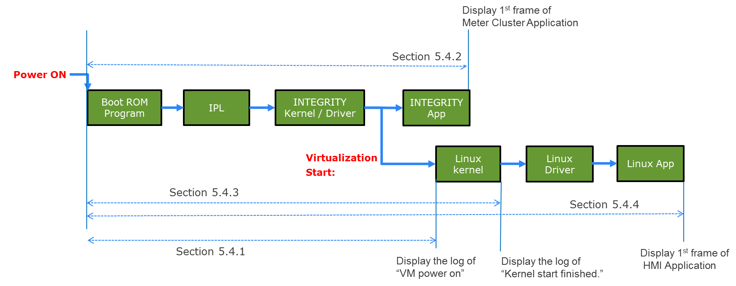

|  |  |
| --- | --- |
| Legend | |
| Boot ROM Program: | Built-in mask ROM program to load the IPL from external serial flash memory. |
| IPL: | Initial Program Loader to load OS and/or U-boot from external serial flash memory. |

Figure 5‑6: Simplified BOOT Sequence

In this section, we are using following optimization to create the INTEGRITY monolith image.

- Decreasing the size of a monolith's binary in rcar_kernel_wrapper.readme.txt

- Multivisor Fast Boot in release_notes.txt

This system is setting unused ram size to 112MB

ghs,size-megabytes = <112>;

Above files are provided by GHS.

Note that the virtualized Linux boot time can be reduced by using the updated INTEGRITY environment. This result is currently measured in T9.0 environment. It is known that the T10.1 release reduces boot time by approximately 1 second, and further releases are expected to reduce boot time even further.

*Attention:*

*If you have modified the HyperFlash contents of supplied Salvator-X board,*

*please write Monolith(Type1_mono.5.4) to HyperFlash in Appendix A.*

### From power on to booting of INTEGRITY OS

1. Description

Measure the time from power on until ready of INTEGRITY Kernel to start virtual machine on virtualization PoC.

Measurement tool is boot time measurement tool. (RENESAS original)

The following figure describes measurement target.

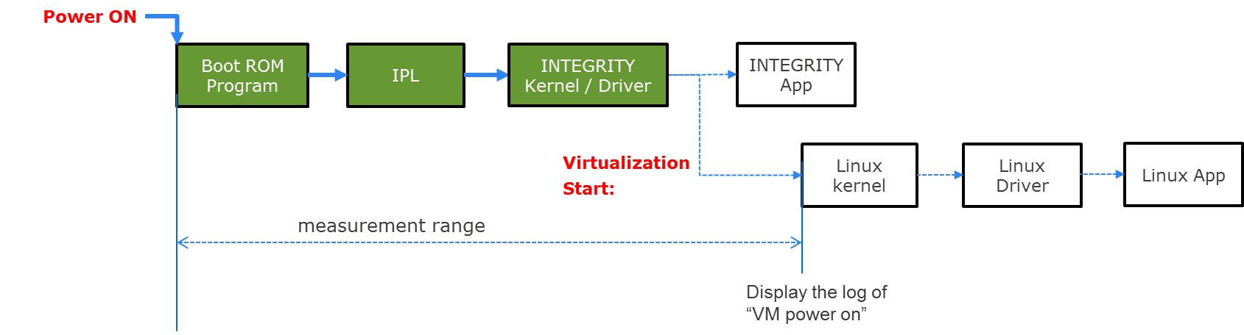

Figure 5‑7: Images of power on to booting of INTEGRITY OS

1. Precondition

* Measure on virtualization PoC (Type1)
* Verified 10 times and use the average as the result value.
* Measure time until the log of “VM power on” in INTEGRITY side.
* Take the boot situation on video.

1. How to measure
2. Take the boot situation on video.
3. Search the frame which Salvator-X LED14 changes to ON from the video.
4. Search the frame which contains the INTEGRITY Kernel log “VM powered on” from the video.

[ 2.04387] VM powered on

1. Calculate the interval time between the frames specified at the above step 2 and step 3.
2. Result

Table 5‑20: Result

|  |  |
| --- | --- |
|  | **Virtualization PoC (Type1) [sec]** |
| **Ave.** | 3.38 |
| **1** | 3.37 |
| **2** | 3.40 |
| **3** | 3.37 |
| **4** | 3.37 |
| **5** | 3.34 |
| **6** | 3.40 |
| **7** | 3.40 |
| **8** | 3.40 |
| **9** | 3.37 |
| **10** | 3.37 |

1. Consideration

In the boot time analysis, we use IPL to load the INTEGRITY OS image from HyperFlash directly, instead of loading the u-boot and use it for loading INTEGRITY OS image from either network or flash storage (SD Card, USB flash, or eMMC) to simulate the actual target hardware.

At the result of 3.38sec and the message “VM powered on” is 2.04sec so it is calculated that 1.34sec is the time before stating INTEGRITY Kernel including IPL initialization and image copy.

This time we are using the serial output on IPL for development, but actually it is possible to reduce the boot time by disabling IPL's serial message output.

The estimated boot time from power on to launch the INTEGRITY kernel is below:

INTEGRITY kernel launch time =

17ms (power-on reset time of Salvator-X board)

+ 77ms (IPL common processing time)

+ 386ms (IPL loading and validation time for 32MB INTEGRITY image from HyperFlash)

= 480ms

### From power on to starting up of Meter cluster application on INTEGRITY

1. Description

Measure the time from power on until the completion of the 1st frame.

Measurement tool is boot time measurement tool. (RENESAS original)

The following figure describes measurement target.

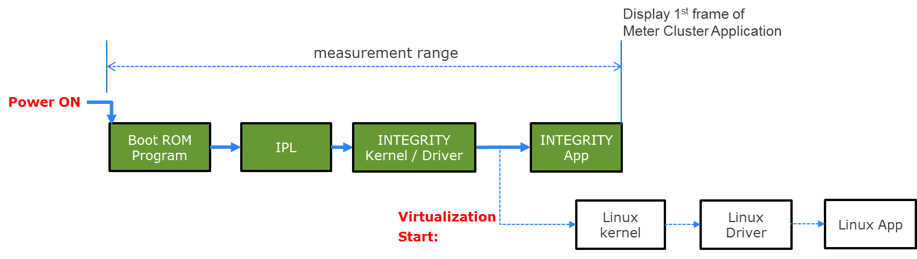

Figure 5‑8: Images of power on to starting up of Meter cluster application on INTEGRITY

1. Precondition

* Measure on virtualization PoC (Type1)
* Verified 10 times and use the average as the result value.
* Measure time until the Meter Cluster Application is launched in HDMI1 Display.
* Use the video taken at section 5.4.1.

1. How to measure
2. Take the boot situation on video.
3. Search the frame which Salvator-X LED14 changes to ON from the video.
4. Search the frame which contains a title ”R-Car” in orange color, which is output in the HDMI1 display right after the Meter Cluster Application is launched.
5. Calculate the interval time between the frames specified at the above step 1 and step 2.
6. Result

Table 5‑21: Result

|  |  |
| --- | --- |
|  | **Virtualization PoC (Type1) [sec]** |
| **Ave.** | 4.04 |
| **1** | 4.04 |
| **2** | 4.07 |
| **3** | 4.00 |
| **4** | 4.04 |
| **5** | 4.00 |
| **6** | 4.07 |
| **7** | 4.04 |
| **8** | 4.07 |
| **9** | 4.04 |
| **10** | 4.04 |

1. Consideration

The time difference from section 5.4.1 is observed only 660ms. The GFX Library usually take longer time for initialization before drawing the 1st frame so we are estimating that the GFX driver initialization start earlier than the time of “VM powered on”.

### From power on to booting of Linux OS

1. Description

Verify the time from power on until ready of Linux Kernel on virtualization PoC.

The following figure describes measurement target.

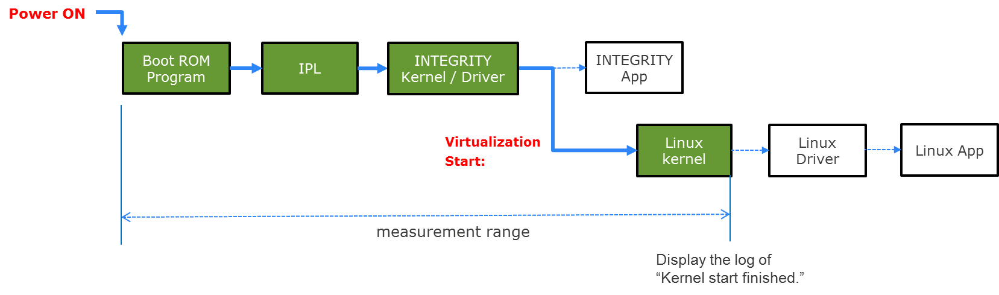

Figure 5‑9: Images of power on to booting of Linux OS

1. Precondition

* Measure on virtualization PoC (Type1)
* Verified 10 times and use the average as the result value.
* Measure time until the log of “Kernel start finished” is output on Linux side.
* Use the video taken at section 5.4.1.

1. How to measure
2. Take the boot situation on video.
3. Search the frame which Salvator-X LED14 changes to ON from the video..
4. Search the frame which contains the Linux Kernel log “Kernel start finished.” from the video.

[ 2.376525] Kernel start finished.

1. Calculate the interval time between the frames specified at the above step 1 and step2.
2. Result

Table 5‑22: Result

|  |  |
| --- | --- |
|  | **Virtualization PoC (Type1) [sec]** |
| **Ave.** | 5.94 |
| **1** | 6.17 |
| **2** | 6.50 |
| **3** | 6.07 |
| **4** | 5.24 |
| **5** | 5.67 |
| **6** | 6.07 |
| **7** | 5.70 |
| **8** | 5.80 |
| **9** | 6.10 |
| **10** | 6.07 |

1. Consideration

Refer 5.4.1.

### From power on to starting up of Video app and MAP/HMI of graphics on Linux OS

1. Description

Verify the time from power on program until the completion of the 1st frame of Video and Map/HMI on virtualization PoC.

The following figure describes measurement target.

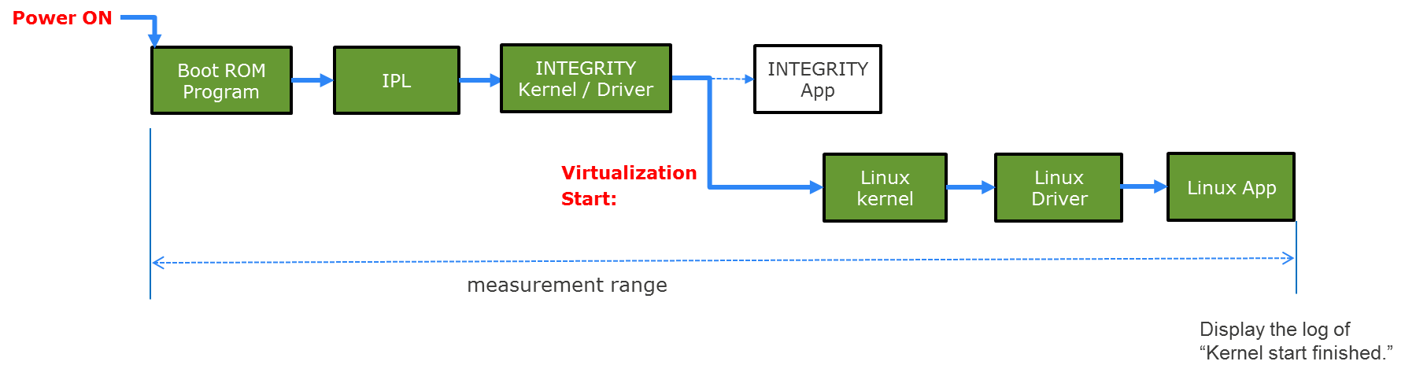

Figure 5‑10: power on to starting up of Video app and MAP/HMI of graphics on Linux OS

1. Precondition

* Measure on virtualization PoC (Type1)
* Verified 10 times and use the average as the result value.
* Measure time until the HMI Application is launched in HDMI0 Display.
* Use the video taken at section 5.4.1.

1. How to measure
2. Take the boot situation on video.
3. Search the frame which Salvator-X LED14 changes to ON from the video.
4. Search the frame which contains the HMI image, which is output in the HDMI0 display right after the HMI Application is launched.
5. Calculate the interval time between the frames specified at the above step 1 and step2.
6. Result

Table 5‑23: Result

|  |  |
| --- | --- |
|  | **Virtualization PoC (Type1) [sec]** |
| **Ave.** | 20.88 |
| **1** | 20.64 |
| **2** | 20.74 |
| **3** | 20.97 |
| **4** | 21.47 |
| **5** | 20.07 |
| **6** | 20.97 |
| **7** | 20.97 |
| **8** | 21.37 |
| **9** | 20.97 |
| **10** | 20.60 |

1. Consideration

Refer 5.4.1.

## Interrupt Time

### Delay time for interrupt

1. Description

Measure the interrupt performance on virtualized Linux using Cyclictest.

1. Precondition

* Measure on virtualized Linux (Type4) without other applications
* Use Cyclictest on terminal software.
* Verified 10 times and use the average as the result value.
* This environment is set kernel optimization (kernel_opt).

1. How to measure
2. Login to Linux.

salvator-x login: root

1. Run the following command to change the directory.

root@salvator-x:~# cd tools

1. Run the following Cyclictest’s command.

root@salvator-x:~/tools# /cyclictest -n -p 70 -i 4 -l 100000 -q -a

After finishing a command, you will see the log like below.

Red square is results.

# /dev/cpu_dma_latency set to 0us

T: 0 ( 1733) P:70 I:4 C: 100000 Min: 3 Act: 4 Avg: 5 Max: 29

1. Run the step 2 process 10 seconds after the result is displayed.

Repeat this 9 times.

1. Result

Table 5‑24: Result

|  |  |  |  |
| --- | --- | --- | --- |
|  | **Virtualized Linux (Type4)** | | |
|  | **Ave.(us)** | **Min.(us)** | **Max.(us)** |
|  | Ave 5 | Min 3 | Max 35 |
| **1** | 5.00 | 3.00 | 29.00 |
| **2** | 5.00 | 4.00 | 31.00 |
| **3** | 5.00 | 3.00 | 27.00 |
| **4** | 5.00 | 3.00 | 29.00 |
| **5** | 5.00 | 4.00 | 31.00 |
| **6** | 5.00 | 3.00 | 35.00 |
| **7** | 5.00 | 3.00 | 25.00 |
| **8** | 5.00 | 4.00 | 30.00 |
| **9** | 6.00 | 3.00 | 26.00 |
| **10** | 4.00 | 3.00 | 26.00 |

1. Consideration

This result is expected.

### Delay time variation

1. Description

Measure the maximum and minimum interrupt performance value on virtualized Linux using Cyclictest.

1. Precondition

* Extract maximum value and minimum value at 5.5.1 results.

1. How to measure
2. Type 4: Refer to 5.5.1.
3. Result

Table 5‑25: Result

|  |  |  |
| --- | --- | --- |
|  | **Min(us)** | **Max(us)** |
| **Virtualized Linux (Type4)** | 3 | 35 |

1. Consideration

This result is expected.

### Lock Synchronization latency

Out of Scope.

## Drawing Performance

### FPS on Linux graphics

1. Description

Measure the FPS of the Linux graphics application (glmark2 2014). The target OS is native Linux, and the window size is 1920x720.







Figure 5‑11: Images of glmark2 2014 (extracted)

1. Precondition

* Measure on Native Linux. (Type2)
* Application: glmark2 2014 2.0.1 (it shall be stored in the root file system)
* Window size for Linux: 1920x720
* Window System: DRM

Note: glmark2 runs without VSYNC synchronization. Therefore, the FPS will be more than 60 FPS.

1. How to measure
2. Login to Linux

salvator-x login: root

1. Stop Weston using the following command.

root@salvator-x:~# systemctl stop weston

1. Edit /etc/powervr.ini as follows to use the DRM Window System and HDMI output.

Before the modification

WindowSystem=libpvrWAYLAND_WSEGL.so

After the modification

;WindowSystem=libpvrWAYLAND_WSEGL.so

WindowSystem=libpvrDRM_WSEGL.so

;Use HDMI output

SetDefaultDisplay=1

1. Disable Weston using the following command.

root@salvator-x@:~# systemctl disable weston

1. Reboot Salvator-X
2. Push any key on the terminal before counting down of the U-boot to setup the U-boot.
3. Enter editenv command as follows.

=> editenv bootargs

1. You will see the following line.

edit: bootargs = "consoleblank=0 console=ttySC0,115200 rw rootwait root=/dev/mmcblk0p2 cma=512M"

Add “rootdelay=10 video=HDMI-A-1:1920x720@60m” as follows and press Enter.

edit: bootargs = "consoleblank=0 console=ttySC0,115200 rw rootwait root=/dev/mmcblk0p2 cma=512M rootdelay=10 video=HDMI-A-1:1920x720@60m"

1. Save the see the following line.

=> saveenv

1. Reboot Salvator-X and start Linux.
2. Login to Linux

salvator-x login: root

1. Run glmark2 as follows

root@salvator-x:~# cd glmark2

root@salvator-x:~/glmark2# ./glmark2-es2-nullws --size 1920x720

After finishing glmark2, you will see the log like below. Get the “glmark2 Score: XXXX” as a FPS result.

=======================================================

glmark2 2014.03

=======================================================

OpenGL Information

GL_VENDOR: Imagination Technologies

GL_RENDERER: PowerVR Rogue GX6650

GL_VERSION: OpenGL ES 3.2 build 1.7@4276001

=======================================================

(omitted)

=======================================================

glmark2 Score: 1246

=======================================================

1. Result

Table 5‑26: Result

|  |  |  |
| --- | --- | --- |
| **Test environment** | **Application** | **Score [FPS]** |
| Native Linux (Type2) | glmark2 2014 | 1246 |

1. Consideration

For comparisons between native INTEGRITY or virtualized Linux, refer to 5.6.2 or 5.6.3.

### FPS on INTEGRITY graphics

1. Description

Measure the FPS of the INTEGRITY graphics applications (glmark2 2014 and GFXBench3.0). The target OS is INTEGRITY Multivisor and the window size is 1920x720.

Manhattan T-Rex

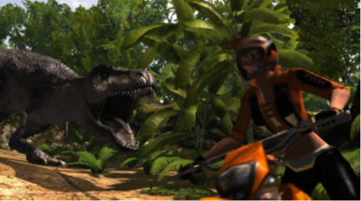

Figure 5‑12: Images of GFXBench 3.0

1. Precondition

* Measure on native INTEGRITY (Type3)
* Application1: glmark2 2014 2.0.1
* Application2: GFXBench 3.0.22, Manhattan and T-Rex
* Window size for INTEGRITY: 1920x720

Note: GFXBench3.0 shall be installed only when we evaluate it. The deliverables shall not include it. glmark2 2014 for INTEGRITY shall be installed only when we evaluate it because it is GPLv3. It need to be ported from glmark2 2014 for Linux.

Note: glmark2 runs without VSYNC synchronization. Therefore, the FPS will be more than 60 FPS.

1. How to measure
2. Rebuild the device tree blob file (.dtb) specifying the NFS server address. Store it to the SD card.
3. Store the data for glmark2 or GFXBench to the NFS.
4. Start Type3_glmark2_mono (glmark2) or Type3_GFXBench_mono (GFXBench3.0) using MULTI Debugger.
5. Start the application.
6. In case of glmark2: After finishing glmark2, you will see the log like below. Get the “glmark2 Score: XXXX” as an FPS result.

I/O: =======================================================

I/O: glmark2 2014

I/O: =======================================================

I/O: OpenGL Information

I/O: GL_VENDOR: Imagination Technologies

I/O: GL_RENDERER: PowerVR Rogue GX6650

I/O: GL_VERSION: OpenGL ES 3.1 build 1.7@4276001 (MAIN)

I/O: =======================================================

(omitted)

I/O: =======================================================

I/O: glmark2 Score: 1201

I/O: =======================================================

1. In case of GFXBench3.0: After finishing GFXBench3.0, you will see the log like below. Get ‘”fps”: xxx’ an FPS results.

Manhattan

I/O: [INFO ]: gl_manhattan_off test running...

I/O: Log: DeleteGLobal: 376d4d0

I/O: [INFO ]: {

I/O: "results":

I/O: [

I/O: {

I/O: "elapsed_time": 62015,

I/O: "error_string": "",

I/O: "gfx_result":

I/O: {

I/O: "egl_config_id": -1,

I/O: "fps": 20.7,

I/O: "frame_count": 1265,

I/O: "frametimes": [ 822, 95, 52, 52, 43, 57, 735, 93, 54, 48, 45,

(omitted)

I/O: 51, 55, 52, 51, 52 ],

I/O: "graphics_version": "OpenGL ES 3.1 build 1.7@4276001 (MAIN)",

I/O: "renderer": "PowerVR Rogue GX6650",

I/O: "surface_height": 720,

I/O: "surface_width": 1920,

I/O: "vendor": ""

I/O: },

I/O: "load_time": 143594,

I/O: "measured_time": 62015,

I/O: "result_id": 0,

I/O: "score": 1264.89794921875,

I/O: "status": "OK",

I/O: "test_id": "gl_manhattan_off",

I/O: "unit": "frames",

I/O: "version": 1

I/O: }

I/O: ]

I/O: }

T-Rex

I/O: [INFO ]: gl_trex_off test running...

I/O: Log: DeleteGLobal: 22e0f88

I/O: [INFO ]: {

I/O: "results":

I/O: [

I/O: {

I/O: "elapsed_time": 56005,

I/O: "error_string": "",

I/O: "gfx_result":

I/O: {

I/O: "egl_config_id": -1,

I/O: "fps": 59.1,

I/O: "frame_count": 3247,

I/O: "frametimes": [ 1154, 42, 31, 26, 23, 23, 14, 27, 28, 28, 28,

(omitted)

I/O: 18, 17, 19, 17, 19 ],

I/O: "graphics_version": "OpenGL ES 3.1 build 1.7@4276001 (MAIN)",

I/O: "renderer": "PowerVR Rogue GX6650",

I/O: "surface_height": 720,

I/O: "surface_width": 1920,

I/O: "vendor": ""

I/O: },

I/O: "load_time": 76027,

I/O: "measured_time": 56005,

I/O: "result_id": 0,

I/O: "score": 3246.884033203125,

I/O: "status": "OK",

I/O: "test_id": "gl_trex_off",

I/O: "unit": "frames",

I/O: "version": 1

I/O: }

I/O: ]

I/O: }

1. Result

Table 5‑27: Result

|  |  |  |
| --- | --- | --- |
| **Test environment** | **Application** | **Score [FPS]** |
| Native INTEGRITY (Type3) | glmark2 2014 | 1201 |
| GFXBench3.0 Manhattan | 20.7 |
| GFXBench3.0 T-Rex | 59.1 |

1. Consideration

The glmark2 FPS for native Linux was 1246. Therefore, the difference of the performance between native Linux and native INTEGRITY was ((1246-1201)/1246)*100 = 4%. The difference is currently under investigation and will be updated in a future revision.

### The overhead (FPS) compared virtualized Linux with native Linux

1. Description

Measure the FPS of the Linux graphics application (glmark2 2014). The target OS is both native Linux and virtualized Linux. The window size is 1920x720.

1. Precondition

Type 2: refer to 5.6.1.

Type 4: see below.

* Measure on virtualized Linux. (Type4)
* Application: glmark2 2014 2.0.1 (it shall be stored in the root file system)
* Window size for Linux: 1920x720
* Window System: DRM

Note: glmark2 runs without VSYNC synchronization. Therefore, the FPS will be more than 60 FPS.

1. How to measure

Type 2: refer to 5.6.1.

Type 4: see below.

1. Update the device tree blob (.dtb) file to change the window size for Linux. Edit int1144/devtree-arm64/rcar/device-tree-source/r8a7795-salvator-x/r8a7795-salvator-x-multivisor.dtsi as follows.

Before the modification

bootargs = "consoleblank=0 console=ttySC0,115200 rw rootwait root=/dev/mmcblk0p2 cma=512M rootdelay=10";

After the modification

bootargs = "consoleblank=0 console=ttySC0,115200 rw rootwait root=/dev/mmcblk0p2 cma=512M rootdelay=10 video=HDMI-A-1:1920x720@60m";

1. Build the .dtb file and store it to the SD card.
2. Start Type4_mono using MULTI Debugger.
3. Login to Linux using Terminal.

salvator-x login: root

1. Stop Weston using the following command.

salvator-x@root# systemctl stop weston

1. Edit /etc/powervr.ini as follows to use the DRM Window System.

Before the modification

WindowSystem=libpvrWAYLAND_WSEGL.so

After the modification

;WindowSystem=libpvrWAYLAND_WSEGL.so   
WindowSystem=libpvrDRM_WSEGL.so

1. Disable Weston using the following command.

salvator-x@root# systemctl disable weston

1. Restart Type4_mono.
2. Login to Linux.

root@salvator-x:~# systemctl stop weston

1. Run glmark2 as follows

root@salvator-x:~# cd glmark2

root@salvator-x:~/glmark2# ./glmark2-es2-nullws --size 1920x720

After finishing glmark2, you will see the log like below. Get the “glmark2 Score: XXXX” as a FPS result.

=======================================================

glmark2 2014.03

=======================================================

OpenGL Information

GL_VENDOR: Imagination Technologies

GL_RENDERER: PowerVR Rogue GX6650

GL_VERSION: OpenGL ES 3.2 build 1.7@4276001

=======================================================

(omitted)

=======================================================

glmark2 Score: 1121

=======================================================

1. Check the overhead as follows.

((Native Linux FPS) - (Virtualized Linux FPS)) / (Native Linux FPS) * 100 [%]

1. Result

Table 5‑28: Result

|  |  |  |  |
| --- | --- | --- | --- |
| **Test environment** | **Application** | **Score [FPS]** | **Overhead: ((A – B) /A)*100** |
| (A) Native Linux (Type2) | glmark2 2014 | 1246 | 10.0% |
| (B) Virtualized Linux (Type 4) | glmark2 2014 | 1121 |

1. Consideration

The overhead was 10%. As this is unexpected, we are investigating this. Currently we found that especially glBindFramebuffer(), glDrawArrays(), and eglSwapBuffers() on virtualized Linux took much time than those on native Linux. We will investigate it to reduce the overhead.

## Video & Audio Performance

### FPS on Linux Video decode

1. Description

Measure the video display performance (Frame per second) of Center Information when using media player to playback Video on virtualization PoC.

1. Precondition

* Measure on virtualization PoC (Type1)
* Incorporate a mechanism to measure the fps (Frame per second) at media player using the following files.

Table 5‑29: Lists of Video attributes

|  |  |  |  |  |
| --- | --- | --- | --- | --- |
| **File name** | **size** | **FPS** | **Bitrate (Kbps)** | **Codec** |
| big_buck_bunny_720p_h264.mp4 | 1280x720 | 24.000 | 5283 | H.264 |
| big_buck_bunny_720p_h264_60fps.mp4 (*1) | 1280x720 | 60.000 | 4889 | H.264 |
| *1 : re-encoding big_buck_bunny_720p_h264.mp4 to FPS 60 | | | | |

* Disable automatic playback of Video/Audio playback app.

1. Login to Linux.

salvator-x login: root

1. Run the following command to change the directory.

root@salvator-x:~# cd /etc/init.d/

1. Edit “rundemo” file.

root@salvator-x:/etc/init.d# vi rundemo

1. Enter "i" for insert mode
2. Add a "#" to the beginning of "/home/root/movie/playloop.sh"
3. Press "Esc" button for command mode
4. Press ":wq" button for write and finish
5. Reboot Salvator-X

Note) Delete "#" after the test

#!/bin/sh

sleep 5

export XDG_RUNTIME_DIR=/run/user/root

export LD_LIBRARY_PATH=/home/root/Futuremark

sleep 5

cd /home/root/IMG_SDK35

export WSEGL_ENABLE_TRIPLE_BUFFERING=2

./OGLES3Coverflow -aasamples=4 -width=1920 -height=720 -posx=0 -posy=0 &

#/home/root/movie/playloop.sh &

sleep 2

/home/root/camera.sh &

sleep 180

reboot

1. How to measure
2. Login to Linux.

salvator-x login: root

1. Run the following command.

root@salvator-x:~# amixer set "DVC Out" 1%

1. Run the following command.

root@salvator-x:~# modprobe -a mmngr mmngrbuf vspm vspm_if vsp2 uvcs_drv

1. Run the following command.

root@salvator-x:~# export XDG_RUNTIME_DIR=/run/user/root

1. Run the following command.

root@salvator-x:~# gst-launch-1.0 --padprobe v:sink --timer filesrc location=movie/big_buck_bunny_720p_h264.mp4 ! qtdemux name=demux demux.audio_0 ! queue ! omxaaclcdec ! alsasink device=hw:0,0 demux.video_0 ! queue ! h264parse ! omxh264dec ! vspfilter ! video/x-raw, format=BGRA, width=1920, height=720 ! waylandsink name=v

After finishing a command, you will see the log like below.

Red square is a result.

Got EOS from element "pipeline0".

Execution ended after 0:09:56.509504679

Setting pipeline to PAUSED ...

Setting pipeline to READY ...

Setting pipeline to NULL ...

Total time: 596.509521 seconds

Frames: 14155 processed

Avg. FPS: 23.73

1. Run the following command.

root@salvator-x:~# gst-launch-1.0 --padprobe v:sink --timer filesrc location=movie/big_buck_bunny_720p_h264_60fps.mp4 ! qtdemux name=demux demux.audio_0 ! queue ! omxaaclcdec ! alsasink device=hw:0,0 demux.video_0 ! queue ! h264parse ! omxh264dec ! vspfilter ! video/x-raw, format=BGRA, width=1920, height=720 ! waylandsink name=v

After finishing a command, you will see the log like below.

Red square is a result.

Got EOS from element "pipeline0".

Execution ended after 0:09:56.541268921

Setting pipeline to PAUSED ...

Setting pipeline to READY ...

Setting pipeline to NULL ...

Total time: 596.541260 seconds

Frames: 30287 processed

Avg. FPS: 50.77

1. Result

Table 5‑30: Result

|  |  |
| --- | --- |
| **virtualization PoC (Type1)** | **Value [FPS]** |
| big_buck_bunny_720p_h264.mp4 | 23.96 |
| big_buck_bunny_720p_h264_60fps.mp4 | 51.23 |

1. Consideration

We are expecting the full frame rate in playback, and the result for the 60fps content (big_buck_bunny_720p_h264_60fps.mp4) is not expected. Further investigation will be necessary to identify the problem. Refer 5.7.2.

### The overhead (FPS) compared virtualized Linux with native Linux

1. Description

Compare the video display performance (Frame per second) of Center Information when using media player to playback Video/Audio on virtualized Linux and native Linux.

1. Precondition

* Measure on virtualized Linux and native Linux (Type4 and Type2)
* Video/Audio application run only.
* Incorporate a mechanism to measure the fps (Frame per second) at media player using the following files.

Table 5‑31: Lists of Video attributes

|  |  |  |  |  |
| --- | --- | --- | --- | --- |
| **File name** | **size** | **FPS** | **Bitrate (Kbps)** | **Codec** |
| big_buck_bunny_720p_h264.mp4 | 1280x720 | 24.000 | 5283 | H.264 |
| big_buck_bunny_720p_h264_60fps.mp4 (*1) | 1280x720 | 60.000 | 4889 | H.264 |

*1 : re-encoding big_buck_bunny_720p_h264.mp4 to FPS 60

* Disable automatic playback of Media player. Refers to 5.7.1.
* Compare the performance between virtualized Linux and native Linux.

1. How to measure
2. Measurement method refers to 5.7.1.
3. Result

Table 5‑32: Result (FPS)

|  |  |  |  |
| --- | --- | --- | --- |
|  | 1. **Native Linux**   **(Type2) [FPS]** | 1. **Virtualized Linux**   **(Type4) [FPS]** | **Performance difference:**  **(A-B / A)*100 [%]** |
| big_buck_bunny_720p_h264.mp4 | 24.00 | 23.85 | 0.63% |
| big_buck_bunny_720p_h264_60fps.mp4 | 54.51 | 51.05 | 6.35% |

1. Consideration

We are expecting the full frame rate in playback on both virtualized Linux and native Linux, the result for the 60fps content (big_buck_bunny_720p_h264_60fps.mp4) is not expected. Further investigation, especially for the Linux’s software structure related to the movie decoding and screen composition, will be required to identify the problem.

About the performance difference between virtualized Linux and native Linux, one possibility is the performance difference of SD Card driver. The SD card read performance is measured 5.0MB/s on virtualized Linux, and 17.9MB/s on native Linux, due to the clock difference of SD host controller.

### Audio playback performance

1. Description

Measure the audio playback performance of Center Information when using media player on virtualization PoC.

1. Precondition

* Measure on virtualization PoC (Type1)
* Check that there is no noise in playing the specified audio file(s).

Table 5‑33: Lists of Audio attributes

|  |  |  |  |
| --- | --- | --- | --- |
| **File name** | **Samplingrate(KHz)** | **Bitrate (Kbps)** | **Codec** |
| big_buck_bunny_720p_h264.mp4 | 44.1 | 132 | AAC |

* Check by listening.

1. How to measure
2. Measurement method refers to 5.7.1.
3. Result

Sound skipping doesn’t occurs on virtualization PoC.

1. Consideration

This result is expected.

### H.264 decoder/encoder latency

1. Description

Measures the performance (Frame per second) of H.264 Decoder outputs vide of Center Information on virtualization PoC. The requirement of the decoder is to prepare the frame within the specified time (24fps, 60fps). Therefore, measure the frame rate of the output.

We have evaluated decoder only. The encoder is not supported on this virtualization environment (Yocto 2.7.0).

1. Precondition

* Measure on virtualization PoC (Type1)
* Incorporate a mechanism to measure the decode performance media player using the following files.

Table 5‑34: Lists of Video attributes

|  |  |  |  |  |
| --- | --- | --- | --- | --- |
| **File name** | **size** | **FPS** | **Bitrate (Kbps)** | **Codec** |
| big_buck_bunny_720p_h264.mp4 | 1280x720 | 24.000 | 5283 | H.264 |
| big_buck_bunny_720p_h264_60fps.mp4 (*1) | 1280x720 | 60.000 | 4889 | H.264 |
| *1 : re-encoding big_buck_bunny_720p_h264.mp4 to FPS 60 | | | | |

1. How to measure
2. Login to Linux.

salvator-x login: root

1. Run the following command.

root@salvator-x:~# amixer set "DVC Out" 1%

1. Run the following command.

root@salvator-x:~# modprobe -a mmngr mmngrbuf vspm vspm_if vsp2 uvcs_drv

1. Run the following command.

root@salvator-x:~# export XDG_RUNTIME_DIR=/run/user/root

1. Run the following command.

root@salvator-x:~# #gst-launch-1.0 filesrc location=movie/big_buck_bunny_720p_h264.mp4 ! qtdemux ! h264parse ! omxh264dec name=v ! fakesink sync=false -rp v:src

After finishing a command, you will see the log like below.

Red square is a result.

Got EOS from element "pipeline0".

Execution ended after 0:01:33.271932153

Setting pipeline to PAUSED ...

Setting pipeline to READY ...

Setting pipeline to NULL ...

Total time: 93.271935 seconds

Frames: 14315 processed

Avg. FPS: 153.48

Freeing pipeline ...

1. Run the following command.

root@salvator-x:~# gst-launch-1.0 filesrc location=movie/big_buck_bunny_720p_h264_60fps.mp4 ! qtdemux ! h264parse ! omxh264dec name=v ! fakesink sync=false -rp v:src

After finishing a command, you will see the log like below.

Red square is a result.

Got EOS from element "pipeline0".

Execution ended after 0:02:40.763217348

Setting pipeline to PAUSED ...

Setting pipeline to READY ...

Setting pipeline to NULL ...

Total time: 160.763229 seconds

Frames: 35790 processed

Avg. FPS: 222.63

Freeing pipeline ...

1. Result

Table 5‑35: Result

|  |  |
| --- | --- |
| **virtualization PoC (Type1)** | **Value [FPS]** |
| big_buck_bunny_720p_h264.mp4 | 153.48 |
| big_buck_bunny_720p_h264_60fps.mp4 | 222.63 |

1. Consideration

This result is expected.

## Camera Performance

### FPS on Linux of camera

1. Description

Measure the video display performance (Frame per second) of Center Information when using Back Monitor on virtualization PoC.

1. Precondition

* Measure on virtualization PoC (Type1)
* Incorporate a mechanism to measure the FPS (Frame per second) at Back Monitor.
* Connect a Camera to composite (CVBS_IN: CN21)
* Verified 10 minutes and use the average of FPS as the result value.

1. How to measure
2. Login to Linux.

salvator-x login: root

1. Run the following command.

root@salvator-x:~# modprobe -a mmngr mmngrbuf vspm vspm_if vsp2 uvcs_drv

1. Run the following command.

root@salvator-x:~# media-ctl -d /dev/media4 -e "vspi0_vsp2@0 rpf.0 input"

1. Run the following command.

root@salvator-x:~# media-ctl -d /dev/media4 -e "vspi0_vsp2@0 wpf.0 output"

1. Run the following command.

root@salvator-x:~# export XDG_RUNTIME_DIR=/run/user/root

1. Run the following command.

root@salvator-x:~# gst-launch-1.0 --padprobe v:sink --timer v4l2src device=/dev/video0 io-mode=dmabuf ! video/x-raw, format=RGB16, interlace-mode=interleaved ! queue ! vspfilter ! video/x-raw, format=BGRA ! waylandsink name=v

Take the log for 10 minutes, you will see the log like below.

Red square is a result.

FPS: 30 TIME 00:00:45

FPS: 30 TIME 00:00:46

FPS: 30 TIME 00:00:47

FPS: 30 TIME 00:00:48

:

:

1. Result

Table 5‑36: Result

|  |  |
| --- | --- |
| **Test environment** | **FPS** |
| **Virtualization PoC (Type1)** | 29.94 |

1. Consideration

This result is expected.

### FPS on INTEGRITY of camera

1. Description

Measure the video display performance (Frame per second) of Head-up display when using Back Monitor on virtualization PoC.

1. Precondition

* Measure on virtualization PoC (Type1)
* Incorporate a mechanism to measure the fps at Back Monitor.
* Verified 10 minutes and use the average of FPS as the result value.

1. How to measure
2. Launch Type1 and take a log for 10 minutes.

You will see the log like below. Red square is a result.

[VIN] 30 FPS [70568280]

[VIN] 30 FPS [71567723]

LOG: fps: 59.980335

1. Result

Table 5‑37: Result

|  |  |
| --- | --- |
| **Test environment** | **FPS** |
| **Virtualization PoC (Type1)** | 29.97 |

1. Consideration

This result is expected.

### The overhead (FPS) compared virtualized Linux with native Linux

1. Description

Compare the video display performance (Frame per second) of Center Information when using Back monitor on virtualized Linux and native Linux.

1. Precondition

* Measure on virtualized Linux and native Linux (Type4 and Type2)

*Both types stop the function of Video/Audio playback app. Refer to 5.7.1 Precondition.

* Measurement method is same as 5.8.1.

1. How to measure

* Type4: Measurement method refers to 5.8.1.
* Type2

1. Login to Linux.

salvator-x login: root

1. Run the following command.

root@salvator-x:~# modprobe -a mmngr mmngrbuf vspm vspm_if vsp2 uvcs_drv

1. Run the following command.

root@salvator-x:~# media-ctl -d /dev/media4 -e "vspi0_vsp2@0 rpf.0 input"

1. Run the following command.

root@salvator-x:~# media-ctl -d /dev/media4 -e "vspi0_vsp2@0 wpf.0 output"

1. Run the following command.

root@salvator-x:~# export XDG_RUNTIME_DIR=/run/user/root

1. Run the following command.

root@salvator-x:~# gst-launch-1.0 --padprobe v:sink --timer v4l2src device=/dev/video1 io-mode=dmabuf ! video/x-raw, format=RGB16, interlace-mode=interleaved ! queue ! vspfilter ! video/x-raw, format=BGRA ! waylandsink name=v

Take the log for 10 minutes, you will see the log like below. Red square is a result.

FPS: 30 TIME 00:00:45

FPS: 30 TIME 00:00:46

FPS: 30 TIME 00:00:47

FPS: 30 TIME 00:00:48

:

:

1. Result

Table 5‑38: Result

|  |  |  |
| --- | --- | --- |
| **Test environment** | **FPS** | **Performance difference:**  **((B – A) /A)*100** |
| **(A) Native Linux (Type2)** | 29.95 | 0.00% |
| **(B) Virtualized Linux (Type4)** | 29.95 |

1. Consideration

This result is expected.

## Display Performance

### OpenGL Performance

This and Section 5.6.1 and 5.6.2 are duplicated. Refer to Section 5.6.1 and 5.6.2.

### Total performance of display system

1. Description

Measure Composite performance of display on virtualization PoC.

1. Precondition

* Measure on virtualization PoC (Type1)

1. How to measure
2. Check that there are no noise in display for 10 minutes.
3. Result

No noise in 3 displays (Center Information, Instrument Cluster and Head-up display) for 10 minutes.

1. Consideration

This result is expected.

### The overhead (processing time) of display virtualization

1. Description

Measure the paint processing time of display on virtualized Linux and native Linux .

1. Precondition

* Measure on virtualized Linux and native Linux(Type4 and Type2)
* Use Video / Audio playback app only.
* Use JSON-timeline on Weston
* Verified 10 minutes and use the average, minimum and maximum value as the result value.
* Use a Keyboard connected to Salvator-X

1. How to measure
   1. Enter the following key from the keyboard connected to Salvator-X for starting record a log.

Press [Super(windows key) + Shift + Space + T]

* 1. Run the Salvator-X
  2. Enter the following key from the keyboard connected to Salvator-X

Press [Super(windows key) + Shift + Space + T] for stopping record a log.

* 1. Output a Timeline log (weston-timeline - *. Log) on root folder (/)

After finishing a command, you will see the log like below.

Red square is results.

{ "id":1, "type":"weston_output", "name":"HDMI-A-1" }

{ "T":[99, 620759003], "N":"core_repaint_finished", "wo":1, "vblank":[99, 620699000] }

{ "T":[99, 629974763], "N":"core_repaint_begin", "wo":1 }

{ "id":2, "type":"weston_surface", "desc":"top-level window 'nng_navi_win_0'" }

{ "T":[99, 630139403], "N":"core_flush_damage", "ws":2, "wo":1 }

{ "id":3, "type":"weston_surface", "desc":"top-level window 'IMG MDK test'" }

{ "T":[99, 630174923], "N":"core_flush_damage", "ws":3, "wo":1 }

{ "T":[99, 633777563], "N":"core_repaint_posted", "wo":1 }

1. Check the processing time of display as follows. Calculate the average and find minimum and maximum value.

Processing time (ms) = (core_repaint_posted value) – (core_repaint_begin value) / 1000000

Overhead = (Virtualized Linux) - (Native Linux)

1. Result

**Table 5‑39: Result**

|  |  |  |
| --- | --- | --- |
|  | **Processing time (ms)** | |
| **Ave.** | **Max.** |
| **Virtualized Linux (Type4)** | 3.56 | 32.154  *Greater than 3.251 times: 12/14225 times |
| **Native Linux(Type2)** | 1.824 | 3.251 |

Table 5‑40: Overhead

|  |  |  |
| --- | --- | --- |
|  | **Virtualized Linux - Native Linux** | |
| **Ave.** | **Max.** |
| **Processing time (ms)** | 1.74 | 28.9 |

1. Consideration

We expected the same time. As this performance is not expected. Further investigation will be required to identify the problem.

### Image composition performance

1. Description

Measure underflow in the display driver on virtualization PoC. As a result, confirm that display processing is within 1V.

1. Precondition

* Measure on virtualization PoC (Type1)
* Use image composition performance measurement tool. (RENESAS original)

1. How to measure
2. Launch Type1 45000 times

You will see the log like below with Linux. Red square is a result.

[ 19.087542] @ vspd1 underflow count :600

[ 22.874916] @ vspd1 underflow count :600

[ 26.746795] @ vspd1 underflow count :600

[ 30.570880] @ vspd1 underflow count :600

[ 34.454215] @ vspd1 underflow count :600

:

:

Log of INTEGRITY OS like below. The result is the red square which is outputted as vspd2_underflow_count and vspd3_underflow_count.

[VIN] 30 FPS [74514595]

@ vspd2 underflow count :600

@ vspd3 underflow count :600

[VIN] 30 FPS [75514178]

LOG: fps: 60.000000

:

:

* This log outputs the number of times that processing image composition as usual whenever inspects 600 times

1. Result

**Table 5‑41: Result**

|  |  |  |  |
| --- | --- | --- | --- |
|  | **Virtualization PoC (Type1)** | | |
| **Inspect**  **Counts** | **Normally**  **Counts** | **Under-flow**  **Counts** |
| **vspd1 : Display of Center Information (HDMI0)** | 45000 | 45000 | 0 |
| **vspd2 : Display of Instrument Cluster (HDMI1)** | 45000 | 45000 | 0 |
| **vspd3 : Display of Head-up display (Analog-RGB)** | 45000 | 44998 | 2 |

1. Consideration

This result means that the analog RGB output caused underflow, so the proper display operation is not guaranteed. In this kind of case, R-Car H3 SoC can improve the available display performance by modifying the internal bus arbitration algorism settings (Quality-of-Service; QoS).

## RAM I/O Performance

### RAM I/O Performance

1. Description

Measure the RAM’s Read/Write performance when use virtualized Linux, native Linux, and native INTEGRITY.

Measurement tool is lmbench.

1. Precondition

* Measure on special native INTEGRITY for this measurement.
* Use porting lmbench for native INTEGRITY.
* Measure on virtualized Linux, native Linux, and native INTEGRITY (Type2, Type4 and Type3).
* Use lmbench for Linux.
* Verified 10 times and use the average as the result value.

1. How to measure

* Type2, Type4 using lmbench for Linux.

1. Login to Linux.

salvator-x login: root

1. Run the following command to change the directory.

root@salvator-x:~# cd tools/lmbench

1. Run the following command for measurement.

root@salvator-x:~/tools/lmbench# ./bw_file_rd 64M io_only /home/root/test.txt

After finishing a command, you will see the log like below.

Red square is results.

root@salvator-x:~/tools/lmbench# ./bw_file_rd 64M io_only /home/root/test.txt

64.00 1265.77

* Type3 using porting lmbench for native INTEGRITY

1. Lunch Type3 for this measure.
2. Select “Dynamic Download/INDRT Connection (rtserv2) for Device Tree” and press “Connect” button.
3. Select “Run mode target”
4. Right click on “create file”
5. Select [Target] - [Load Module] - [Load Module...] from Menu bar.
6. Load the " bw_file_rd.ael " file included in the deliverables.

You will see the log like below on cmd-tab.

Red square is results.

Target: Loader: Application started

I/O: 1073.7418 MB in 0.0004 secs, 3012743.6139 MB/sec

1. Result

Table 5‑42: Type3 Result

|  |  |
| --- | --- |
|  | **Native INTEGRITY [MB/sec]** |
| **Ave.** | 3011624.721 |
| **1** | 3012743.614 |
| **2** | 3007153.717 |
| **3** | 3005435.223 |
| **4** | 2990403.687 |
| **5** | 3041223.081 |
| **6** | 3008884.215 |
| **7** | 3008241.943 |
| **8** | 2988545.832 |
| **9** | 3036922.253 |
| **10** | 3016693.643 |

Table 5‑43: Type2 Result

|  |  |
| --- | --- |
|  | **Native Linux (Type2) [MB/sec]** |
| **Ave.** | 1432.17 |
| **1** | 1442.81 |
| **2** | 1431.45 |
| **3** | 1431.06 |
| **4** | 1435.49 |
| **5** | 1426.98 |
| **6** | 1422.98 |
| **7** | 1438.40 |
| **8** | 1423.77 |
| **9** | 1432.47 |
| **10** | 1436.30 |

Table 5‑44: Type4 Result

|  |  |
| --- | --- |
|  | **Virtualized Linux (Type4) [MB/sec]** |
| **Ave.** | 1270.79 |
| **1** | 1279.82 |
| **2** | 1265.77 |
| **3** | 1281.56 |
| **4** | 1268.56 |
| **5** | 1276.43 |
| **6** | 1272.09 |
| **7** | 1265.42 |
| **8** | 1270.12 |
| **9** | 1264.27 |
| **10** | 1263.82 |

1. Consideration

The INTEGRITY’s result is unnaturally large. As this benchmark program (bw_file_rd in lmbench) just issue file read command and not actually use the file data, possibly the actual file read operation can be omitted.

The result of the native Linux is 1432.17MB/sec, and the virtualized Linux is 1270.79MB/sec. As the row memory read bandwidth that are measured in 5.11.1 are 2345.02MB/sec and 2338.82MB/sec, the results are reasonable. The performance of virtualized Linux is 11.27% slower than native one. As the filesystem operation usually require many synchronization in the OS domain, it is assumed that relatively larger performance overhead will appear.

## Memory Performance

### Sequential reading performance

1. Description

Measure the performance to read sequential blocks of memory on virtualized Linux and native Linux.

Measurement tool is lmbench.

1. Precondition

* Measure on virtualized Linux on virtualized Linux and native Linux (Type4 and Type2)

*Both types stop the function of Linux App

* Use lmbench’s lat_mem_rd command on terminal software.
* Compare the performance between virtualized Linux and native Linux. The performance results should be near to native OS implementations results.
* Verified 10 times and use the average as the result value.

1. How to measure

* Memory read latency

1. Login to Linux.

salvator-x login: root

1. Run the following command to change the directory.

root@salvator-x:~# cd tools/lmbench

1. Run the following command for measurement.

root@salvator-x:~/tools/lmbench# ./lat_mem_rd 64m 64

After finishing a command, you will see the log like below.

Red square is results.

root@salvator-x:~/tools/lmbench# ./lat_mem_rd 64m 64

"stride=64

0.00049 2.671

0.00098 2.671

0.00195 2.671

0.00293 2.671

0.00391 2.671

0.00586 2.671

0.00781 2.671

0.01172 2.671

0.01562 5.235

0.02344 4.483

0.03125 5.310

0.04688 6.111

0.06250 5.699

0.09375 6.090

0.12500 6.074

0.18750 6.317

0.25000 6.314

0.37500 6.312

0.50000 6.311

0.75000 6.310

1.00000 6.255

1.50000 6.458

2.00000 35.175

3.00000 39.063

4.00000 31.825

6.00000 31.588

8.00000 31.409

12.00000 31.255

16.00000 31.164

24.00000 31.096

32.00000 31.037

48.00000 30.996

64.00000 31.199

1. Run the step 3 process 10 seconds after the result is displayed.

Repeat this 9 times.

* Measure Mbyte/s

1. Login to Linux.

salvator-x login: root

1. Run the following command to change the directory.

root@salvator-x:~# cd tools/lmbench

1. Run the following command for measurement.

root@salvator-x:~/tools/lmbench# ./bw_mem 64m rd

After finishing a command, you will see the log like below.

Red square is results.

root@salvator-x:~/tools/lmbench# ./bw_mem 64m rd

67.11 2346.46

1. Run the step 3 process 10 seconds after the result is displayed.

Repeat this 9 times.

1. Result

**Table 5‑45: Memory read latency Result (Type4)**

|  |  |  |  |  |  |  |  |  |  |  |
| --- | --- | --- | --- | --- | --- | --- | --- | --- | --- | --- |
| **Array size**  **(MB)** | **1** | **2** | **3** | **4** | **5** | **6** | **7** | **8** | **9** | **10** |
| **0.00049** | 2.67 | 2.67 | 2.67 | 2.68 | 2.67 | 2.67 | 2.67 | 2.67 | 2.67 | 2.67 |
| **0.00098** | 2.67 | 2.67 | 2.67 | 2.68 | 2.67 | 2.67 | 2.67 | 2.67 | 2.67 | 2.67 |
| **0.00195** | 2.67 | 2.67 | 2.67 | 2.68 | 2.67 | 2.67 | 2.67 | 2.67 | 2.67 | 2.67 |
| **0.00293** | 2.67 | 2.67 | 2.67 | 2.67 | 2.67 | 2.67 | 2.67 | 2.67 | 2.67 | 2.67 |
| **0.00391** | 2.67 | 2.67 | 2.67 | 2.68 | 2.67 | 2.67 | 2.67 | 2.67 | 2.67 | 2.67 |
| **0.00586** | 2.67 | 2.67 | 2.67 | 2.67 | 2.67 | 2.67 | 2.67 | 2.67 | 2.67 | 2.67 |
| **0.00781** | 2.67 | 2.67 | 2.67 | 2.67 | 2.67 | 2.67 | 2.67 | 2.67 | 2.67 | 2.67 |
| **0.01172** | 2.67 | 2.67 | 2.67 | 2.68 | 2.67 | 2.67 | 2.67 | 2.67 | 2.67 | 2.67 |
| **0.01562** | 5.24 | 5.34 | 2.67 | 2.68 | 2.67 | 2.67 | 2.67 | 2.67 | 2.67 | 2.67 |
| **0.02344** | 4.48 | 2.67 | 4.42 | 4.38 | 2.67 | 4.52 | 4.50 | 2.67 | 2.67 | 2.67 |
| **0.03125** | 5.31 | 3.98 | 4.47 | 3.98 | 4.06 | 3.98 | 4.90 | 5.69 | 4.40 | 4.41 |
| **0.04688** | 6.11 | 5.80 | 5.02 | 5.01 | 5.22 | 5.84 | 5.80 | 5.26 | 5.80 | 4.43 |
| **0.06250** | 5.70 | 6.11 | 5.90 | 6.10 | 6.09 | 6.09 | 5.90 | 6.02 | 5.89 | 6.09 |
| **0.09375** | 6.09 | 6.07 | 6.09 | 6.07 | 6.07 | 6.07 | 5.50 | 6.07 | 6.07 | 6.08 |
| **0.12500** | 6.07 | 6.08 | 6.07 | 6.08 | 6.08 | 6.07 | 5.67 | 6.06 | 6.07 | 6.07 |
| **0.18750** | 6.32 | 6.33 | 6.32 | 6.33 | 6.32 | 6.32 | 6.32 | 6.31 | 6.33 | 6.32 |
| **0.25000** | 6.31 | 6.31 | 6.31 | 6.32 | 6.32 | 6.31 | 6.31 | 6.31 | 6.32 | 6.31 |
| **0.37500** | 6.31 | 6.31 | 6.31 | 6.31 | 6.31 | 6.31 | 6.31 | 6.31 | 6.31 | 6.31 |
| **0.50000** | 6.31 | 6.32 | 6.32 | 6.30 | 6.31 | 6.31 | 6.31 | 6.31 | 6.32 | 6.31 |
| **0.75000** | 6.31 | 6.31 | 6.31 | 6.11 | 6.31 | 6.31 | 6.31 | 6.31 | 6.31 | 6.31 |
| **1.00000** | 6.26 | 6.32 | 6.31 | 6.13 | 6.31 | 6.31 | 6.30 | 6.31 | 6.27 | 6.43 |
| **1.50000** | 6.46 | 12.61 | 11.93 | 7.09 | 8.19 | 13.29 | 9.64 | 10.34 | 9.71 | 8.16 |
| **2.00000** | 35.18 | 34.06 | 35.93 | 31.88 | 33.05 | 36.66 | 35.88 | 38.78 | 34.59 | 38.16 |
| **3.00000** | 39.06 | 37.51 | 42.61 | 37.27 | 43.93 | 43.61 | 38.87 | 40.44 | 39.81 | 41.78 |
| **4.00000** | 31.83 | 32.23 | 32.76 | 31.58 | 32.47 | 33.19 | 31.91 | 32.65 | 31.83 | 32.75 |
| **6.00000** | 31.59 | 31.98 | 32.18 | 31.36 | 32.03 | 32.45 | 31.65 | 32.12 | 31.73 | 32.14 |
| **8.00000** | 31.41 | 31.60 | 31.83 | 31.25 | 31.76 | 32.04 | 31.45 | 31.78 | 31.42 | 31.82 |
| **12.00000** | 31.26 | 31.49 | 31.54 | 31.26 | 31.52 | 31.66 | 31.27 | 31.49 | 31.26 | 31.50 |
| **16.00000** | 31.16 | 31.26 | 31.39 | 31.08 | 31.41 | 31.48 | 31.18 | 31.35 | 31.18 | 31.36 |
| **24.00000** | 31.10 | 31.15 | 31.21 | 31.03 | 31.28 | 31.30 | 31.10 | 31.20 | 31.08 | 31.21 |
| **32.00000** | 31.04 | 31.11 | 31.27 | 31.01 | 31.22 | 31.20 | 31.06 | 31.15 | 31.17 | 31.26 |
| **48.00000** | 31.00 | 31.03 | 31.09 | 30.98 | 31.16 | 31.11 | 31.01 | 31.07 | 31.00 | 31.07 |
| **64.00000** | 31.20 | 31.06 | 31.05 | 31.06 | 31.17 | 31.06 | 31.05 | 31.05 | 31.06 | 31.05 |

**Table 5‑46: Memory read latency Result (Type2)**

|  |  |  |  |  |  |  |  |  |  |  |
| --- | --- | --- | --- | --- | --- | --- | --- | --- | --- | --- |
| **Array size**  **(MB)** | **1** | **2** | **3** | **4** | **5** | **6** | **7** | **8** | **9** | **10** |
| **0.00049** | 2.67 | 2.67 | 2.67 | 2.67 | 2.67 | 2.67 | 2.67 | 2.68 | 2.67 | 2.67 |
| **0.00098** | 2.67 | 2.67 | 2.68 | 2.67 | 2.67 | 2.67 | 2.67 | 2.68 | 2.67 | 2.67 |
| **0.00195** | 2.67 | 2.67 | 2.67 | 2.67 | 2.67 | 2.67 | 2.68 | 2.68 | 2.67 | 2.67 |
| **0.00293** | 2.67 | 2.67 | 2.68 | 2.68 | 2.67 | 2.67 | 2.67 | 2.67 | 2.67 | 2.67 |
| **0.00391** | 2.67 | 2.68 | 2.67 | 2.67 | 2.67 | 2.67 | 2.67 | 2.67 | 2.67 | 2.67 |
| **0.00586** | 2.67 | 2.67 | 2.67 | 2.67 | 2.67 | 2.67 | 2.67 | 2.68 | 2.67 | 2.67 |
| **0.00781** | 2.67 | 2.67 | 2.68 | 2.67 | 2.67 | 2.68 | 2.68 | 2.68 | 2.67 | 2.67 |
| **0.01172** | 2.67 | 2.67 | 2.67 | 2.67 | 2.67 | 2.67 | 2.67 | 2.67 | 2.67 | 2.67 |
| **0.01562** | 2.67 | 2.67 | 2.68 | 2.67 | 2.67 | 5.37 | 5.51 | 5.37 | 2.67 | 2.67 |
| **0.02344** | 2.67 | 2.67 | 4.97 | 4.45 | 2.67 | 2.68 | 4.45 | 2.68 | 4.51 | 4.41 |
| **0.03125** | 4.10 | 3.98 | 4.00 | 5.24 | 2.67 | 4.45 | 4.46 | 4.48 | 2.67 | 3.98 |
| **0.04688** | 6.11 | 5.57 | 5.58 | 5.81 | 5.54 | 5.83 | 6.13 | 6.13 | 4.95 | 5.58 |
| **0.06250** | 5.25 | 6.09 | 6.09 | 5.70 | 5.70 | 5.29 | 5.70 | 5.27 | 5.25 | 5.86 |
| **0.09375** | 6.09 | 6.07 | 6.09 | 6.07 | 6.09 | 6.07 | 6.09 | 6.11 | 5.80 | 6.06 |
| **0.12500** | 6.07 | 6.07 | 6.07 | 6.08 | 6.07 | 6.10 | 6.07 | 6.10 | 5.88 | 6.07 |
| **0.18750** | 6.31 | 6.31 | 6.31 | 6.32 | 6.31 | 6.31 | 6.32 | 6.31 | 6.31 | 6.31 |
| **0.25000** | 6.31 | 6.31 | 6.34 | 6.31 | 6.31 | 6.31 | 6.34 | 6.34 | 6.31 | 6.31 |
| **0.37500** | 6.31 | 6.33 | 6.31 | 6.31 | 6.31 | 6.33 | 6.31 | 6.31 | 6.31 | 6.31 |
| **0.50000** | 6.30 | 6.31 | 6.33 | 6.33 | 6.31 | 6.30 | 6.33 | 6.33 | 6.31 | 6.30 |
| **0.75000** | 6.23 | 6.31 | 6.15 | 6.31 | 6.31 | 6.30 | 6.31 | 6.33 | 6.30 | 6.30 |
| **1.00000** | 6.18 | 6.30 | 6.14 | 6.51 | 6.31 | 6.30 | 6.32 | 6.33 | 6.30 | 6.30 |
| **1.50000** | 6.04 | 6.91 | 7.47 | 15.30 | 12.11 | 22.10 | 7.40 | 7.28 | 9.00 | 10.78 |
| **2.00000** | 27.18 | 32.63 | 27.14 | 35.95 | 30.11 | 31.23 | 33.97 | 33.97 | 39.46 | 34.08 |
| **3.00000** | 41.69 | 43.86 | 38.90 | 45.89 | 41.06 | 46.38 | 40.83 | 47.37 | 46.87 | 44.68 |
| **4.00000** | 31.56 | 33.43 | 31.49 | 32.83 | 32.41 | 32.44 | 32.43 | 33.53 | 33.22 | 33.18 |
| **6.00000** | 31.37 | 32.41 | 31.61 | 32.15 | 31.95 | 31.93 | 31.78 | 32.30 | 32.33 | 32.33 |
| **8.00000** | 31.21 | 32.00 | 31.25 | 31.86 | 31.59 | 31.95 | 31.74 | 32.23 | 31.90 | 31.89 |
| **12.00000** | 31.04 | 31.63 | 31.11 | 31.52 | 31.29 | 31.43 | 31.21 | 31.59 | 31.50 | 31.48 |
| **16.00000** | 30.97 | 31.30 | 31.06 | 31.58 | 31.16 | 31.30 | 31.42 | 31.30 | 31.28 | 31.31 |
| **24.00000** | 30.89 | 31.12 | 31.01 | 31.21 | 31.02 | 31.37 | 31.10 | 31.23 | 31.11 | 31.12 |
| **32.00000** | 30.88 | 31.02 | 31.17 | 31.31 | 30.95 | 31.10 | 31.00 | 31.15 | 31.01 | 31.03 |
| **48.00000** | 30.81 | 30.95 | 30.95 | 30.93 | 30.88 | 31.21 | 30.98 | 31.04 | 30.92 | 30.94 |
| **64.00000** | 30.88 | 31.22 | 31.21 | 31.21 | 30.87 | 31.00 | 31.22 | 30.99 | 30.87 | 31.00 |

**Table 5‑47: Memory read latency Result**

|  |  |  |  |  |  |  |
| --- | --- | --- | --- | --- | --- | --- |
|  | **Virtualized Linux (Type4) [ns]** | | | **Native Linux(Type2) [ns]** | | |
| **Array size**  **(MB)** | **Ave.** | **Min.** | **Max.** | **Ave.** | **Min.** | **Max.** |
| **0.00049** | 2.67 | 2.67 | 2.68 | 2.67 | 2.67 | 2.68 |
| **0.00098** | 2.67 | 2.67 | 2.68 | 2.67 | 2.67 | 2.68 |
| **0.00195** | 2.67 | 2.67 | 2.68 | 2.67 | 2.67 | 2.68 |
| **0.00293** | 2.67 | 2.67 | 2.67 | 2.67 | 2.67 | 2.68 |
| **0.00391** | 2.67 | 2.67 | 2.68 | 2.67 | 2.67 | 2.68 |
| **0.00586** | 2.67 | 2.67 | 2.67 | 2.67 | 2.67 | 2.68 |
| **0.00781** | 2.67 | 2.67 | 2.67 | 2.67 | 2.67 | 2.68 |
| **0.01172** | 2.67 | 2.67 | 2.68 | 2.67 | 2.67 | 2.67 |
| **0.01562** | 3.20 | 2.67 | 5.34 | 3.49 | 2.67 | 5.51 |
| **0.02344** | 3.57 | 2.67 | 4.52 | 3.62 | 2.67 | 4.97 |
| **0.03125** | 4.52 | 3.98 | 5.69 | 4.00 | 2.67 | 5.24 |
| **0.04688** | 5.43 | 4.43 | 6.11 | 5.72 | 4.95 | 6.13 |
| **0.06250** | 5.99 | 5.70 | 6.11 | 5.62 | 5.25 | 6.09 |
| **0.09375** | 6.02 | 5.50 | 6.09 | 6.05 | 5.80 | 6.11 |
| **0.12500** | 6.03 | 5.67 | 6.08 | 6.06 | 5.88 | 6.10 |
| **0.18750** | 6.32 | 6.31 | 6.33 | 6.31 | 6.31 | 6.32 |
| **0.25000** | 6.31 | 6.31 | 6.32 | 6.32 | 6.31 | 6.34 |
| **0.37500** | 6.31 | 6.31 | 6.31 | 6.31 | 6.31 | 6.33 |
| **0.50000** | 6.31 | 6.30 | 6.32 | 6.32 | 6.30 | 6.33 |
| **0.75000** | 6.29 | 6.11 | 6.31 | 6.28 | 6.15 | 6.33 |
| **1.00000** | 6.29 | 6.13 | 6.43 | 6.30 | 6.14 | 6.51 |
| **1.50000** | 9.74 | 6.46 | 13.29 | 10.44 | 6.04 | 22.10 |
| **2.00000** | 35.42 | 31.88 | 38.78 | 32.57 | 27.14 | 39.46 |
| **3.00000** | 40.49 | 37.27 | 43.93 | 43.75 | 38.90 | 47.37 |
| **4.00000** | 32.32 | 31.58 | 33.19 | 32.65 | 31.49 | 33.53 |
| **6.00000** | 31.92 | 31.36 | 32.45 | 32.02 | 31.37 | 32.41 |
| **8.00000** | 31.64 | 31.25 | 32.04 | 31.76 | 31.21 | 32.23 |
| **12.00000** | 31.42 | 31.26 | 31.66 | 31.38 | 31.04 | 31.63 |
| **16.00000** | 31.29 | 31.08 | 31.48 | 31.27 | 30.97 | 31.58 |
| **24.00000** | 31.17 | 31.03 | 31.30 | 31.12 | 30.89 | 31.37 |
| **32.00000** | 31.15 | 31.01 | 31.27 | 31.06 | 30.88 | 31.31 |
| **48.00000** | 31.05 | 30.98 | 31.16 | 30.96 | 30.81 | 31.21 |
| **64.00000** | 31.08 | 31.05 | 31.20 | 31.05 | 30.87 | 31.22 |

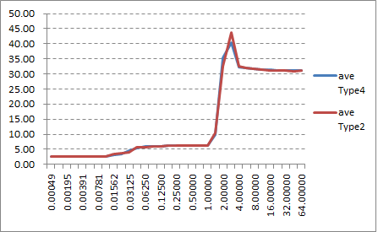

Figure 5‑13: Average Result Linux and Native Linux (Type4 and Type2)

**Table 5‑48: Data Transmission rate (Mbyte/s)**

|  |  |  |  |  |  |  |  |  |  |  |  |
| --- | --- | --- | --- | --- | --- | --- | --- | --- | --- | --- | --- |
| **Test environment** | Ave. | 1 | 2 | 3 | 4 | 5 | 6 | 7 | 8 | 9 | 10 |
| **Virtualized Linux (Type4)** | 2338.82 | 2346.46 | 2338.45 | 2333.09 | 2334.79 | 2346.46 | 2336.09 | 2339.27 | 2338.21 | 2345.56 | 2329.85 |
| **Native Linux (Type2)** | 2345.02 | 2332.60 | 2347.61 | 2357.18 | 2332.68 | 2356.93 | 2332.44 | 2348.19 | 2348.35 | 2347.53 | 2346.71 |

1. Consideration

The result of "lat_mem_rd" reflects well about the memory system hierarchy of the target hardware.

Both Native Linux and Virtualized Linux has the similar form which has the 3 specific score groups.

The first one is around 2.7ns and mainly observed under 32kB test size.

In these cases, the read access of this test is cached in the main CPU's L1 data cache (ARM Cortex-A57: 32kB L1 data cache per core), so this reflects the L1 cache read performance.

The next one is about 6.0ns to 6.3ns and mainly observed between 32kB to 1.5MB.

In these cases, the read access size exceeds the L1 data cache size and causes L1 data cache miss, but can be cached in the 2MB L2 unified cache, so this reflects the L2 cache read performance.

And the last one is around 31ns and mainly observed in 2MB or more.

In this size, the read access of this test exceeds the L2 cache size and causes L2 cache miss every time once the L2 cache is fully filled by the test read.

As L2 cache miss takes cache line fetch from the main memory (LPDDR4 memory on R-Car H3 SiP), this reflects the LPDDR4 read performance.

It is observed that the latency time of virtualized Linux increases a little earlier than native Linux when the test size increases. For this behavior, we are estimating that this is effected by the program working set size difference of the operating system portion. The virtualized Linux requires OS kernel feature not only for Linux but also for INTEGRITY kernel, and consumes more cache lines for operation. When the test size is nearly equal to either L1 or L2 cachesize, it increases the virtualized Linux’s latency time.

### Sequential writing performance

1. Description

Measure the performance to write sequential blocks of memory on virtualized Linux and native Linux.

Measurement tool is lmbench.

1. Precondition

* Measure on virtualized Linux on virtualized Linux and native Linux (Type4 and Type2)

*Both types stop the function of Linux App

* Use lmbench’s lat_mem_wr command on terminal software.
* Compare the performance between virtualized Linux and native Linux. The performance results should be near to native OS implementations results.
* Verified 10 times and use the average as the result value.

1. How to measure
2. Login to Linux.

salvator-x login: root

1. Run the following command to change the directory.

root@salvator-x:~# cd tools/lmbench

1. Run the following command for measurement.

root@salvator-x:~# cd tools/lmbench

root@salvator-x:~/tools/lmbench# ./bw_mem 1m wr

root@salvator-x:~/tools/lmbench# ./bw_mem 2m wr

root@salvator-x:~/tools/lmbench# ./bw_mem 4m wr

root@salvator-x:~/tools/lmbench# ./bw_mem 8m wr

root@salvator-x:~/tools/lmbench# ./bw_mem 16m wr

root@salvator-x:~/tools/lmbench# ./bw_mem 32m wr

root@salvator-x:~/tools/lmbench# ./bw_mem 64m wr

After finishing a command, you will see the log like below.

Red square is results.

root@salvator-x:~/tools/lmbench# ./bw_mem 1m wr

1.05 13676.19

1. Run the step 3 process 10 seconds after the result is displayed.

Repeat this 9 times.

1. Result

**Table 5‑49: Result (Type4)**

|  |  |  |  |  |  |  |  |  |  |  |
| --- | --- | --- | --- | --- | --- | --- | --- | --- | --- | --- |
| Test size | **1** | **2** | **3** | **4** | **5** | **6** | **7** | **8** | **9** | **10** |
| **1M** | 13609.71 | 13669.76 | 13666.27 | 13660.88 | 13666.27 | 13672.12 | 13570.52 | 13627.70 | 13664.70 | 13664.70 |
| **2M** | 3913.92 | 4018.93 | 4286.26 | 4491.49 | 4316.61 | 4146.06 | 4414.28 | 4215.77 | 4917.56 | 3799.19 |
| **4M** | 2211.02 | 2202.89 | 2221.95 | 2209.47 | 2209.08 | 2212.19 | 2215.30 | 2216.47 | 2195.59 | 2203.66 |
| **8M** | 1952.20 | 1959.50 | 1962.25 | 1952.88 | 1952.20 | 1950.16 | 1958.58 | 1958.35 | 1950.16 | 1953.79 |
| **16M** | 1938.89 | 1943.61 | 1946.54 | 1939.56 | 1942.26 | 1942.93 | 1944.73 | 1937.55 | 1940.01 | 1938.44 |
| **32M** | 1940.80 | 1928.75 | 1940.68 | 1939.45 | 1947.44 | 1945.64 | 1946.76 | 1940.35 | 1948.91 | 1947.10 |
| **64M** | 1944.56 | 1940.80 | 1948.06 | 1946.93 | 1947.10 | 1941.70 | 1938.67 | 1940.80 | 1940.96 | 1940.85 |

**Table 5‑50: Result (Type2)**

|  |  |  |  |  |  |  |  |  |  |  |
| --- | --- | --- | --- | --- | --- | --- | --- | --- | --- | --- |
| Test size | **1** | **2** | **3** | **4** | **5** | **6** | **7** | **8** | **9** | **10** |
| **1M** | 13676.19 | 13633.49 | 13676.19 | 13631.28 | 13680.58 | 13674.38 | 13671.91 | 13670.09 | 13609.71 | 13699.20 |
| **2M** | 4759.94 | 5047.76 | 5493.01 | 5387.18 | 4085.12 | 5110.21 | 4948.81 | 4822.74 | 4979.54 | 4768.96 |
| **4M** | 2237.36 | 2236.56 | 2221.17 | 2248.55 | 2220.38 | 2235.37 | 2218.03 | 2234.98 | 2231.01 | 2231.80 |
| **8M** | 1971.01 | 1966.39 | 1951.97 | 1967.77 | 1969.85 | 1964.09 | 1975.42 | 1972.40 | 1947.44 | 1968.46 |
| **16M** | 1949.71 | 1952.66 | 1952.20 | 1951.75 | 1953.34 | 1952.43 | 1957.44 | 1952.20 | 1951.97 | 1953.11 |
| **32M** | 1955.04 | 1935.65 | 1950.05 | 1955.27 | 1951.52 | 1954.13 | 1953.00 | 1954.82 | 1935.87 | 1936.09 |
| **64M** | 1937.66 | 1951.92 | 1950.67 | 1952.31 | 1952.37 | 1952.03 | 1952.20 | 1955.04 | 1936.20 | 1953.96 |

Table 5‑51: Result

|  |  |  |  |  |  |  |
| --- | --- | --- | --- | --- | --- | --- |
| Test size | **Virtualized Linux (Type4) [ns]** | | | **Native Linux(Type2) [ns]** | | |
|  | **Ave.** | **Min.** | **Max.** | **Ave.** | **Min.** | **Max.** |
| **1M** | 13647.26 | 13570.52 | 13672.12 | 13662.30 | 13609.71 | 13699.20 |
| **2M** | 4252.01 | 3799.19 | 4917.56 | 4940.33 | 4085.12 | 5493.01 |
| **4M** | 2209.76 | 2195.59 | 2221.95 | 2231.52 | 2218.03 | 2248.55 |
| **8M** | 1955.01 | 1950.16 | 1962.25 | 1965.48 | 1947.44 | 1975.42 |
| **16M** | 1941.45 | 1937.55 | 1946.54 | 1952.68 | 1949.71 | 1957.44 |
| **32M** | 1942.59 | 1928.75 | 1948.91 | 1948.14 | 1935.65 | 1955.27 |
| **64M** | 1943.04 | 1938.67 | 1948.06 | 1949.44 | 1936.20 | 1955.04 |

1. Consideration

As lmbench doesn’t has the benchmark for the memory write latency, this time we used memory bandwidth benchmark instead. As the cache line length is 64 bytes, the bandwidth of 1938.67MB/sec (64MB on Type4) and 1936.20MB/sec (64MB on Type2) are corresponding to 33.012ns and 33.054ns of the latency time. They are a little larger than read latency, and this is reasonable because the write cache miss initially issues memory read to fill the cache line, and replace the specific position of the cache line by the store data.

### Random reading performance

1. Description

Measure the performance to read random blocks of memory on virtualized Linux and native Linux.

Measurement tool is lmbench.

1. Precondition

* Measure on virtualized Linux on virtualized Linux and native Linux (Type4 and Type2)

*Both types stop the function of Linux App

* Use lmbench’s lat_mem_rd command on terminal software.
* Compare the performance between virtualized Linux and native Linux. The performance results should be near to native OS implementations results.
* Verified 10 times and use the average as the result value.

1. How to measure
2. Login to Linux.

salvator-x login: root

1. Run the following command to change the directory.

root@salvator-x:~# cd tools/lmbench

1. Run the following command for measurement.

root@salvator-x:~/tools/lmbench# ./lat_mem_rd 64m 131072

After finishing a command, you will see the log like below.

Red square is results.

root@salvator-x:~/tools/lmbench# ./lat_mem_rd 64m 131072

"stride=131072

0.12500 2.669

0.18750 2.669

0.25000 2.669

0.37500 2.669

0.50000 7.675

0.75000 11.827

1.00000 13.012

1.50000 14.905

2.00000 15.180

3.00000 85.090

4.00000 124.127

6.00000 150.806

8.00000 161.898

12.00000 174.101

16.00000 183.324

24.00000 203.268

32.00000 219.112

48.00000 316.886

64.00000 324.883

4. Run the step 3 process 10 seconds after the result is displayed.

Repeat this 9 times.

1. Result

**Table 5‑52: Result (Type4)**

|  |  |  |  |  |  |  |  |  |  |  |
| --- | --- | --- | --- | --- | --- | --- | --- | --- | --- | --- |
| **Array size**  **(MB)** | **1** | **2** | **3** | **4** | **5.** | **6** | **7** | **8** | **9** | **10** |
| **0.1250** | 2.678 | 2.677 | 2.678 | 2.671 | 2.678 | 2.678 | 2.678 | 2.674 | 2.674 | 2.677 |
| **0.1875** | 2.677 | 2.675 | 2.671 | 2.671 | 2.674 | 2.675 | 2.675 | 2.675 | 2.675 | 2.674 |
| **0.2500** | 2.675 | 2.671 | 2.674 | 2.671 | 2.671 | 2.671 | 2.671 | 2.671 | 2.675 | 2.674 |
| **0.3750** | 2.671 | 7.589 | 2.671 | 2.671 | 2.675 | 2.675 | 2.675 | 2.671 | 2.671 | 2.675 |
| **0.5000** | 2.675 | 7.681 | 2.675 | 2.67 | 14.126 | 2.675 | 2.671 | 2.671 | 2.674 | 2.671 |
| **0.7500** | 2.671 | 7.635 | 2.675 | 2.671 | 14.154 | 2.671 | 2.675 | 2.674 | 2.671 | 14.045 |
| **1.0000** | 2.675 | 7.261 | 9.692 | 7.154 | 13.04 | 6.062 | 9.925 | 7.154 | 10.872 | 9.148 |
| **1.5000** | 11.053 | 10.047 | 10.351 | 14.08 | 13.86 | 12.149 | 11.982 | 12.132 | 11.033 | 12.133 |
| **2.0000** | 13.015 | 12.4 | 11.603 | 13.443 | 15.215 | 13.109 | 12.065 | 12.746 | 13.71 | 13.249 |
| **3.0000** | 14.612 | 13.876 | 25.972 | 22.967 | 100.178 | 13.767 | 51.394 | 13.765 | 14.156 | 53.043 |
| **4.0000** | 14.942 | 33.825 | 87.631 | 86.079 | 126.024 | 50.151 | 103.167 | 42.234 | 17.947 | 103.829 |
| **6.0000** | 95.295 | 104.702 | 127.579 | 129.772 | 150.442 | 103.938 | 134.868 | 103.974 | 95.932 | 138.147 |
| **8.0000** | 124.612 | 127.143 | 143.325 | 144.049 | 159.85 | 130.508 | 148.273 | 129.189 | 122.214 | 151.129 |
| **12.0000** | 145.637 | 145.644 | 157.804 | 157.374 | 169.459 | 147.583 | 163.278 | 149.143 | 145.502 | 165.212 |
| **16.0000** | 158.973 | 157.879 | 167.848 | 167.535 | 176.399 | 160.876 | 171.76 | 160.594 | 156.41 | 172.546 |
| **24.0000** | 174.125 | 173.915 | 180.59 | 179.913 | 186.548 | 175.466 | 181.717 | 174.025 | 173.975 | 183.141 |
| **32.0000** | 189.616 | 190.056 | 193.498 | 194.073 | 199.172 | 191.493 | 195.995 | 190.194 | 189.508 | 196.876 |
| **48.0000** | 201.914 | 203.956 | 211.815 | 210.206 | 218.474 | 204.41 | 212.537 | 203.416 | 202.865 | 213.208 |
| **64.0000** | 259.192 | 260.523 | 260.651 | 258.855 | 260.39 | 260.431 | 258.424 | 260.634 | 256.988 | 259.821 |

**Table 5‑53: Result (Type2)**

|  |  |  |  |  |  |  |  |  |  |  |
| --- | --- | --- | --- | --- | --- | --- | --- | --- | --- | --- |
| **Array size**  **(MB)** | **1** | **2** | **3** | **4** | **5.** | **6** | **7** | **8** | **9** | **10** |
| **0.1250** | 2.685 | 2.669 | 2.685 | 2.669 | 2.669 | 2.685 | 2.685 | 2.669 | 2.685 | 2.684 |
| **0.1875** | 2.685 | 2.685 | 2.685 | 2.669 | 2.669 | 2.685 | 2.669 | 2.669 | 2.669 | 2.669 |
| **0.2500** | 2.685 | 2.669 | 2.669 | 2.669 | 2.669 | 2.685 | 2.685 | 2.669 | 2.685 | 2.685 |
| **0.3750** | 2.685 | 2.685 | 2.685 | 2.669 | 2.669 | 7.717 | 2.669 | 2.669 | 2.685 | 2.685 |
| **0.5000** | 2.685 | 7.673 | 2.669 | 2.669 | 2.669 | 14.89 | 2.685 | 2.669 | 7.673 | 2.685 |
| **0.7500** | 7.618 | 14.457 | 10.907 | 2.669 | 7.618 | 16.108 | 2.685 | 7.618 | 12.976 | 5.07 |
| **1.0000** | 6.084 | 14.934 | 9.925 | 11.321 | 10.426 | 16.108 | 10.571 | 14.513 | 12.836 | 2.685 |
| **1.5000** | 12.585 | 15.513 | 13.424 | 11.566 | 11.176 | 15.771 | 11.232 | 11.232 | 13.759 | 9.731 |
| **2.0000** | 13.047 | 15.395 | 12.124 | 14.013 | 12.972 | 15.86 | 13.089 | 12.805 | 14.346 | 12.459 |
| **3.0000** | 14.846 | 94.259 | 40.594 | 14.599 | 14.596 | 112.466 | 14.934 | 14.68 | 73.577 | 14.431 |
| **4.0000** | 50.366 | 128.609 | 95.775 | 24.694 | 24.349 | 135.323 | 50.15 | 49.882 | 116.946 | 72.706 |
| **6.0000** | 112.184 | 149.779 | 132.711 | 98.118 | 98.052 | 153.704 | 110.25 | 102.457 | 142.839 | 117.665 |
| **8.0000** | 133.017 | 156.419 | 144.157 | 123.454 | 121.296 | 159.388 | 131.707 | 127.372 | 151.527 | 134.726 |
| **12.0000** | 146.128 | 162.947 | 154.907 | 139.549 | 139.507 | 166.064 | 145.149 | 143.174 | 160.646 | 148.956 |
| **16.0000** | 154.18 | 167.999 | 161.478 | 150.347 | 149.064 | 169.785 | 154.012 | 154.19 | 165.46 | 156.009 |
| **24.0000** | 163.744 | 172.576 | 169.516 | 160.806 | 160.214 | 173.623 | 163.827 | 163.545 | 171.947 | 166.264 |
| **32.0000** | 171.928 | 179.99 | 175.803 | 169.935 | 171.108 | 180.781 | 171.61 | 170.506 | 179.332 | 174.417 |
| **48.0000** | 182.319 | 187.053 | 185.623 | 180.483 | 181.039 | 188.694 | 182.848 | 181.476 | 187.615 | 184.219 |
| **64.0000** | 219.294 | 221.76 | 219.582 | 221.968 | 219.059 | 227.985 | 219.693 | 220.078 | 221.206 | 221.885 |

Table 5‑54: Result

|  |  |  |  |  |  |  |
| --- | --- | --- | --- | --- | --- | --- |
|  | **Virtualized Linux (Type4) [ns]** | | | **Native Linux(Type2) [ns]** | | |
| **Array size**  **(MB)** | **Ave.** | **Min.** | **Max.** | **Ave.** | **Min.** | **Max.** |
| **0.1250** | 2.68 | 2.67 | 2.68 | 2.68 | 2.67 | 2.69 |
| **0.1875** | 2.67 | 2.67 | 2.68 | 2.68 | 2.67 | 2.69 |
| **0.2500** | 2.67 | 2.67 | 2.68 | 2.68 | 2.67 | 2.69 |
| **0.3750** | 3.16 | 2.67 | 7.59 | 3.18 | 2.67 | 7.72 |
| **0.5000** | 4.32 | 2.67 | 14.13 | 4.90 | 2.67 | 14.89 |
| **0.7500** | 5.45 | 2.67 | 14.15 | 8.77 | 2.67 | 16.11 |
| **1.0000** | 8.30 | 2.68 | 13.04 | 10.94 | 2.69 | 16.11 |
| **1.5000** | 11.88 | 10.05 | 14.08 | 12.60 | 9.73 | 15.77 |
| **2.0000** | 13.06 | 11.60 | 15.22 | 13.61 | 12.12 | 15.86 |
| **3.0000** | 32.37 | 13.77 | 100.18 | 40.90 | 14.43 | 112.47 |
| **4.0000** | 66.58 | 14.94 | 126.02 | 74.88 | 24.35 | 135.32 |
| **6.0000** | 118.46 | 95.30 | 150.44 | 121.78 | 98.05 | 153.70 |
| **8.0000** | 138.03 | 122.21 | 159.85 | 138.31 | 121.30 | 159.39 |
| **12.0000** | 154.66 | 145.50 | 169.46 | 150.70 | 139.51 | 166.06 |
| **16.0000** | 165.08 | 156.41 | 176.40 | 158.25 | 149.06 | 169.79 |
| **24.0000** | 178.34 | 173.92 | 186.55 | 166.61 | 160.21 | 173.62 |
| **32.0000** | 193.05 | 189.51 | 199.17 | 174.54 | 169.94 | 180.78 |
| **48.0000** | 208.28 | 201.91 | 218.47 | 184.14 | 180.48 | 188.69 |
| **64.0000** | 259.59 | 256.99 | 260.65 | 221.25 | 219.06 | 227.99 |

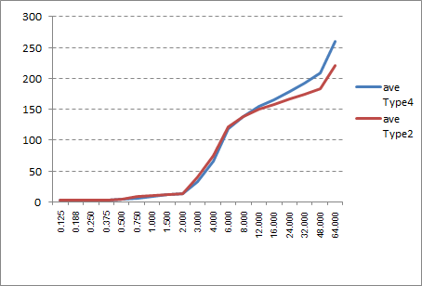

Figure 5‑14: Average Result Linux and Native Linux (Type4 and Type2)

1. Consideration

As it is not easy to perform 'random' access performance to the memory, this test simulates the random access condition by mostly-cache-miss address condition. In R-Car H3, the main CPU (ARM Cortex-A57) has 2MB unified L2C with 16-way and 64-byte line length. This means when the cacheable memory access is issued in every top boundary of 128kB, the top line of all 16 ways of cache arrays are consumed after 16th memory access, and all of the following memory access causes cache miss.

It is observed that when the test size is smaller than 8MB, the result is similar, or virtualized Linux is faster than native Linux. The faster virtualized Linux is currently unexpected and require further investigation.

In contrast, when the test size is larger than 8MB, the virtualized Linux is meaningfully slower than native Linux. As the TLB miss (both L1 data TLB and L2 unified TLB miss) occurs when the test size is larger than 4MB, the performance difference is expected to be produced by the difference of TLB miss processing. When in the native Linux environment, TLB miss causes the translation table walk once, but in virtualized Linux it causes twice due to the 2-stage address translation. See 5.11.7 and 5.11.8 for detail.

### Random writing performance

1. Description

Measure the performance to write random blocks of memory on virtualized Linux and native Linux.

Measurement tool is Renesas original test program.

1. Precondition

* Measure on virtualized Linux on virtualized Linux and native Linux (Type4 and Type2)

*Both types stop the function of Linux App

* Use Renesas original test program. (random_write)
* Compare the performance between virtualized Linux and native Linux. The performance results should be near to native OS implementations results.
* Verified 10 times and use the average as the result value.

1. How to measure
2. Login to Linux.

salvator-x login: root

1. Run the following command to change the directory.

root@salvator-x:~# cd tools

1. Run the following command to measure the Random writing performance 10 times.

root@salvator-x:~/tools# ./random_write

After finishing a command, you will see the log like below.

Red square is results.

root@salvator-x:~/tools# ./random_write

alloc_size[byte], count, count_max, start[sec], start[nsec], end[sec], end[nsec]

2097152, 0, 10, 184, 162289764, 184, 162338604, 48840

2097152, 1, 10, 184, 162434604, 184, 162472524, 37920

2097152, 2, 10, 184, 162481884, 184, 162482364, 480

2097152, 3, 10, 184, 162488124, 184, 162488604, 480

2097152, 4, 10, 184, 162494124, 184, 162494484, 360

2097152, 5, 10, 184, 162499884, 184, 162500364, 480

2097152, 6, 10, 184, 162505884, 184, 162506244, 360

2097152, 7, 10, 184, 162511524, 184, 162511884, 360

2097152, 8, 10, 184, 162517164, 184, 162517644, 480

2097152, 9, 10, 184, 162522804, 184, 162523164, 360

4194304, 0, 10, 184, 162541884, 184, 163453644, 911760

4194304, 1, 10, 184, 163559004, 184, 163601364, 42360

4194304, 2, 10, 184, 163608804, 184, 163612524, 3720

4194304, 3, 10, 184, 163618404, 184, 163621884, 3480

4194304, 4, 10, 184, 163627284, 184, 163628364, 1080

4194304, 5, 10, 184, 163633524, 184, 163634364, 840

4194304, 6, 10, 184, 163639644, 184, 163640364, 720

4194304, 7, 10, 184, 163645764, 184, 163646484, 720

4194304, 8, 10, 184, 163651644, 184, 163652364, 720

4194304, 9, 10, 184, 163657644, 184, 163658364, 720

8388608, 0, 10, 184, 163677084, 184, 165532045, 1854961

8388608, 1, 10, 184, 165683485, 184, 166216525, 533040

8388608, 2, 10, 184, 166231525, 184, 166237165, 5640

8388608, 3, 10, 184, 166243045, 184, 166246165, 3120

8388608, 4, 10, 184, 166251685, 184, 166254325, 2640

8388608, 5, 10, 184, 166259605, 184, 166262245, 2640

8388608, 6, 10, 184, 166267765, 184, 166270405, 2640

8388608, 7, 10, 184, 166275805, 184, 166278325, 2520

8388608, 8, 10, 184, 166283965, 184, 166286245, 2280

8388608, 9, 10, 184, 166292125, 184, 166294765, 2640

16777216, 0, 10, 184, 166320925, 184, 172131925, 5811000

16777216, 1, 10, 184, 172387765, 184, 174471565, 2083800

16777216, 2, 10, 184, 174489325, 184, 174509965, 20640

16777216, 3, 10, 184, 174516085, 184, 174525325, 9240

16777216, 4, 10, 184, 174531085, 184, 174539605, 8520

16777216, 5, 10, 184, 174545245, 184, 174553525, 8280

16777216, 6, 10, 184, 174559165, 184, 174566965, 7800

16777216, 7, 10, 184, 174572605, 184, 174581485, 8880

16777216, 8, 10, 184, 174587005, 184, 174595645, 8640

16777216, 9, 10, 184, 174601045, 184, 174608845, 7800

33554432, 0, 10, 184, 174636325, 184, 185291005, 10654680

33554432, 1, 10, 184, 185696725, 184, 197594606, 11897881

33554432, 2, 10, 184, 198046166, 184, 207793166, 9747000

33554432, 3, 10, 184, 208227446, 184, 221096247, 12868801

33554432, 4, 10, 184, 221500527, 184, 233233767, 11733240

33554432, 5, 10, 184, 233638287, 184, 244573288, 10935001

33554432, 6, 10, 184, 245018488, 184, 256515928, 11497440

33554432, 7, 10, 184, 256938688, 184, 268807409, 11868721

33554432, 8, 10, 184, 269193449, 184, 279993569, 10800120

33554432, 9, 10, 184, 280422569, 184, 290886090, 10463521

50331648, 0, 10, 184, 291260970, 184, 308172330, 16911360

50331648, 1, 10, 184, 308732370, 184, 325567291, 16834921

50331648, 2, 10, 184, 326156611, 184, 342395252, 16238641

50331648, 3, 10, 184, 343343972, 184, 359209892, 15865920

50331648, 4, 10, 184, 360752372, 184, 378412053, 17659681

50331648, 5, 10, 184, 378997413, 184, 395120494, 16123081

50331648, 6, 10, 184, 395674654, 184, 411530734, 15856080

50331648, 7, 10, 184, 412315774, 184, 429724175, 17408401

50331648, 8, 10, 184, 430367855, 184, 448244856, 17877001

50331648, 9, 10, 184, 448877616, 184, 465900817, 17023201

67108864, 0, 10, 184, 466462537, 184, 489351938, 22889401

67108864, 1, 10, 184, 491128778, 184, 514392819, 23264041

67108864, 2, 10, 184, 515150979, 184, 538065940, 22914961

67108864, 3, 10, 184, 538811260, 184, 561737380, 22926120

67108864, 4, 10, 184, 562498421, 184, 584818901, 22320480

67108864, 5, 10, 184, 585567341, 184, 607276542, 21709201

67108864, 6, 10, 184, 607982022, 184, 632766823, 24784801

67108864, 7, 10, 184, 633606943, 184, 657430784, 23823841

67108864, 8, 10, 184, 658176824, 184, 682881945, 24705121

67108864, 9, 10, 184, 683602905, 184, 706038106, 22435201

-- finished.

1. Result

**Table 5‑55: Result (Type4)**

|  |  |  |  |  |  |  |  |  |  |  |
| --- | --- | --- | --- | --- | --- | --- | --- | --- | --- | --- |
| **Array size**  **(MB)** | **1** | **2** | **3** | **4** | **5** | **6** | **7** | **8** | **9** | **10** |
| **2M** | 0.04236 | 0.02928 | 0.00072 | 0.00036 | 0.00036 | 0.00036 | 0.00036 | 0.00036 | 0.00036 | 0.00048 |
| **4M** | 0.65052 | 0.03360 | 0.00276 | 0.00120 | 0.00072 | 0.00072 | 0.00072 | 0.00072 | 0.00072 | 0.00072 |
| **8M** | 1.92516 | 0.60564 | 0.00420 | 0.00396 | 0.00216 | 0.00264 | 0.00204 | 0.00216 | 0.00228 | 0.00204 |
| **16M** | 4.38828 | 1.90884 | 0.01512 | 0.00708 | 0.00660 | 0.00756 | 0.00804 | 0.00780 | 0.00684 | 0.00684 |
| **32M** | 9.27384 | 8.73480 | 8.98452 | 9.02604 | 9.01296 | 9.14568 | 8.94012 | 9.05112 | 8.95584 | 8.90136 |
| **48M** | 13.67736 | 13.82160 | 13.53372 | 13.63812 | 13.56264 | 13.97652 | 14.03928 | 13.80252 | 13.91436 | 13.74948 |
| **64M** | 18.93768 | 17.70492 | 18.25560 | 17.74824 | 18.28896 | 17.91444 | 18.00984 | 17.75580 | 18.18672 | 18.36936 |

**Table 5‑56: Result (Type2)**

|  |  |  |  |  |  |  |  |  |  |  |
| --- | --- | --- | --- | --- | --- | --- | --- | --- | --- | --- |
| **Array size**  **(MB)** | **1** | **2** | **3** | **4** | **5** | **6** | **7** | **8** | **9** | **10** |
| **2M** | 0.03756 | 0.00192 | 0.00060 | 0.00072 | 0.00036 | 0.00048 | 0.00036 | 0.00072 | 0.00060 | 0.00036 |
| **4M** | 0.65796 | 0.00444 | 0.00228 | 0.00228 | 0.00216 | 0.00228 | 0.00180 | 0.00204 | 0.00216 | 0.00228 |
| **8M** | 1.86924 | 0.47436 | 0.00768 | 0.00504 | 0.00528 | 0.00576 | 0.00480 | 0.00504 | 0.00552 | 0.00540 |
| **16M** | 4.37940 | 1.61028 | 0.02004 | 0.01044 | 0.01044 | 0.01044 | 0.01044 | 0.01044 | 0.01032 | 0.01044 |
| **32M** | 9.33072 | 8.56212 | 8.75352 | 8.93064 | 9.02640 | 8.97372 | 9.09624 | 9.02280 | 9.07680 | 8.67060 |
| **48M** | 13.89948 | 12.71736 | 13.64856 | 13.78860 | 13.88268 | 13.87536 | 13.67964 | 13.75200 | 13.82088 | 14.01768 |
| **64M** | 17.94108 | 17.47488 | 17.56656 | 18.25212 | 18.69636 | 18.13944 | 18.29844 | 18.31908 | 17.66844 | 18.49116 |

Table 5‑57: Result

|  |  |  |  |  |  |  |
| --- | --- | --- | --- | --- | --- | --- |
| **Array size**  **(MB)** | **Virtualized Linux (Type4) [ns]** | | | **Native Linux (Type2) [ns]** | | |
| **Ave.** | **Min.** | **Max.** | **Ave.** | **Min.** | **Max.** |
| **2M** | 0.04236 | 0.00036 | 0.00750 | 0.03756 | 0.00036 | 0.004368 |
| **4M** | 0.65052 | 0.00072 | 0.06924 | 0.65796 | 0.0018 | 0.067968 |
| **8M** | 1.92516 | 0.00204 | 0.25523 | 1.86924 | 0.0048 | 0.238812 |
| **16M** | 4.38828 | 0.00660 | 0.63630 | 4.3794 | 0.01032 | 0.608268 |
| **32M** | 9.27384 | 8.73480 | 9.00263 | 9.33072 | 8.562121 | 8.9443564 |
| **48M** | 14.03928 | 13.53372 | 13.77156 | 14.01768 | 12.717361 | 13.7082245 |
| **64M** | 18.93768 | 17.70492 | 18.11716 | 18.696361 | 17.474881 | 18.0847568 |

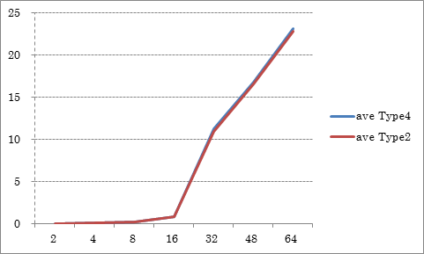

Figure 5‑15: Average Result Virtualized Linux and Native Linux (Type4 and Type2)

1. Consideration

As same as 5.11.3, this test also simulates the random access by using specific address condition to force the cache line conflict.

Generally, the test result (ms) is in proportional when the test size is larger than 8MB. The result for less or equal 8MB are vary. We are estimating that if the test size is smaller or equal to 8MB (= only 64 addresses for test), the store request will possibly merged on the store buffer and reduces the write requests for the LPDDR4 main memory. Unlike the random read case, the performance of the native Linux and virtualized Linux are observed almost same in the all test size. The possible reason is estimated that the store request can be buffered, and the TLB miss latency can be hidden in the preceding cache miss processing time.

### Memory Allocate/Deallocate performance

1. Description

Measure the performance to allocate blocks of memory and deallocate the same blocks on virtualized Linux and native Linux.

Measurement tool is Renesas original test program.

1. Precondition

* Measure on virtualized Linux on virtualized Linux and native Linux (Type4 and Type2)

*Both types stop the function of Linux App

* Use Renesas original test program. (alloc_dealloc)
* Compare the performance between virtualized Linux and native Linux. The performance results should be near to native OS implementations results.
* Verified 10 times and use the average as the result value.

1. How to measure
2. Login to Linux.

salvator-x login: root

1. Run the following command to change the directory.

root@salvator-x:~# cd tools

1. Run the following command to measure the Memory Allocate/Deallocate performance 10 times.

root@salvator-x:~/tools# ./alloc_dealloc

After finishing a command, you will see the log like below.

Red square is results.

root@salvator-x:~/tools# ./alloc_dealloc

alloc_size[byte], count, count_max, start[sec], start[nsec], end[sec], end[nsec], diff[nsec]

2097152, 0, 10, 119, 675161486, 119, 676956686, 1795200

2097152, 1, 10, 119, 676999046, 119, 678334646, 1335600

2097152, 2, 10, 119, 678348446, 119, 678367286, 18840

2097152, 3, 10, 119, 678373286, 119, 678384326, 11040

2097152, 4, 10, 119, 678389606, 119, 678399326, 9720

2097152, 5, 10, 119, 678404606, 119, 678414686, 10080

2097152, 6, 10, 119, 678420686, 119, 678430526, 9840

2097152, 7, 10, 119, 678435806, 119, 678445166, 9360

2097152, 8, 10, 119, 678450446, 119, 678459806, 9360

2097152, 9, 10, 119, 678465206, 119, 678474806, 9600

4194304, 0, 10, 119, 678480566, 119, 680846246, 2365680

4194304, 1, 10, 119, 680868446, 119, 683235326, 2366880

4194304, 2, 10, 119, 683251166, 119, 683314886, 63720

4194304, 3, 10, 119, 683321006, 119, 683380886, 59880

4194304, 4, 10, 119, 683388326, 119, 683445086, 56760

4194304, 5, 10, 119, 683452046, 119, 683507726, 55680

4194304, 6, 10, 119, 683513966, 119, 683566406, 52440

4194304, 7, 10, 119, 683573006, 119, 683624366, 51360

4194304, 8, 10, 119, 683630486, 119, 683684486, 54000

4194304, 9, 10, 119, 683691326, 119, 683745086, 53760

8388608, 0, 10, 119, 683751566, 119, 688888647, 5137081

8388608, 1, 10, 119, 688919367, 119, 691322367, 2403000

8388608, 2, 10, 119, 691341807, 119, 691468287, 126480

8388608, 3, 10, 119, 691476447, 119, 691601847, 125400

8388608, 4, 10, 119, 691610727, 119, 691734567, 123840

8388608, 5, 10, 119, 691741647, 119, 691862967, 121320

8388608, 6, 10, 119, 691870767, 119, 691991727, 120960

8388608, 7, 10, 119, 691998927, 119, 692149887, 150960

8388608, 8, 10, 119, 692162247, 119, 692284047, 121800

8388608, 9, 10, 119, 692291247, 119, 692412927, 121680

16777216, 0, 10, 119, 692420607, 119, 698691087, 6270480

16777216, 1, 10, 119, 698722647, 119, 701908287, 3185640

16777216, 2, 10, 119, 701931567, 119, 702532047, 600480

16777216, 3, 10, 119, 702540447, 119, 703520247, 979800

16777216, 4, 10, 119, 703528647, 119, 703806927, 278280

16777216, 5, 10, 119, 703814127, 119, 704105007, 290880

16777216, 6, 10, 119, 704115087, 119, 704399367, 284280

16777216, 7, 10, 119, 704406807, 119, 704664927, 258120

16777216, 8, 10, 119, 704672247, 119, 704933967, 261720

16777216, 9, 10, 119, 704942007, 119, 705197367, 255360

33554432, 0, 10, 119, 705206007, 119, 718937368, 13731361

33554432, 1, 10, 119, 719255848, 119, 732041368, 12785520

33554432, 2, 10, 119, 732076408, 119, 745467089, 13390681

33554432, 3, 10, 119, 745498289, 119, 758549009, 13050720

33554432, 4, 10, 119, 758579489, 119, 772443090, 13863601

33554432, 5, 10, 119, 772473930, 119, 784075530, 11601600

33554432, 6, 10, 119, 784103850, 119, 799029931, 14926081

33554432, 7, 10, 119, 799061731, 119, 812426132, 13364401

33554432, 8, 10, 119, 812463812, 119, 825670772, 13206960

33554432, 9, 10, 119, 825697652, 119, 838968933, 13271281

50331648, 0, 10, 119, 838995813, 119, 858921573, 19925760

50331648, 1, 10, 119, 858953973, 119, 879499534, 20545561

50331648, 2, 10, 119, 879529774, 119, 899781215, 20251441

50331648, 3, 10, 119, 899813015, 119, 917663136, 17850121

50331648, 4, 10, 119, 917694096, 119, 939956617, 22262521

50331648, 5, 10, 119, 939993217, 119, 958662937, 18669720

50331648, 6, 10, 119, 958694017, 119, 978534818, 19840801

50331648, 7, 10, 119, 978571298, 119, 998353539, 19782241

50331648, 8, 10, 119, 998388579, 120, 17454540, 19065961

50331648, 9, 10, 120, 17488380, 120, 38087221, 20598841

67108864, 0, 10, 120, 38126341, 120, 63385262, 25258921

67108864, 1, 10, 120, 63419462, 120, 90176103, 26756641

67108864, 2, 10, 120, 90215103, 120, 114481744, 24266641

67108864, 3, 10, 120, 114515224, 120, 141748265, 27233041

67108864, 4, 10, 120, 141783305, 120, 166453986, 24670681

67108864, 5, 10, 120, 166494426, 120, 193258027, 26763601

67108864, 6, 10, 120, 193285987, 120, 217231868, 23945881

67108864, 7, 10, 120, 217264868, 120, 243662349, 26397481

67108864, 8, 10, 120, 243694629, 120, 267378070, 23683441

67108864, 9, 10, 120, 267408310, 120, 293071151, 25662841

-- finished.

1. Result

**Table 5‑58: Result (Type4)**

|  |  |  |  |  |  |  |  |  |  |  |
| --- | --- | --- | --- | --- | --- | --- | --- | --- | --- | --- |
| **Array size**  **(MB)** | **1** | **2** | **3** | **4** | **5** | **6** | **7** | **8** | **9** | **10** |
| **2M** | 1.63740 | 1.34880 | 0.01728 | 0.00996 | 0.00948 | 0.00960 | 0.00972 | 0.00948 | 0.00936 | 0.00948 |
| **4M** | 2.22336 | 1.29840 | 0.05184 | 0.04308 | 0.04248 | 0.04440 | 0.04500 | 0.04380 | 0.04440 | 0.04380 |
| **8M** | 3.50856 | 1.97088 | 0.13080 | 0.12852 | 0.12360 | 0.12120 | 0.12156 | 0.12120 | 0.12180 | 0.12216 |
| **16M** | 6.16272 | 3.23760 | 0.25104 | 0.24816 | 0.24696 | 0.24960 | 0.24876 | 0.24660 | 0.24828 | 0.24912 |
| **32M** | 11.08860 | 10.80300 | 10.97712 | 10.92012 | 10.93188 | 10.86540 | 11.00568 | 10.93836 | 10.89228 | 10.86912 |
| **48M** | 16.34928 | 15.21552 | 15.54264 | 15.69276 | 16.03968 | 15.81336 | 15.92712 | 16.00848 | 15.96396 | 15.99540 |
| **64M** | 21.41364 | 19.84644 | 20.74308 | 20.96724 | 20.87376 | 20.91876 | 20.95980 | 20.31012 | 20.85504 | 20.67840 |

**Table 5‑59: Result (Type2)**

|  |  |  |  |  |  |  |  |  |  |  |
| --- | --- | --- | --- | --- | --- | --- | --- | --- | --- | --- |
| **Array size**  **(MB)** | **1** | **2** | **3** | **4** | **5** | **6** | **7** | **8** | **9** | **10** |
| **2M** | 1.72224 | 1.18176 | 0.01440 | 0.00984 | 0.00960 | 0.00984 | 0.00972 | 0.00960 | 0.00984 | 0.00960 |
| **4M** | 2.28300 | 1.27488 | 0.05088 | 0.04308 | 0.04260 | 0.05064 | 0.04416 | 0.04428 | 0.04248 | 0.04272 |
| **8M** | 3.53136 | 2.00724 | 0.12324 | 0.12084 | 0.13680 | 0.12480 | 0.11880 | 0.12000 | 0.11976 | 0.11964 |
| **16M** | 6.00696 | 3.31860 | 0.24864 | 0.26520 | 0.24528 | 0.24456 | 0.25056 | 0.25344 | 0.25260 | 0.26844 |
| **32M** | 11.28720 | 10.94304 | 10.96320 | 10.90296 | 10.72728 | 10.85376 | 11.14068 | 11.02704 | 10.81728 | 11.05776 |
| **48M** | 15.91368 | 15.74028 | 15.86424 | 15.99348 | 15.88404 | 15.86100 | 15.63744 | 16.13556 | 15.80496 | 15.93732 |
| **64M** | 21.41364 | 19.68180 | 20.44608 | 20.51640 | 20.91144 | 20.47980 | 20.67780 | 21.11076 | 20.79684 | 20.89596 |

Table 5‑60: Result

|  |  |  |  |  |  |  |
| --- | --- | --- | --- | --- | --- | --- |
| **Array size**  **(MB)** | **Virtualized Linux (Type4) [ns]** | | | **Native Linux (Type2) [ns]** | | |
| **Ave.** | **Min.** | **Max.** | **Ave.** | **Min.** | **Max.** |
| **2M** | 1.63740 | 0.00936 | 0.30706 | 1.72224 | 0.0096 | 0.298644 |
| **4M** | 2.22336 | 0.04248 | 0.38806 | 2.283 | 0.04248 | 0.391872 |
| **8M** | 3.50856 | 0.12120 | 0.64703 | 3.53136 | 0.1188 | 0.652248 |
| **16M** | 6.16272 | 0.24660 | 1.13888 | 6.006961 | 0.24456 | 1.1354281 |
| **32M** | 11.08860 | 10.80300 | 10.92916 | 11.2872 | 10.72728 | 10.9720204 |
| **48M** | 16.34928 | 15.21552 | 15.85482 | 16.13556 | 15.637441 | 15.8772007 |
| **64M** | 21.41364 | 19.84644 | 20.75663 | 21.413641 | 19.6818 | 20.6930528 |

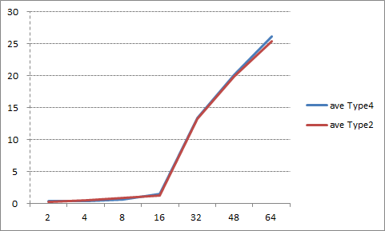

Figure 5‑16: Average Result Virtualized Linux and Native Linux (Type4 and Type2)

1. Consideration

This test result is observed quite similar to the result of 5.11.4, random write performance. As this memory allocation benchmark program performs 32-bit data write per every 4kB allocation size to force the actual allocation of the memory page, this data write is estimated to determine this memory allocation/deallocation performance benchmark.

### Read Cached/Uncached memory performance

1. Description

Measure the performance to read the cached/uncached memory on virtualized Linux and native Linux.

Measurement tool is lmbench.

1. Precondition

* Measure on virtualized Linux and native Linux (Type4 and Type2)

*Both types stop the function of Linux App

* Use the result of Sequential Read for the smallest test size as cached performance, and the result of Random Read for the largest size as uncached performance.
* Compare the performance between virtualized Linux and native Linux. The performance results should be near to native OS implementations results.
* Verified 10 times and use the average as the result value.

1. How to measure
2. Cached performance is taken from the minimum size (0.00049MB) result of 5.11.1
3. Uncached performance is taken from the maximum size (64.000MB) result of 5.11.3

As the uncached memory access is similar to the cache miss operation, the uncached memory access performance can be substituted by the cache miss performance. The typical cached performance is the smallest size of the sequential read test (5.1.1) which the test size is enough smaller than L1 cache size (32kB), and the typical uncached performance is the largest size of the random read test (5.1.3) wich is the nearest one of the true uncache performance.

1. Result

Table 5‑61: Cached Result

|  |  |
| --- | --- |
| **Virtualized Linux**  **(Type4) [ns]** | **Native Linux**  **(Type2) [ns]** |
| 2.67 | 2.67 |

Table 5‑62: UnCached Result

|  |  |
| --- | --- |
| **Virtualized Linux**  **(Type4) [ns]** | **Native Linux**  **(Type2) [ns]** |
| 260.65 | 227.99 |

1. Consideration

This result is expected. As the uncached memory access performance is taken from the result of random access test, it includes the effect of TLB miss. See 5.11.3 for detail.

### TLB(Translation look aside buffer) miss performance

1. Description

Measure the performance of TLB miss penalty on virtualized Linux and native Linux.

Measurement tool is lmbench.

Following Figure 5-13 describes the address translation hardware. When the TLB miss occur, the Native Linux performs the page table walk once for Linux only, and the Virtualized Linux does twice, one for the Virtualized Linux itself, and one more for Hypervisor. On the other hand, when TLB hits in address translation, the performance will not differ because page table walk doesn’t happen.

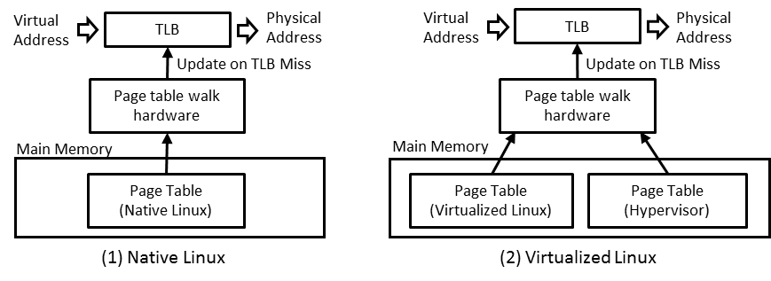

Figure 5‑17: Address translation model

1. Precondition

* Measure on virtualized Linux on virtualized Linux and native Linux (Type4 and Type2)

*Both types stop the function of Linux App

* Use lmbench’s lat_mem_rd command on terminal software.
* Compare the performance between virtualized Linux and native Linux.
* Verified 10 times and use the average as the result value.

1. How to measure
2. Login to Linux.

salvator-x login: root

1. Run the following command to change the directory.

root@salvator-x:~# cd tools/lmbench

1. Run the following command for measurement.

root@salvator-x:~/tools/lmbench# ./lat_mem_rd 16M 1048576

After finishing a command, you will see the log like below.

Red square is results.

root@salvator-x:~/tools/lmbench# ./lat_mem_rd 16M 1048576

"stride=1048576

1.00000 2.674

1.50000 2.671

2.00000 2.671

3.00000 2.670

4.00000 2.670

6.00000 13.135

8.00000 11.771

12.00000 12.521

16.00000 13.693

1. Result(Reference value)

**Table 5‑63: Result (Type4)**

|  |  |  |  |  |  |  |  |  |  |  |
| --- | --- | --- | --- | --- | --- | --- | --- | --- | --- | --- |
| **Array size**  **(MB)** | **1** | **2** | **3** | **4** | **5** | **6** | **7** | **8** | **9** | **10** |
| **1** | 2.671 | 2.671 | 2.670 | 2.674 | 2.674 | 2.674 | 2.671 | 2.671 | 2.671 | 2.67 |
| **1.5** | 2.671 | 2.671 | 2.671 | 2.670 | 2.671 | 2.671 | 2.671 | 2.671 | 2.671 | 2.67 |
| **2** | 2.671 | 2.671 | 2.671 | 2.671 | 2.671 | 2.671 | 2.671 | 2.671 | 2.671 | 2.68 |
| **3** | 2.671 | 2.671 | 2.671 | 2.671 | 2.671 | 2.671 | 2.671 | 2.671 | 2.671 | 2.68 |
| **4** | 2.671 | 7.679 | 7.679 | 7.679 | 2.671 | 2.671 | 13.545 | 13.942 | 13.619 | 13.79 |
| **6** | 13.134 | 13.134 | 10.940 | 13.134 | 11.036 | 11.036 | 14.025 | 14.026 | 13.150 | 13.13 |
| **8** | 14.026 | 13.357 | 11.770 | 14.025 | 11.789 | 11.789 | 13.357 | 13.357 | 14.025 | 14.05 |
| **12** | 12.523 | 13.580 | 13.579 | 13.579 | 12.523 | 12.523 | 13.579 | 13.581 | 14.025 | 13.58 |
| **16** | 12.899 | 13.691 | 12.902 | 12.898 | 12.899 | 12.899 | 13.692 | 12.919 | 13.698 | 12.92 |

**Table 5‑64: Result (Type2)**

|  |  |  |  |  |  |  |  |  |  |  |
| --- | --- | --- | --- | --- | --- | --- | --- | --- | --- | --- |
| **Array size**  **(MB)** | **1** | **2** | **3** | **4** | **5** | **6** | **7** | **8** | **9** | **10** |
| **1** | 2.685 | 2.669 | 2.684 | 2.669 | 2.669 | 2.669 | 2.669 | 2.685 | 2.669 | 2.684 |
| **1.5** | 2.669 | 2.669 | 2.669 | 2.669 | 2.669 | 2.669 | 2.669 | 2.685 | 2.669 | 2.685 |
| **2** | 2.669 | 2.669 | 2.669 | 2.669 | 2.669 | 2.669 | 2.669 | 2.685 | 2.669 | 2.685 |
| **3** | 2.669 | 2.669 | 7.125 | 7.671 | 2.669 | 2.669 | 2.669 | 2.685 | 2.669 | 7.693 |
| **4** | 7.719 | 13.806 | 7.720 | 2.669 | 2.669 | 7.673 | 7.673 | 2.685 | 7.676 | 7.720 |
| **6** | 14.013 | 10.911 | 13.132 | 13.123 | 11.010 | 13.123 | 11.010 | 10.842 | 13.201 | 13.201 |
| **8** | 13.354 | 11.761 | 14.022 | 11.760 | 13.345 | 13.345 | 11.761 | 11.830 | 13.354 | 13.354 |
| **12** | 13.576 | 14.013 | 14.022 | 12.511 | 12.511 | 13.568 | 12.511 | 13.650 | 13.577 | 13.577 |
| **16** | 13.762 | 13.679 | 12.966 | 13.680 | 12.887 | 12.888 | 13.679 | 12.964 | 12.896 | 12.965 |

Table 5‑65: Result

|  |  |  |  |  |  |  |
| --- | --- | --- | --- | --- | --- | --- |
|  | **Virtualized Linux(Type4) [ns]** | | | **Native Linux(Type2) [ns]** | | |
| **Array size**  **(MB)** | **Latency**  **Ave.** | **Latency**  **min.** | **Latency**  **max.** | **Latency**  **Ave.** | **Latency**  **min.** | **Latency**  **max.** |
| **1** | 2.672 | 2.670 | 2.674 | 2.675 | 2.669 | 2.685 |
| **1.5** | 2.671 | 2.670 | 2.671 | 2.672 | 2.669 | 2.685 |
| **2** | 2.671 | 2.671 | 2.671 | 2.672 | 2.669 | 2.685 |
| **3** | 2.671 | 2.671 | 2.671 | 4.119 | 2.669 | 7.693 |
| **4** | 8.017 | 2.671 | 13.942 | 6.801 | 2.669 | 13.806 |
| **6** | 12.624 | 10.940 | 14.026 | 12.357 | 10.842 | 14.013 |
| **8** | 13.055 | 11.770 | 14.026 | 12.789 | 11.760 | 14.022 |
| **12** | 13.277 | 12.523 | 14.025 | 13.352 | 12.511 | 14.022 |
| **16** | 13.166 | 12.898 | 13.698 | 13.237 | 12.887 | 13.762 |

1. Consideration

The TLB miss latency is calculated by subtracting the average result of typical TLB and L2C hit latency (1MB results of 5.11.1) from the typical TLB miss and L2C hit latency (16MB results of 5.11.7).

It is about 7ns (virtualized Linux: 6.88, native Linux: 6.94) per one access, and it is smaller than the L2C miss latency (about 31ns) measured in 5.1.1. This result also mean the TLB page table walk in this test scenario does not produce external memory access, and the 2-stage translation overhead is not observed in the result of virtualized Linux.

### VA - IPA -PA conversion performance

1. Description

Measure the performance to translate the virtual address into intermediate and physical address by the MMU on virtualized Linux.

1. Precondition

* This VA-IPA-PA conversion performance is calculated by the TLB miss penalty of both the virtualized Linux and the native Linux. As the test result of 5.11.7 does not have the specific difference between the native Linux and the virtualized Linux, the result of 5.11.3 is used to calculate the performance difference of the VA-IPA-PA translation on virtualized Linux, and VA-PA translation on native Linux. The result of 5.11.7 is used as the common TLB miss overhead for both VA-IPA-PA and VA-PA translations.

1. How to measure
2. Use result of 5.11.3 and 5.11.7.
3. Result

Table 5‑66: Result

|  |  |
| --- | --- |
|  | **VA-IPA-PA translation latency (ns)** |
| **Type 4 (Virtualized Linux)** | 83.56 |

The calculation of VA-IPA-PA translation time (Ttr) is listed below.

Ttr =

((Virtualized Linux's random read latency: A)

- (Native Linux's random read latency: B)) * 2

+ (Virtualized Linux's one TLB-miss overhead: C)

= 83.56 (ns)

The A value includes the L2 cache miss read time and TLB miss overhead with 2-stage translation. (VA-IPA-PA), and the B value includes the L2 cache miss read time and TLB miss overhead with 1-stage translation. (VA-PA). So the Ttr can be calculated by ((A) - (B)) * 2 + (C).

The actual value is:

A: 64MB average result of Virtualized Linux in 5.11.3 (259.59ns)

B: 64MB average result of Native Linux in 5.11.3 (221.25ns)

C: Calculated TLB miss overhead of Virtualized Linux in 5.11.7 (6.88ns)

1. Consideration

From the result of 5.11.1 and 5.11.3, this VA-IPA-PA overhead include 2 times of external memory read cycles. For the result of 5.11.7, the observed of TLB miss doesn’t contain any external memory read access, and this is why 5.11.7 doesn’t observe the meaningful difference between native Linux and virtualized Linux.

## Network Performance(Linux)

### Send / Receive data to cloud

Out of Scope.

### Packet Loss

Out of Scope.

### End-to-end Input events delivery latency

Out of Scope.

### Delay variation(Jitter)

Out of Scope.

### Send / Receive data to cloud

Out of Scope.

### Throughput(Bandwidth)

Out of Scope.

### Ethernet Bit error rate (BER)

Out of Scope.

## Power Consumption Performance

### standby current

Out of Scope.

### Power consumption when sleep mode

Out of Scope.

### Average power usage performance

Out of Scope.

## RTOS performance

### INTEGRITY OS Performance

All measurements below using api_measurements.gpj in release T14.0 and are in nanoseconds.

#### Deadlock break time

1. Description

Out of scope.

1. Precondition
2. How to measure

1. Result

1. Consideration

#### Semaphore processing

1. Description

1. Precondition

GHS special environment is needed. Our PoC doesn't include it.

1. How to measure

GHS special environment is needed. Our PoC doesn't include it.

1. Result

Table 5‑67: Result (nano second)

|  |  |
| --- | --- |
| TryToObtainSemaphore on available Semaphore | 321.332 |
| TryToObtainSemaphore on unavailable Semaphore | 324.627 |
| TimedWaitForSemaphore on available Semaphore | 1136.588 |
| ReleaseSemaphore no waiter | 310.069 |
| TryToClearSemaphore | 310.685 |
| GetSemaphoreValue | 312.120 |
| WaitForLocalMutex on available LocalMutex | 7.336 |
| ReleaseLocalMutex | 6.002 |
| TryToObtainLocalMutex on available LocalMutex | 6.002 |
| TryToObtainLocalMutex on unavailable LocalMutex | 6.002 |
| TryToObtainSemaphore on available Semaphore | 321.332 |

1. Consideration

This result is expected.

#### Message Passing

1. Description

1. Precondition

GHS special environment is needed. Our PoC doesn't include it.

1. How to measure

GHS special environment is needed. Our PoC doesn't include it.

1. Result

Table 5‑68: Result (nano second)

|  |  |
| --- | --- |
| 0-byte message SynchronousSend | 440.850 |
| SynchronousReceive on Object with pending message | 322.660 |
| Simple AllocateMessageQueueBuffer | 67.586 |
| Simple SendOnMessageQueue | 64.801 |
| Simple GetMessageCountForMessageQueue | 60.468 |
| Simple TimedReceiveOnMessageQueue | 65.464 |
| Simple ReceiveOnMessageQueue | 68.113 |
| Simple FreeMessageQueueBuffer | 21.527 |

1. Consideration

This result is expected.

#### Context Switching

1. Description

1. Precondition

GHS special environment is needed. Our PoC doesn't include it.

1. How to measure

GHS special environment is needed. Our PoC doesn't include it.

1. Result

Table 5‑69: Result (nano second)

|  |  |
| --- | --- |
| context-switch overhead | 680.429 |

1. Consideration

This result is expected.

#### Interrupt Latency

1. Description

1. Precondition

GHS special environment is needed. Our PoC doesn't include it.

1. How to measure

GHS special environment is needed. Our PoC doesn't include it.

1. Result

Table 5‑70: Result (nano second)

|  |  |
| --- | --- |
| Timer interrupt latency | 360.121 |

1. Consideration

This result is expected.

## Application Switching performance

### Application Switching performance

Out of Scope.

## Malicious App

### INTEGRITY meter cluster application keeps 60fps even if Linux malicious app runs

1. Description

Measure the FPS of the INTEGRITY graphics meter application (Rightware graphics meter) with a malicious application running on virtualized Linux.

The GPU on R-Car H3 can process multiple graphics applications at the same time using the context switch. There is a granularity in the context switch. If a graphics application (e.g. malicious app on Linux) did either of the followings, the GPU could not do the context switch for a long time and the performance of other graphics applications (e.g. meter cluster on INTEGRITY Disable script to run the demo applications automatically.) would drop.

* Draw many polygons in one glDrawXXX()
* Do many pixel processing in one sub-surface (“tile”) of the drawing surface

The GPU on R-Car H3 has a GPU robustness feature to avoid the performance drop caused by malicious applications on Linux. On Linux, a malicious application would issue a high load GPU workload to the GPU via the graphics driver. GPU has a timeout value for the GPU workloads. If the workload from Linux run too long and exceeds the timeout, GPU judges that the workload is “malicious” and kill it.

This section tests it.

 

|  |  |
| --- | --- |
| (a) Many polygons | (b) Heavy shaders |

Figure 5‑18: Images of malicious applications

Table 5‑71: Malicious applications features

|  |  |
| --- | --- |
| **Item** | **Description** |
| Application | * Renesas original malicious applications  1. Many polygons: draw 1,800 balls (about 10,000 polygons/ball) 2. Heavy shaders: draw 5000 lines in one fragment shader  * OpenGL ES 3.1 application |
| Resolution | * 1920x720 |

1. Precondition

* Measure on virtualization PoC but Rightware meter cluster only runs (Type1)
* Enable the GPU robustness feature
* Application on INTEGRITY: Rightware meter cluster
* Application on Linux: Renesas original malicious application (Many polygons or Heavy shaders. They shall be stored in the root file system)
* Window size on INTEGRITY/Linux: 1920x720
* Window system on Linux: DRM

1. How to measure (preliminary)
2. Start Type1_mono.5.16.1 using MULTI debugger.
3. Login to Linux using Terminal.

salvator-x login: root

1. Stop Weston using the following command.

root@salvator-x:~# systemctl stop weston

1. Edit /etc/powervr.ini as follows to use the DRM Window System.

Before the modification

WindowSystem=libpvrWAYLAND_WSEGL.so

After the modification

;WindowSystem=libpvrWAYLAND_WSEGL.so   
WindowSystem=libpvrDRM_WSEGL.so

1. Disable Weston using the following command.

root@salvator-x:~# systemctl disable weston

1. Restart Type1_mono.5.16.1.
2. Login to Linux.

salvator-x login: root

1. Run the malicious application as

root@salvator-x:~# cd malicious_app

In case of Many polygons

root@salvator-x:~/malicious_app# ./ManyPolygons -count=1800 -fps -info

In case of Heavy shaders

root@salvator-x:~/malicious_app# ./HeavyShaders -count=5000 -fps

1. Check the performance of Rightware meter cluster by the FPS outputs shown to MULTI Debugger.

(omitted)

I/O: LOG: fps: 59.980335

I/O:

I/O: LOG: fps: 59.980335

I/O:

I/O: LOG: fps: 59.980335

I/O:

I/O: LOG: fps: 59.980335

(omitted)

1. Result (preliminary figures)

Table 5‑72: Result

|  |  |
| --- | --- |
| **App on Linux** | **FPS of the Rightware meter cluster on INTEGRITY** |
| (a) Many polygons | 60 |
| (b) Heavy traffic shaders | 60 |

1. Consideration

Rightware graphics meter kept 60FPS even if there is a malicious application on virtualized Linux. On the other hand, if we test with the GPU robustness feature disabled, the FPS of the Rightware graphics meter dropped and it ran awkwardly. The FPS was 20 in case of (a) and 16 in case of (b) respectively. This means that the effect of the GPU robustness feature.

Note: As the GPU robustness feature kills the GPU workload of the malicious application, nothing is drawn and the malicious application seems stopped.

### INTEGRITY meter cluster application keeps 60fps even if memory leak or memory corruption is occurred on Linux side

1. Description

Measure the FPS of the INTEGRITY graphics meter application (Rightware graphics meter) with an application which cause memory leaking or a memory corruption on virtualized Linux.

Table 5‑73: Applications which cause memory leaking / memory corruption features

|  |  |
| --- | --- |
| **Item** | **Description** |
| Application | * Renesas original applications  1. Memory leaking: allocate 50MB memory every 500ms 2. Memory corruption: write data to the Linux kernel memory |
| Resolution | * 1920x720 |

1. Precondition

* Measure on virtualization PoC but Rightware meter cluster only runs (Type1)
* Application on INTEGRITY: Rightware meter cluster
* Application on Linux: Renesas original application (Memory leaking or Memory corruption. They shall be stored in the root file system)
* Window size on INTEGRITY/Linux: 1920x720
* Window system on Linux: DRM

1. How to measure
2. Start Type1_mono.5.16.2 using MULTI debugger.
3. Login to Linux using Terminal.

salvator-x login: root

1. Restart Type1_mono.5.16.2.
2. In case of memory leaking application, run it as follows.

root@salvator-x:~# cd memory_app

root@salvator-x:~/memory_app# ./MemoryLeak

You will see the following message like follows. The application will be killed by the Linux kernel.

MemoryLeak: Memory allocation succeeded.

MemoryLeak: cnt=1 memory size=50000000byte total size=50000000byte

MemoryLeak: Memory allocation succeeded.

MemoryLeak: cnt=2 memory size=50000000byte total size=100000000byte

MemoryLeak: Memory allocation succeeded.

(omitted)

MemoryLeak: cnt=19 memory size=50000000byte total size=950000000byte

MemoryLeak: Memory allocation succeeded.

MemoryLeak: cnt=20 memory size=50000000byte total size=1000000000byte

[ 93.484050] gst-launch-1.0 invoked oom-killer: gfp_mask=0x24201ca, order=0, oom_score_adj=0

[ 93.492438] CPU: 1 PID: 1926 Comm: gst-launch-1.0 Tainted: G W O 4.4.0-yocto-standard #3

[ 93.501526] Hardware name: Renesas SalvatorX board based on r8a7795 (DT)

[ 93.508233] Call trace:

(omitted)

[ 94.063130] Out of memory: Kill process 1994 (MemoryLeak) score 536 or sacrifice child

[ 94.071063] Killed process 1994 (MemoryLeak) total-vm:1037088kB, anon-rss:1024464kB, file-rss:4kB, shmem-rss:0kB

Killed

1. In case of memory corrupt application, run it as follows.

root@salvator-x:~# cd memory_app

root@salvator-x:~/memory_app# ./MemoryCorrpution_mmap 1208483840 8800

Then sometimes the Terminal returns nothing because Linux hanged up depending on the timing.

1. During memory leaking or memory corruption application is running, check the performance of Rightware meter cluster by the FPS outputs shown to MULTI Debugger.

(omitted)

I/O: LOG: fps: 59.980335

I/O:

I/O: LOG: fps: 59.980335

I/O:

I/O: LOG: fps: 59.980335

I/O:

I/O: LOG: fps: 59.980335

(omitted)

1. Result

Table 5‑74: Result

|  |  |
| --- | --- |
| **App on Linux** | **FPS of the Rightware meter cluster on INTEGRITY** |
| (a) Memory leaking | 60 |
| (b) Memory corruption | 60 |

1. Consideration

Rightware graphics meter kept 60FPS even if there is a memory leaking or memory corruption application on virtualized Linux. This shows the safety of the virtualization system using INTEGRITY Multivisor. However we sometimes got the following results. We will solve them in the future.

* The Rightware cluster runs jumpy one time
* The Rightware cluster stops

## Robustness

### Unexpected memory access blocking system by using IPMMU,LifeCycle

1. Description

Figure 5‑19 describes the operation model of IPMMU. It can provide the address translation and address space protection for built-in bus master modules in R-Car SoCs.

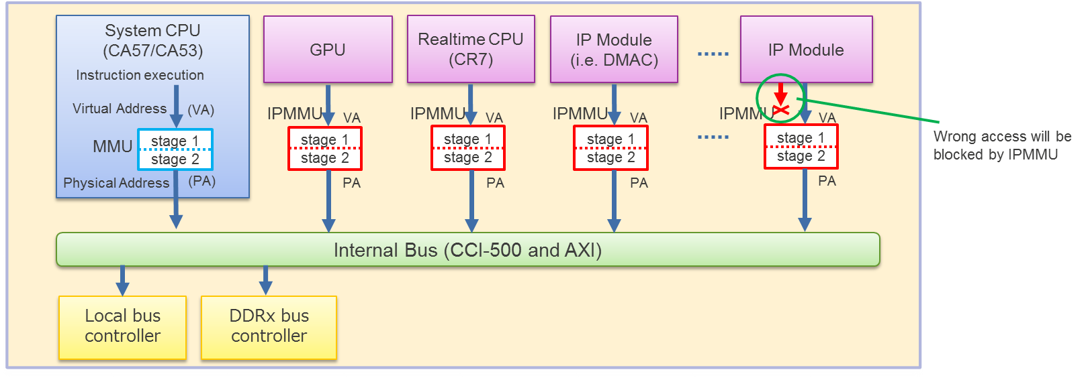

Figure 5‑19: IPMMU operation model

Figure 5‑20 describes the operation model of LifeCycle. LifeCycle will put the specified security level to each access request issued by R-Car Gen3 built-in modules, and guard its register space by the request’s security level. This generally protect the hardware modules from being accessed by the unauthorized bus master, either CPU or other built-in module.

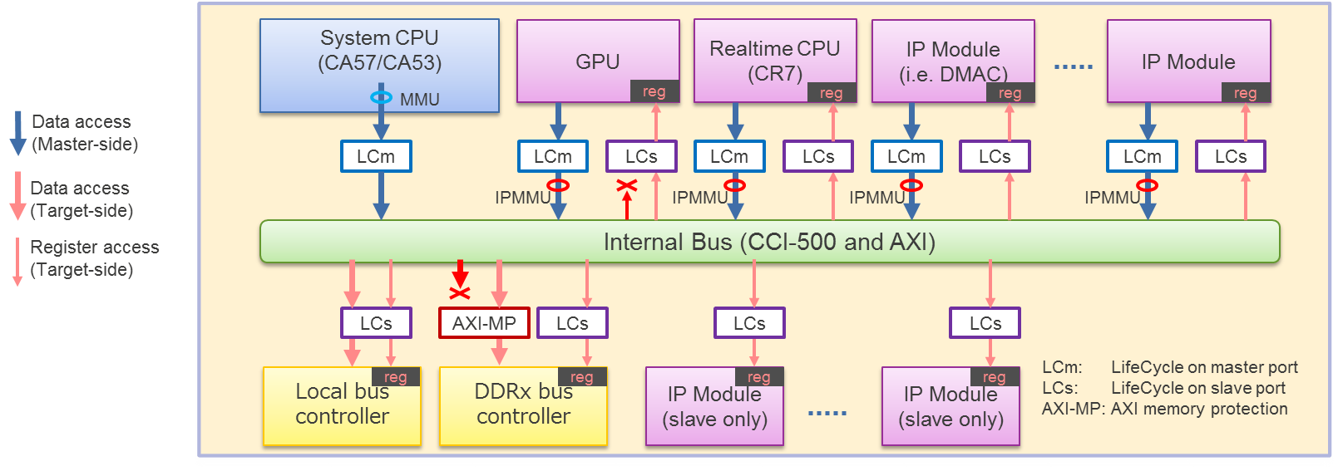

Figure 5‑20: LifeCycle operation model

1. Precondition

* Measure on virtualization PoC (Type1)
* Connect a Camera to composite (CVBS_IN: CN21)

1. How to measure

* IPMMU Confirmation procedure

Use GHS test program and Renesas original test program.

GHS test program uses IPMMU, to check whether the meter cluster application is not disturbed even if the display memory is to be corrupted by other hardware module intentionally.

Normal camera image -> broken camera image, in this way image are displayed alternately for the first 10 seconds. In the next 10 seconds, IPMMU protects illegal memory access and normal camera image continues to be displayed.

Renesas original test program uses LifeCycle, to check whether the part of the display unit hardware (DU0/DU1) that Linux are using can be protected by LifeC, and when the specific LifeC setting is issued, Linux can no longer access the display unit hardware (stopped and put error due to blocked DU0/1 access).

* LifeCycle Confirmation procedure

1. Launch Type1
2. Select [Target] – [Connect] from Menu bar of MULTI
3. Select “Dynamic Download/INDRT Connection (rtserv2) for Device Tree” and press “Connect” button.
4. Select “Run mode target”
5. Select [Target] - [Load Module] - [Load Module...] from Menu bar.
6. Load the " LifeCTest.ael" file included in the deliverables.
7. Press F5 for start.
8. Result

* IPMMU

Result is expected.

* LifeCycle

When LifeCycle application start, Kernel panic in Linux is occurred.

[ 40.219695] [<ffffffc0000855e0>] el1_irq+0xa0/0x10c

[ 40.224568] [<ffffffc0000867c0>] arch_cpu_idle+0x10/0x18

[ 40.229883] [<ffffffc0000ebf1c>] cpu_startup_entry+0x13c/0x230

[ 40.235718] [<ffffffc00070bd2c>] rest_init+0x84/0x90

[ 40.240682] [<ffffffc000a3e940>] start_kernel+0x384/0x398

[ 40.246077] [<ffffffc0000811b4>] 0xffffffc0000811b4

[ 40.250950] handlers:

[ 40.253225] [<ffffffc000431ea0>] rcar_du_crtc_irq

[ 40.257930] Disabling IRQ #51

1. Consideration

These results are expected.

## Rebooting of Linux

### INTEGRITY meter cluster application keeps 60fps even if Linux rebooting is executed

1. Description

Measure the display performance (frame per sec) of Instrument Cluster keeps 60fps even if Linux rebooting is executed on virtualization PoC.

1. Precondition

* Measure on virtualization PoC (Type1)
* Measure FPS by incorporating the FPS measurement method on Meter Cluster.
* Verified 10 times and use the average as the result value.

1. How to measure
2. Make a following script (file name: rundemo) to reboot Linux shortly.

#!/bin/sh

sleep 5

export XDG_RUNTIME_DIR=/run/user/root

export LD_LIBRARY_PATH=/home/root/Futuremark

sleep 5

cd /home/root/nng_env/center

export WSEGL_ENABLE_TRIPLE_BUFFERING=12

./salvatorx-linux_salvatorx_64-release&

sleep 5

cd /home/root/IMG_SDK35

export WSEGL_ENABLE_TRIPLE_BUFFERING=2

./OGLES3Coverflow -aasamples=4 -width=1920 -height=720 -posx=0 -posy=0 &

export XDG_RUNTIME_DIR=/run/user/root

modprobe -a mmngr mmngrbuf vspm vspm_if vsp2 uvcs_drv

gst-launch-1.0 \

filesrc location=/home/root/movie/big_buck_bunny_720p_h264.mp4 \

! qtdemux name=demux \

demux.audio_0 ! queue \

! omxaaclcdec \

! alsasink device=hw:0,0 \

demux.video_0 ! queue \

! h264parse \

! omxh264dec \

! vspfilter \

! video/x-raw, format=BGRA, width=1920, height=720 \

! waylandsink &

sleep 20

reboot -f

1. Replace the above rundemo with /etc/init.d/rundemo in the rootfs.
2. Run the monolith for the PoC (Type1_mono).
3. Login to Linux.

salvator-x login: root

1. Enable autorun setting for rundemo.

root@salvator-x:~# cd /etc/init.d

root@salvator-x:/etc/init.d# update-rc.d rundemo defaults

1. Run the monolith for the PoC (Type1_mono). Linux applications will start automatically.
2. After the 3D navigation start to show the map, clear the log in the MULTI Debugger.
3. Start to check the performance of Rightware meter cluster by the FPS outputs shown to MULTI Debugger until the Linux rebooting finish.

(omitted)

I/O: LOG: fps: 59.980335

I/O:

I/O: LOG: fps: 59.980335

I/O:

I/O: LOG: fps: 59.980335

I/O:

I/O: LOG: fps: 59.980335

(omitted)

1. Repeat “step 3 - step 5” nine times.
2. Result

Table 5‑75: FPS of the Rightware meter cluster

|  |  |  |  |  |  |  |  |  |  |  |  |
| --- | --- | --- | --- | --- | --- | --- | --- | --- | --- | --- | --- |
|  | Ave. | 1 | 2 | 3 | 4 | 5 | 6 | 7 | 8 | 9 | 10 |
| **Rightware meter cluster FPS** | 59 | 59 | 60 | 60 | 59 | 59 | 59 | 59 | 59 | 60 | 59 |

1. Consideration

Rightware graphics meter kept almost 60FPS even if Linux rebooted. This shows the safety of the virtualization system using INTEGRITY Multivisor. If any issues occur on Linux (e.g. hang-up, run unstably, etc.) we can reboot Linux without any side effects on INTEGRITY, especially for the meter cluster.

## Memory usage

### Check the memory usage of Multivisor

1. Description

Measure the memory usage of Multivisor of Center Information and Instrument Cluster / Head-up display on virtualization PoC.

Measurement tool is top command for Linux, Multi Debugger for INTEGRITY.

1. Precondition

* Measure on virtualization PoC (Type1)
* Use a tool including in Multi Debugger.

1. How to measure

Calculate a use memory size by subtracting unused memory from a total memory size (3,968 Mbyte).

Estimated memory usage = Total memory - free memory [Virtualized Linux, Memory Pool, heap]

　Note that this value is not exactly because we have omitted the small pieces of memory.

* Measurement of the unused memory size in Center Information

1. Login to Linux.

salvator-x login: root

1. Run the following top command.

root@salvator-x:~# top –d10 –n61

After finishing a command, you will see the log like below.

Red square is a result.

root@salvator-x:~/bin/x86_64-linux-gnu# top -d10

Mem: 578956K used, 1273804K free, 20824K shrd, 9940K buff, 119992K cached

CPU: 27% usr 5% sys 0% nic 67% idle 0% io 0% irq 0% sirq

Load average: 1.08 1.21 1.21 1/104 1794

* Measurement of the unused memory size in MemoryPool

1. Select [Target] – [Connect] from Menu bar on MULTI.
2. Select “Dynamic Download/INDRT Connection (rtserv2) for Device Tree” and press “Connect” button.
3. Select “Run mode target”
4. Run the following command on “Trg” tab.

INDRT2>ct

1. Run the following command on “Trg” tab.

INDRT2>lt

After finishing a command, you will see the log like below. Check the result of the memory size (the right side) of the line of "Type1_kernel".

Type1_kernel 0x0000000000001000/0x000000000cb24000

0xffffffa6c571e000 exited 127 0x0000000000000630/0x0000000000008000 0.17% Initial

0xffffffa6c5720000 running 0 0x0000000000000020/0x0000000000000400 41.14% Idle0

0xffffffa6c5722000 running 0 0x0000000000000020/0x0000000000000400 61.42% Idle1

0xffffffa6c5724000 running 0 0x0000000000000020/0x0000000000000400 63.93% Idle2

Similarly, we choice the large value of result of "multivisor_loader", "pvrserver_as0", "devtree_generic_server_module" and "Sakura".

1. Run the step 5 process 10 seconds after the result is displayed.

Repeat this for 10 minutes.

* Measurement of the unused memory size in Heap Memory

1. Select [Target] – [Connect] from Menu bar of MULTI
2. Select “Dynamic Download/INDRT Connection (rtserv2) for Device Tree” and press “Connect” button.
3. Expand a tree of "INTEGRITY SMP Application" in "Target View", and choose "Core 1, Cortex-A57/Type1_mono".
4. Select [Debug] – [Halt on Selected Items] from Menu bar of MULTI
5. Run the following command on “Cmd” tab.

MULTI> heapview

After finishing a command, you will see the log like below. Check the result of the “free” value.

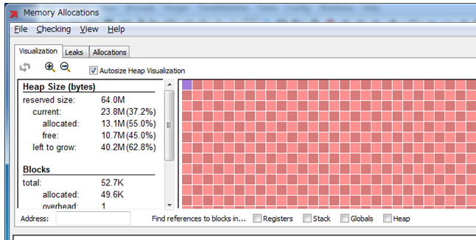

1. Expand a tree of "Run mode target" in "Target View", and find “devtree_generic_server_module”
2. Expand a tree of “devtree_generic_server_module”, and choose “Initial”
3. Select [Debug] – [Halt on Selected Items] from Menu bar of MULTI
4. Run the following command on “Cmd” tab.

MULTI> heapview

After finishing a command, you will see the log like below. Check the result of the “free” value.



1. Continue, and run "step 6 - step 9" for the following targets.

“DISCOM_sample_virt”

“FBServer”

“INT_Logo_sample_virt”

“ip46router_devtree_module”

“ivfsserver_devtree_module”

“multivisor_loader”

“multivisor_net_server”

“multivisor_vmm”

“pvrserver_as0”

“Sakura”

1. Result

Table 5‑76: Unused memory in Center Information

|  |  |
| --- | --- |
|  | **Center Information**  **[Byte]** |
| **Ave.** | 862529536 |
| **1** | 885567488 |
| **2** | 877494272 |
| **3** | 871903232 |
| **4** | 870629376 |
| **5** | 867295232 |
| **6** | 861986816 |
| **7** | 857751552 |
| **8** | 854102016 |
| **9** | 843231232 |
| **10** | 835334144 |

Table 5‑77: Unused memory in Memory Pool

|  |  |
| --- | --- |
| **AddressSpace** | **MemoryPool [Byte]** |
| **Type1_kernel** | 213008384 |
| **multivisor_loader** | 209858560 |
| **pvrserver_as0** | 165662720 |
| **devtree_generic_server_module** | 22028288 |
| **Sakura** | 67108864 |
| **Total** | 677666816 |

Table 5‑78: Unused memory in Heap Memory

|  |  |  |  |  |  |  |
| --- | --- | --- | --- | --- | --- | --- |
|  | **Type1_kernel**  **[Byte]** | **devtree_generic_server_module**  **[Byte]** | **DISCOM_sample_virt**  **[Byte]** | **FBServer**  **[Byte]** | **INT_Logo_sample_virt**  **[Byte]** | **ip46router_devtree_module**  **[Byte]** |
| **Ave.** | 35574 | 12083 | 10824 | 11674 | 10711 | 4813 |
| **1** | 34918 | 12083 | 10752 | 11674 | 10752 | 4812 |
| **2** | 35737 | 12083 | 10854 | 11674 | 10650 | 4812 |
| **3** | 35737 | 12083 | 10854 | 11674 | 10650 | 4812 |
| **4** | 35737 | 12083 | 10854 | 11674 | 10650 | 4812 |
| **5** | 35430 | 12083 | 10854 | 11674 | 10650 | 4812 |
| **6** | 34918 | 12083 | 10854 | 11674 | 10752 | 4812 |
| **7** | 35942 | 12083 | 10854 | 11674 | 10752 | 4812 |
| **8** | 35942 | 12083 | 10752 | 11674 | 10752 | 4812 |
| **9** | 35635 | 12083 | 10752 | 11674 | 10752 | 4812 |
| **10** | 35737 | 12083 | 10854 | 11674 | 10752 | 4812 |
|  | **ivfsserver_devtree_module**  **[Byte]** | **multivisor_loader**  **[Byte]** | **multivisor_net_server**  **[Byte]** | **multivisor_vmm**  **[Byte]** | **pvrserver_as0**  **[Byte]** | **Sakura**  **[Byte]** |
| **Ave.** | 13537 | 10547 | 7373 | 65536 | 540201 | 13956547 |
| **1** | 16486 | 10547 | 7373 | 65536 | 600781 | 11324621 |
| **2** | 13209 | 10547 | 7373 | 65536 | 657510 | 13316915 |
| **3** | 13209 | 10547 | 7373 | 65536 | 384410 | 14365491 |
| **4** | 13209 | 10547 | 7373 | 65536 | 441242 | 14365491 |
| **5** | 13209 | 10547 | 7373 | 65536 | 441242 | 14365491 |
| **6** | 13209 | 10547 | 7373 | 65536 | 711270 | 14365491 |
| **7** | 13209 | 10547 | 7373 | 65536 | 512000 | 14365491 |
| **8** | 13209 | 10547 | 7373 | 65536 | 541082 | 14365491 |
| **9** | 13209 | 10547 | 7373 | 65536 | 556339 | 14365491 |
| **10** | 13209 | 10547 | 7373 | 65536 | 556134 | 14365491 |

Table 5‑79: Result

|  |  |
| --- | --- |
| Estimated memory usage | 4160749568 – (862529536 + 677666816 + 14679419 ) = 2605873797 (Byte)  =2485.16(MByte) |

1. Consideration

This result is expected

## Stress Tolerance

### Perform a continuous test for 48 hours with stress of various tools and video/audio playback

1. Description

Confirm to perform virtualization PoC keeping for 48 hours with stress of various tools and video/audio playback.

1. Precondition

* Measure on virtualization PoC (Type1)

1. How to measure
2. Start Type1_mono.
3. Leave it for 48 hours.
4. Check that it keeps running without any issues or not.
5. Result

We have checked that the system ran 5 hours. We have seen several issues when running longer time.

1. Consideration

We think there are still some stability issues remaining in this environment and will need further investigation.

## Security

### Domain, Application Isolation

1. Description

Measure that INTEGRITY keeps running without any influence even if the Linux application accesses the memory on INTEGRITY.

The following figure shows the imageof memory protection. Each application should run in its own space.

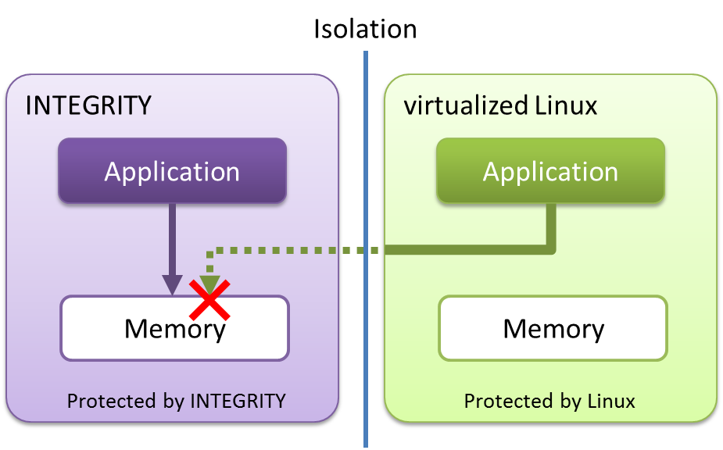

Figure 5‑21: Image of memory protection

1. Precondition

* Measure on virtualization PoC (Type1)
* Use Renesas original test program. The test program generates access request to unauthorized address space intentionally. And an application in INTEGRITY keep running without influence.

1. How to measure
2. Refer to 5.16.
3. Result

Refer to 5.16

1. Consideration

Refer to 5.16

### Illegal access of Resources / Memory

This and Section 5.21.1 is duplicated. Refer to Section 5.21.1.

### Encryption/Decryption Performance

Out of Scope.

### Secure boot process for each domain

Out of Scope.

## End-to-End Latency

### End-to-End UI Latency between RTOS and Linux (Image, binary, text)

Out of Scope.

## Memory Utilization of Each Module

### Memory utilization in IVI (Center Information)

1. Description

Measure RAM utilization in Center Information application on virtualization PoC using top command on virtualization PoC.

1. Precondition

* Measure on virtualized Linux on virtualization PoC (Type1)
* Use top command.
* Verified 10 times and use the average as the result value.

1. How to measure
2. Refers to 5.19.1.
3. Result

Table 5‑80: Result

|  |  |
| --- | --- |
| **Virtualization PoC (Type1)** | **Value**  **[Kbyte]** |
| **Center Information** | 1340790.00 |

1. Consideration

This result come from the average of Table 5-73. This result is expected.

### Memory utilization in meter (Instrument Cluster)

1. Description

Measure RAM utilization in Instrument Cluster application on virtualization PoC using Command prompt.

The following applications are measurement target. Refer to Chapter 4 for details.

- Meter Cluster app

- OGLES31

- Display driver

1. Precondition

* Measure on INTEGRITY on virtualization PoC (Type1)
* Use a command on Command prompt.

1. How to measure

Calculate a used memory size by measurement for several kinds of memory sizes that each application uses, and adding each.

Memory utilization = MemoryPool + heap memory + ROM/RAM size + Memory Region.

* Measurement of the used memory size in MemoryPool

Measurement method refers to “Measurement of the unused memory size in MemoryPool” of 5.19.1 .

Excerpt from results of 5.19.1. Check the following results of the memory size (the left side) of the line of "Sakura".

Sakura 0x00000000000cb000/0x0000000004000000

0xffffffa6c57f0000 running 127 0x00000000000187b0/0x0000000000200000 31.39% Initial

0xffffffa00fae3000 pending 128 0x0000000000000168/0x0000000000003cb8 0.00% PosixServer

Similarly, check the result of "pvrserver_as0" and "FBServer".

* Measurement of the used memory size in Heap Memory

Measurement method refers to “Measurement of the unused memory size in MemoryPool” of 5.19.1 .

Excerpt from results of 5.19.1. Check the following results of the memory size (the left side) of the line of "Sakura".



* Measurement of the used memory size in ROM/RAM size

1. Run the following command.(measurement ROM/RAM size of Sakura)

C:\>C:\ghs\comp_201516\gsize.exe -ram -rom C:\Sakura-h3

After finishing a command, you will see the log like below.

Red square is results.

C:\ghs\comp_201516\gsize.exe -ram -rom C:\Sakura-h3

RAM_Size: 1828492

ROM_Size: 19707803

1. Run the following command. (measurement ROM/RAM size of pvrserver_as0)

C:\>C:\ghs\comp_201516\gsize.exe -ram -rom C:\ghs\int1144\bin\devtree-arm64\pvrserver_as0

After finishing a command, you will see the log like below.

Red square is results.

C:\>C:\ghs\comp_201516\gsize.exe -ram -rom C:\pvrserver_as0

RAM_Size: 109684

ROM_Size: 784716

1. Run the following command. (measurement ROM/RAM size of FBServer)

C:\>C:\ghs\comp_201516\gsize.exe -ram -rom C:\FBServer

After finishing a command, you will see the log like below.

Red square is results.

C:\>C:\ghs\comp_201516\gsize.exe -ram -rom C:\FBServer

RAM_Size: 23148

ROM_Size: 122484

* Measurement of the Memory Region size.

The memory region of sakura use maximum following size.

Memory Region Size : 147540214 (Byte)

1. Result

* Instrument Cluster

- Sakura (Meter Cluster app)

- pvrserver_as0 (OGLES31)

- FBServer (Display driver)

Table 5‑81: Used memory Pool

|  |  |  |  |
| --- | --- | --- | --- |
|  | **Sakura**  **(Byte)** | **pvrserver_as0**  **(Byte)** | **FBServer**  **(Byte)** |
| **Ave.** | 895385.6 | 40686387.2 | 0 |
| **1** | 872448 | 40693760 | 0 |
| **2** | 913408 | 40701952 | 0 |
| **3** | 913408 | 40701952 | 0 |
| **4** | 913408 | 40685568 | 0 |
| **5** | 880640 | 40677376 | 0 |
| **6** | 880640 | 40677376 | 0 |
| **7** | 880640 | 40677376 | 0 |
| **8** | 921600 | 40685568 | 0 |
| **9** | 921600 | 40685568 | 0 |
| **10** | 856064 | 40677376 | 0 |

Table 5‑82: Used heap memory

|  |  |  |  |
| --- | --- | --- | --- |
|  | **Sakura**  **(Byte)** | **pvrserver_as0**  **(Byte)** | **FBServer**  **(Byte)** |
| **Ave.** | 13715374 | 12457083 | 568 |
| **1** | 13631488 | 12373197 | 568 |
| **2** | 13631488 | 12478054 | 568 |
| **3** | 13736346 | 12478054 | 568 |
| **4** | 13736346 | 12478054 | 568 |
| **5** | 13736346 | 12478054 | 568 |
| **6** | 13736346 | 12373197 | 568 |
| **7** | 13736346 | 12478054 | 568 |
| **8** | 13736346 | 12478054 | 568 |
| **9** | 13736346 | 12478054 | 568 |
| **10** | 13736346 | 12478054 | 568 |

Table 5‑83: Result

|  |  |  |  |  |  |  |  |
| --- | --- | --- | --- | --- | --- | --- | --- |
| **AddressSpace** | **MemoryPool**  **(Byte)** | **Heap Memory**  **(Byte)** | **ROM size**  **(Byte)** | | **RAM size**  **(Byte)** | | **Memory Region**  **(Byte)** |
| **Sakura** | 895385.6 | 13715374 | 19707803 | | 1828492 | | 147073269.8 |
| **pvrserver_as0** | 40686387.2 | 12457083 | 784716 | | 109684 | | 466944 |
| **FBServer** | 0 | 568 | 122484 | | 23148 | | 0 |
| **Total** | 41581772.8 | 26173025 | 20615003 | | 1961324 | | 147540213.8 |
| **Used memory Size** | | 237628037(Byte)  = 226.62 (MByte) | |

1. Consideration

This results is expected.

### Memory utilization in HUD (Head-up display)

1. Description

Measure RAM utilization in Head-up display application on virtualization PoC using Command prompt.

The following applications are measurement target. Refer to Chapter 4 for details.

- Telltail app

- Display driver

1. Precondition

* Measure on INTEGRITY on virtualization PoC (Type1)
* Use a command on Command prompt.

1. How to measure

Calculate a used memory size by measurement for several kinds of memory sizes that each application uses, and adding each.

Memory utilization = MemoryPool + heap memory + ROM/RAM size + Memory Region.

* Measurement of the used memory size in MemoryPool

Measurement method refers to “Measurement of the unused memory size in MemoryPool” of 5.19.1 .

Excerpt from results of 5.19.1. Check the following results of the memory size (the left side) of the line of "Telltale".

DISCOM_sample_virt 0x0000000000005000/0x0000000000080000

0xffffffa6c57f8000 pending 127 0x00000000000009d0/0x0000000000008000 1.61% Initial

0xffffffa00ff26000 pending 254 0x0000000000000280/0x0000000000000dd0 0.00% OSAAgent

Similarly, check the result of "pvrserver_as0" and "FBServer".

* Measurement of the used memory size in Heap Memory

Measurement method refers to “Measurement of the unused memory size in MemoryPool” of 5.19.1 .

Excerpt from results of 5.19.1. Check the following results of the memory size (the left side) of the line of "DISCOM_sample_virt".



* Measurement of the used memory size in ROM/RAM size

1. Run the following command.(measurement ROM/RAM size of Sakura)

C:\ghs\comp_201516\gsize.exe -ram -rom

After finishing a command, you will see the log like below.

Red square is results.

C:\ghs\int1144\bin\devtree-arm64\DISCOM_sample_virt

RAM_Size: 285296

ROM_Size: 1150472

1. Run the following command. (measurement ROM/RAM size of FBServer)

C:\>C:\ghs\comp_201516\gsize.exe -ram -rom C:\FBServer

After finishing a command, you will see the log like below.

Red square is results.

C:\>C:\ghs\comp_201516\gsize.exe -ram -rom C:\FBServer

RAM_Size: 23148

ROM_Size: 122484

* Measurement of the used memory size in ROM/RAM size

The memory region of Telltale use maximum following size.

Memory Region Size : 2334720 (Byte)

1. Result

* Instrument Cluster

- DISCOM_sample_virt (Telltale)

- FBServer (Display driver)

Table 5‑84: Used memory Pool

|  |  |  |
| --- | --- | --- |
|  | **Telltale**  **(Byte)** | **FBServer**  **(Byte)** |
| **Ave.** | 20480 | 0 |
| **1** | 20480 | 0 |
| **2** | 20480 | 0 |
| **3** | 20480 | 0 |
| **4** | 20480 | 0 |
| **5** | 20480 | 0 |
| **6** | 20480 | 0 |
| **7** | 20480 | 0 |
| **8** | 20480 | 0 |
| **9** | 20480 | 0 |
| **10** | 20480 | 0 |

Table 5‑85: Used heap memory

|  |  |  |
| --- | --- | --- |
|  | **Sakura**  **(Byte)** | **FBServer**  **(Byte)** |
| **Ave.** | 1464 | 568 |
| **1** | 1536 | 568 |
| **2** | 1434 | 568 |
| **3** | 1434 | 568 |
| **4** | 1434 | 568 |
| **5** | 1434 | 568 |
| **6** | 1434 | 568 |
| **7** | 1434 | 568 |
| **8** | 1536 | 568 |
| **9** | 1536 | 568 |
| **10** | 1434 | 568 |

Table 5‑86: Result

|  |  |  |  |  |  |  |  |
| --- | --- | --- | --- | --- | --- | --- | --- |
| **AddressSpace** | **MemoryPool**  **(Byte)** | **Heap Memory**  **(Byte)** | **ROM size**  **(Byte)** | | **RAM size**  **(Byte)** | | **Memory Region**  **(Byte)** |
| **DISCOM_sample_vir** | 20480 | 1464 | 1150472 | | 285296 | | 2334720 |
| **FBServer** | 0 | 568 | 122484 | | 23148 | | 0 |
| **Total** | 20480 | 2036 | 1272956 | | 308444 | | 2334720 |
| **Used memory Size** | | 3938632(Byte)  = 3.76 (MByte) | |

1. Consideration

This results is expected.

## Network Performance(RTOS, Multivisor)

### Send / Receive data to cloud

Out of Scope.

### Packet Loss

Out of Scope.

### End-to-end Input events delivery latency

Out of Scope.

### Delay variation(Jitter)

Out of Scope.

### Throughput(Bandwidth)

Out of Scope.

### Data Queuing

Out of Scope.

### Ethernet Bit error rate (BER)

Out of Scope.

**Appendix-A. How to write U-boot or Monolith to Hyper Flash**

1. Activate the Terminal Software.
2. Power switch turn on Salvator-X board.
3. Run MULTI.
4. Select [Components] – [Open Debugger…] from menu bar

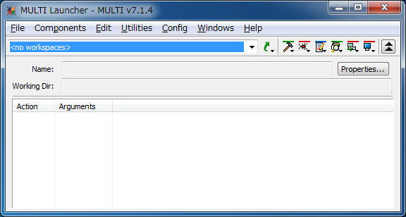

Figure A‑1: Selects [Components] – [Open Debugger…]

The following “Choose a program to debug” window appears.

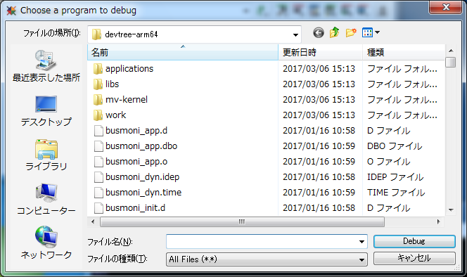

Figure A‑2: “Choose a program to debug” window

1. Select the appropriate monolith file and press [Debug] button

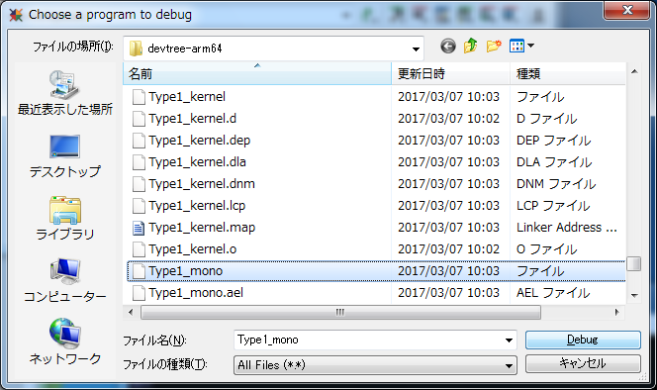

Figure A‑3: Select the appropriate monolith file

Please select Type1_mono, Type3_mono or Type4_mono.

The following debug window appears.

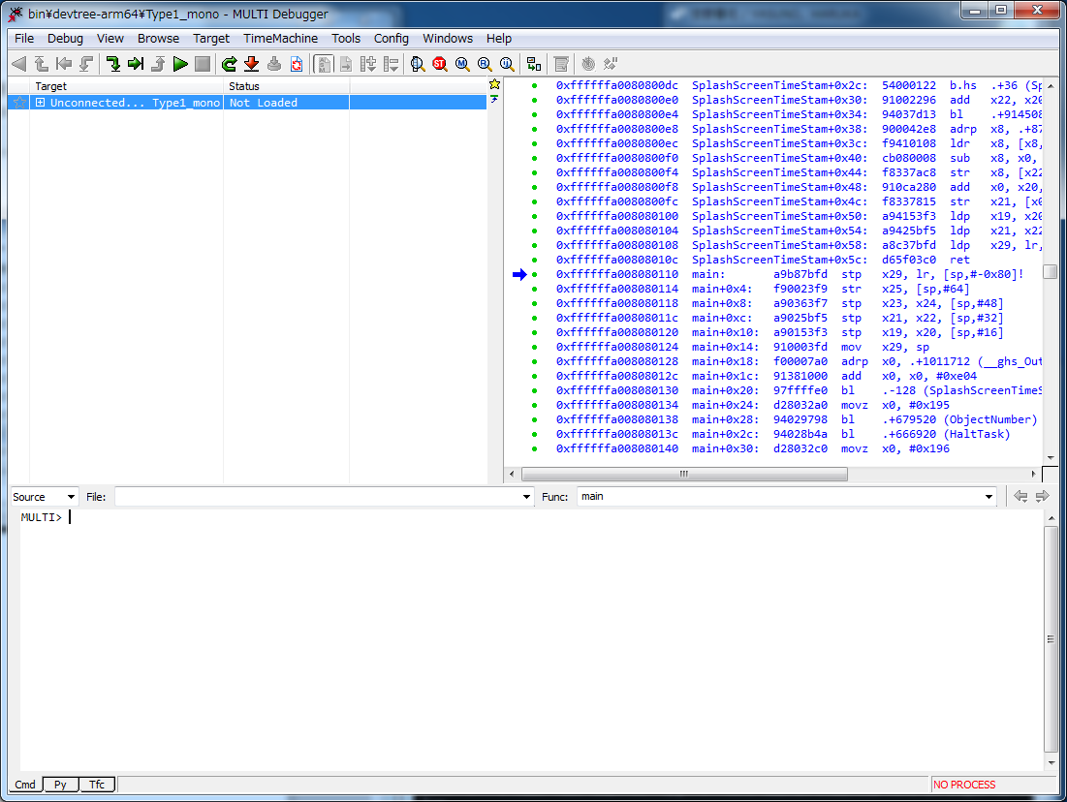

Figure A‑4: Debug window

1. Run to following command in MULTI

* In case of writing U-Boot binary to Hyper Flash

Please following command in MULTI window.

MULTI > py -b -f int1144/devtree-arm64/rcar/flash-bootable-files.py rcar-uboot ${BOOTLOADER}

* In case of writing Monolith binary(Type1_mono.5.4) to Hyper Flash

Please locate integrity-flash.dtb which Renesas provide to int1144/devtree-arm folder

Please following command in MULTI window.

MULTI > py -b -f .int1144/devtree-arm64/rcar/flash-bootable-files.py rcar Type1_mono.5.4. ${BOOTLOADER}

*${BOOTLOADER} means uboot folder path*

**Appendix-B. How to launch Type1, 3 and 4.**

1. Activate the Terminal Software.
2. Power switch turn on Salvator-X board.
3. Run MULTI.
4. Select [Components] – [Open Debugger…] from menu bar



Figure B‑1: Selects [Components] – [Open Debugger…]

The following “Choose a program to debug” window appears.



Figure B‑2: “Choose a program to debug” window

1. Select the appropriate monolith file and press [Debug] button



Figure B‑3: Select the appropriate monolith file

Please select Type1_mono, Type3_mono or Type4_mono.

The following debug window appears.



Figure B‑4: Debug window

1. Connect to a Target

Press the [F5] button, select “Green Hills Probe Connection (mpserv) for Renesas R-Car H3/M3 on Salvator-X” and then press the button “Connect”.

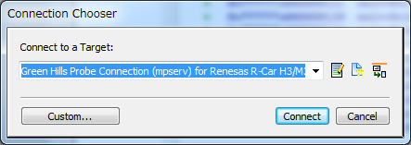

Figure B‑5: Connect to a Target

Press the [OK] button on the following window.

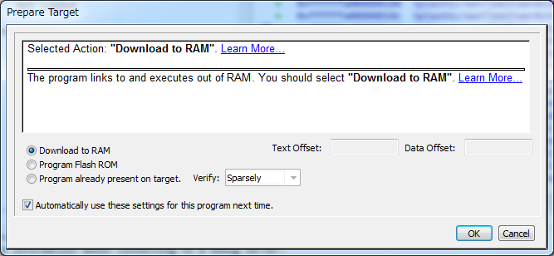

Figure B‑6: Prepare Target

The following “Initializing Target” window appears.

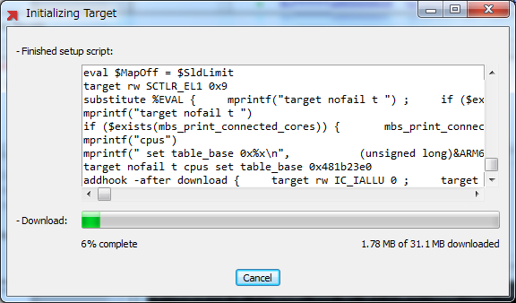

Figure B‑7: Initializing Target

After the download completes, finally the following window appears.

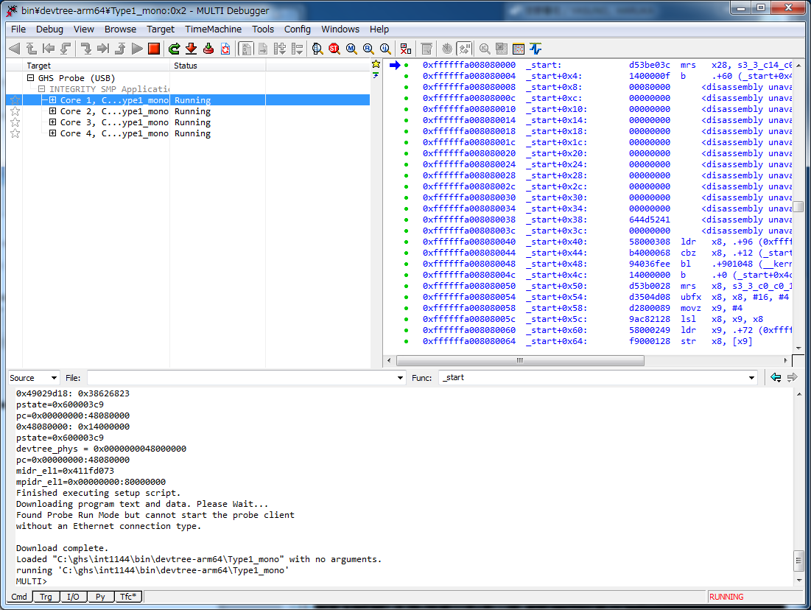

Figure B‑8: Running window

|  |
| --- |
| INTEGRITY® Virtualization Environment Performance Evaluation Report  Publication Date: Rev.1.00 Feb 28, 2017  Rev.1.10 Mar 17, 2017  Rev.1.20 Mar 21, 2017  Rev.1.30 Apr 20, 2017  Published by: Renesas Electronics Corporation |